**NSS ACTIVITIES 2024-25**

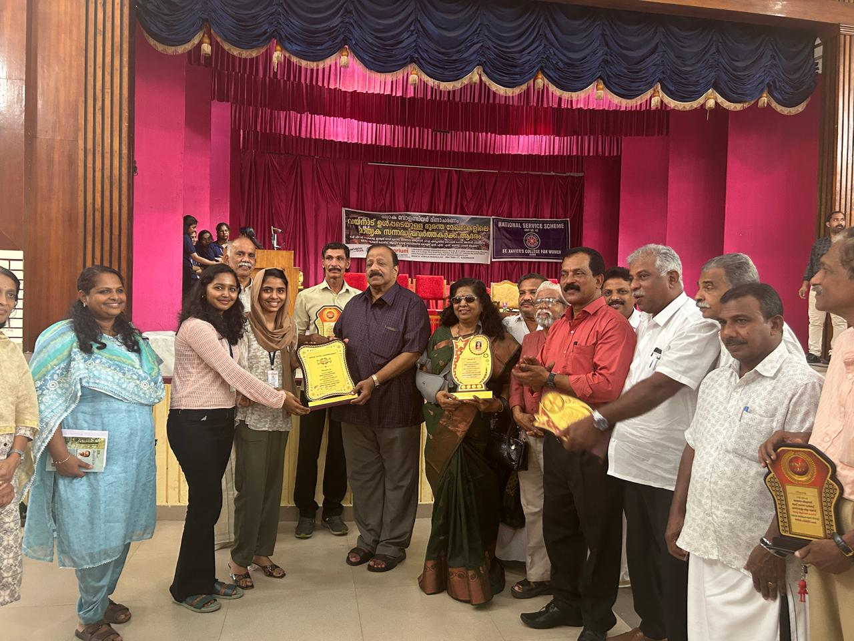

NSS unit No.57 receiving Best NSS unit award in recognition of the services rendered by our NSS unit sponsored by esteemed organizations including IMA Kerala, Red Cross Society, Aluva, Janaseva Shishubhavan, FACT Employees Social Forum, Anwar Palliative Care, and Kerala Action Force. NSS Our NSS volunteer secretaries, Ardra S. Nair and Khadeeja P.A. receiving the award.

**1.PRAVESHANOLSAVAM**

|  |  |
| --- | --- |
| Programme | Praveshanolsavam |
| Organiser | NSS Unit No:57 |
| Associating Partner | NSS Adopted School |
| Beneficiary | Students Of Adopted School |
| Date And Time | O3 June 2024, 09:30 Am |
| Duration | 3 Hrs |
| Objective | Help The Students |
| Outcome | Inculcate Human Values |
| No: Of Participants | 60 |

**SUMMARY**

The NSS Unit No. 57 of Mar Thoma College for Women, Perumbavoor, in association with the NSS Adopted School, Asram L.P. School, organized *Praveshanolsavam* on 3rd June 2024. The event was attended by NSS Programme Officers Dr. Anupama P. and Dr. Avani T., along with 10 NSS volunteers. As part of the celebration, the NSS Programme Officers distributed prizes to the students, while NSS volunteers shared sweets, adding joy to the occasion. The event marked a warm and welcoming start to the new academic year for the young students.

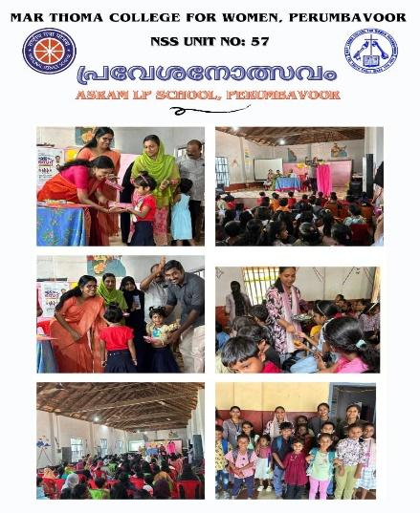 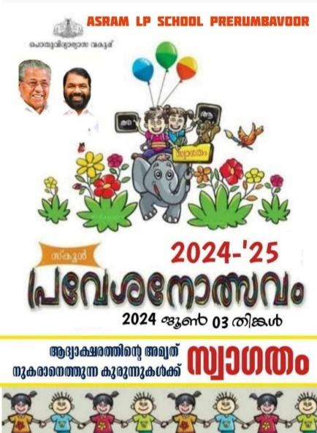

**2. WORLD ENVIRONMENTAL DAY CELEBRATION**

|  |  |
| --- | --- |
| Programme | Environmental Day Programme |
| Organizer | NSS Unit No:57 |
| Beneficiary | Students And Staff |
| Date And Time | 05 June 2024,09:30 Am |
| Duration | Full Day |
| Objective | Promote Environmental Protection And Conservation |
| Outcome | Saplings Were Planted |
| No: Of Participants | 80 |

**SUMMARY**

The NSS Unit No. 57 of Mar Thoma College for Women, Perumbavoor, celebrated *World Environment Day* on 5th June 2024, highlighting this year’s theme: **"Our Land, Our Future."**Principal Smt. Sherin T. Abraham inaugurated the event by planting a sapling, symbolizing the commitment to a greener future. The event was attended by NSS Programme Officers, volunteers, faculty members, and non-teaching staff, making it a collective effort towards environmental sustainability.

As part of the initiative, saplings were distributed to students and faculty members, encouraging everyone to contribute to a healthier planet.

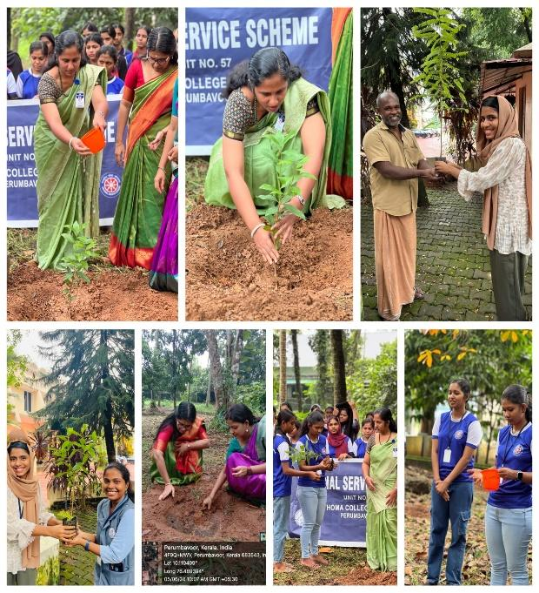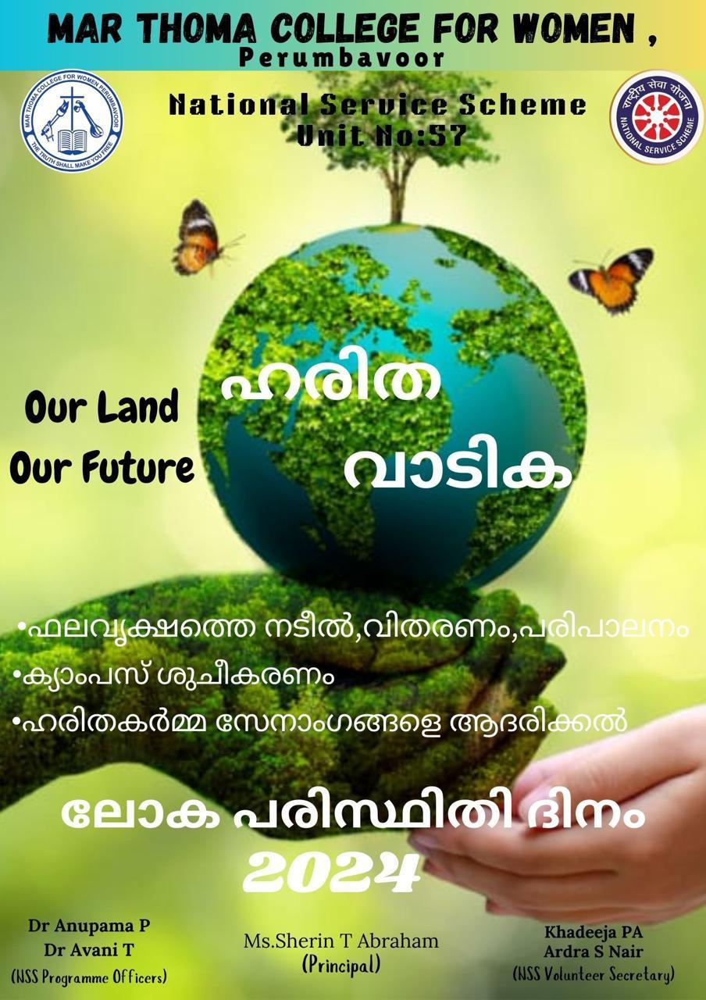

**3.HONOURING HARITHA KARMA SENA**

|  |  |
| --- | --- |
| Programme | Honouring Haritha Karma Sena |
| Organizer | NSS Unit No: 57 |
| Associating Partner | Haritha Karma Sena |
| Beneficiary | Volunteers,Harithakarmasena Members |
| Date And Time | 05 June 2024,03:30 Pm |
| Duration | 1hr |
| Objective | To Recognise And Honour The Selfless Contributions Of Haritha Karmasena |
| Outcome | Motivating Them To Continue Their Environmental Efforts |
| No: Of Participants | 60 |

**SUMMARY**

The NSS Unit No. 57 of Mar Thoma College for Women, Perumbavoor, honored **Haritha Karmasena** members on **5th June 2024** as part of its commitment to environmental sustainability. Principal Smt. Sherin T. Abraham inaugurated the occasion, marking the significance of their contributions.

During the event, Haritha Karmasena members shared their experiences, inspiring students and faculty with their dedication to waste management and environmental conservation. Their interaction, along with the active participation of NSS volunteers, made the program a meaningful and impactful one.

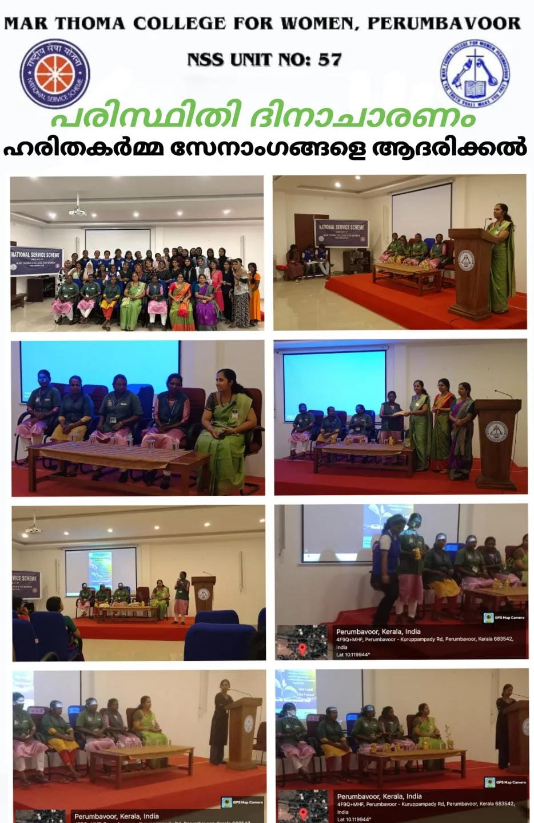

.

**4. WORLD ELDER ABUSE AWARENESS DAY**

|  |  |
| --- | --- |
| Programme | World Elder Abuse Awareness Day |
| Organizer | NSS |
| Associating Partner | Vayomithra |
| Beneficiary | Elders |
| Date And Time | 15th July,10:00am |
| Duration | 30 Min |
| Objective | To Raise Awareness And Mobilize Action Against Elder Abuse |
| Outcome | Increased Awareness And Reporting Of Elder Abuse Cases, Strengthened Community Support Networks, And Enhanced Advocacy For Policies Protecting Older Adults' Rights And Dignity. |
| No: Of Participants | 55 |

SUMMARY

The NSS Unit No. 57 of Mar Thoma College for Women, Perumbavoor, observed **World Elder Abuse Awareness Day** with a commitment to raising awareness and promoting respect for the elderly. **Vayomithram coordinators** attended the event, emphasizing the importance of elder care and protection.

As a mark of their dedication, **NSS volunteers took a pledge** to safeguard and support the elderly, ensuring a society free from abuse and neglect. With the active participation of NSS Programme Officers, volunteers, and Vayomithram coordinators, the event was a meaningful and successful initiative.

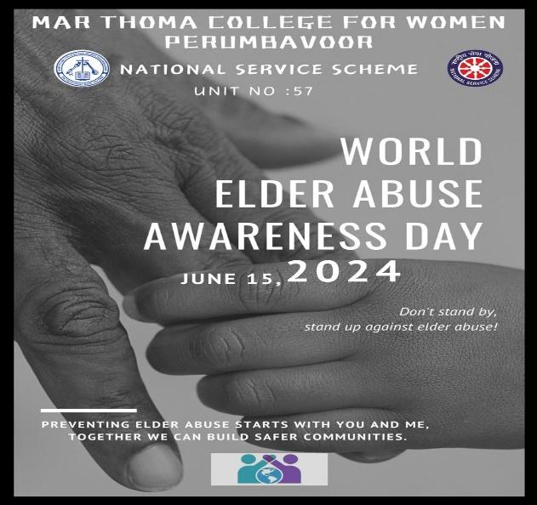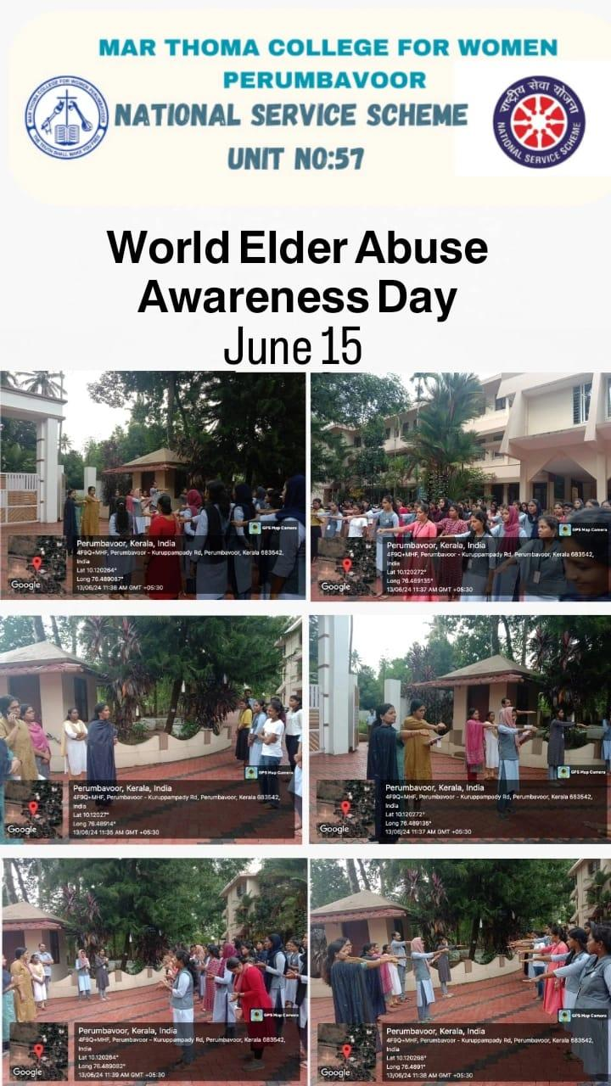

**5.BLOOD DONOURS DAY**

|  |  |
| --- | --- |
| Programme | Blood Donors Day |
| Organizer | NSS Unit |
| Associating Partner |  |
| Beneficiary | Students |
| Date And Time | 14 June 2024,2:30pm |
| Duration | 1 Hrs |
| Objective | To Raise Awareness About The Importance Of Blood Donation, Appreciate The Selfless Contributions Of Voluntary Blood Donors, And Encourage More People To Donate Blood. |
| Outcome | Increased Awareness And Appreciation For Blood Donors, Surge In Voluntary Blood Donations, And Strengthened Community Support For Blood Donation Programs. |
| No: Of Participants | 65 |

**SUMMARY**

On June 14th, 2024, the NSS Volunteers of Mar Thoma College for Women, Perumbavoor, celebrated World Blood Donor Day by spreading awareness about the importance of blood donation. As part of the initiative, volunteers hung informative posters across the college campus, encouraging students and faculty to contribute to this life-saving cause.

The event aimed to highlight the significance of voluntary blood donation and inspire more individuals to become regular donors.

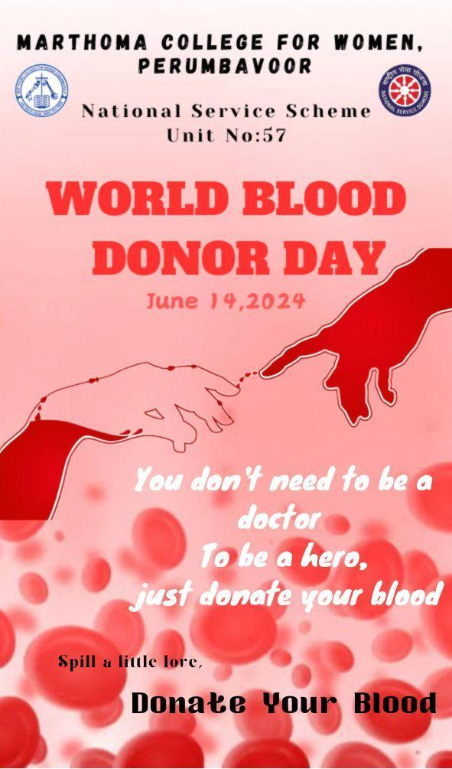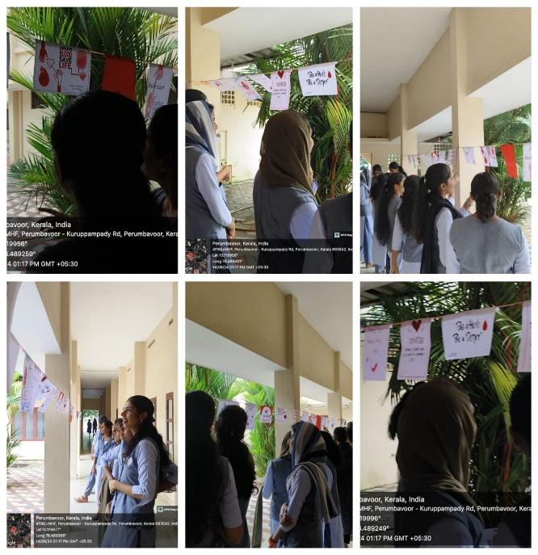

6. INTERNATIONAL YOGA DAY

|  |  |
| --- | --- |
| Programme | International Yoga Day |
| Organizer | NSS,NCC,Dept Of Physical Education |
| Associating Partner | IQAC |
| Beneficiary | Students |
| Date And Time | 21 June,09:30am |
| Duration | 2hrs |
| Objective | To Promote Yoga As A Holistic Approach To Physical, Mental, And Spiritual Well-Being, And To Inspire Global Adoption Of Yoga For A Healthier And Happier Life. |
| Outcome | To Promote Yoga As A Holistic Approach To Physical, Mental, And Spiritual Well-Being, And To Inspire Global Adoption Of Yoga For A Healthier And Happier Life. |
| No: Of Participants | 100 |

SUMMARY

The **NSS and NCC units,** in association with the Department of Physical Education and IQAC, celebrated International Yoga Day on 21st June 2024 at 9:30 AM. This year’s theme, “Yoga for Women Empowerment,” highlighted the role of yoga in promoting physical and mental well-being among women.

Mrs. Ajithanath G., our esteemed resource person, conducted an insightful and highly effective session on yoga. The event saw enthusiastic participation from NSS volunteers, NCC cadets, students, and staff, making it a resounding success.

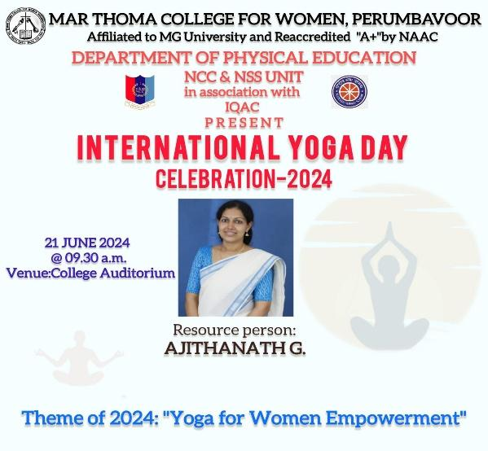 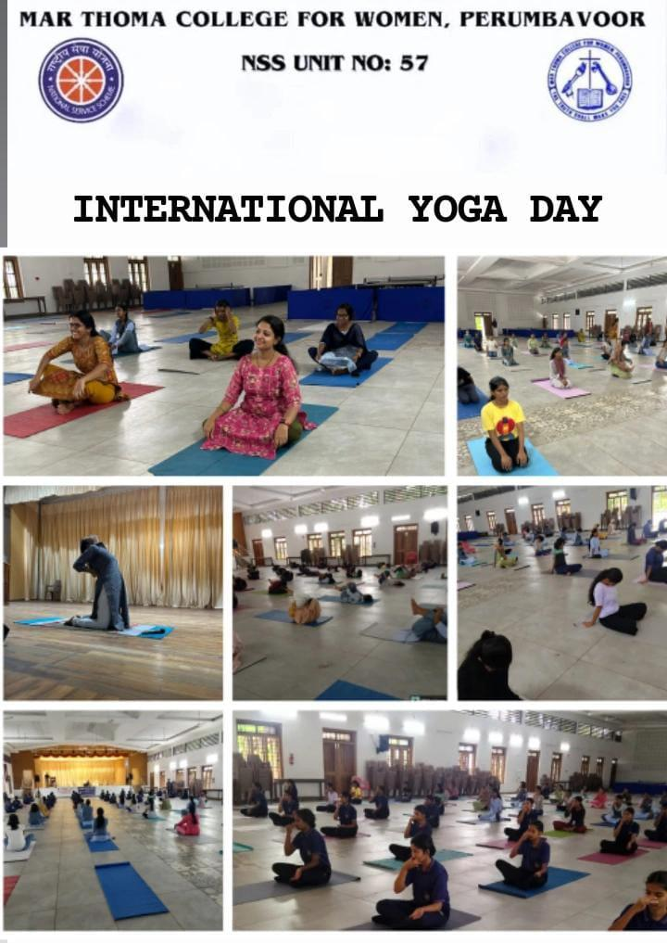

**7.WELCOME FRESHER’S**

|  |  |
| --- | --- |
| Programme | Welcome Fresher’s |
| Organizer | College Union |
| Associating Partner | NSS |
| Beneficiary | Freshers |
| Date And Time | 01 July 2024,09:30am |
| Duration | 3.5hrs |
| Objective | To Warmly Welcome And Integrate New Students Into The College Community, Providing A Supportive And Inclusive Environment To Facilitate Their Academic And Personal Growth. |
| Outcome | To Extend A Warm Welcome To The Faculty Members, Fostering A Positive And Respectful Academic Environment, And Expressing Appreciation For Their Dedication To Education. |
| No: Of Participants | 100 |

SUMMARY

On July 1st, 2024, the new batch of freshers stepped into Mar Thoma College for Women, Perumbavoor, marking the beginning of an exciting academic journey. NSS volunteers extended a heartfelt welcome, creating a warm and inclusive atmosphere for the newcomers.

A significant milestone was also achieved as the college inaugurated its first-ever four-year degree programme. Distinguished guests graced the occasion with their presence and blessings. To celebrate this special day, NSS volunteers distributed sweets, adding joy to the event.

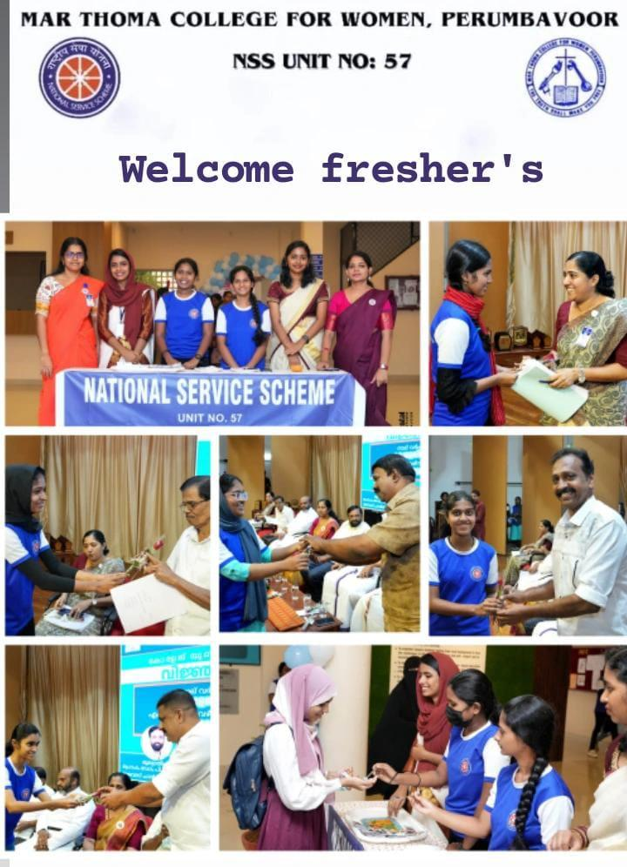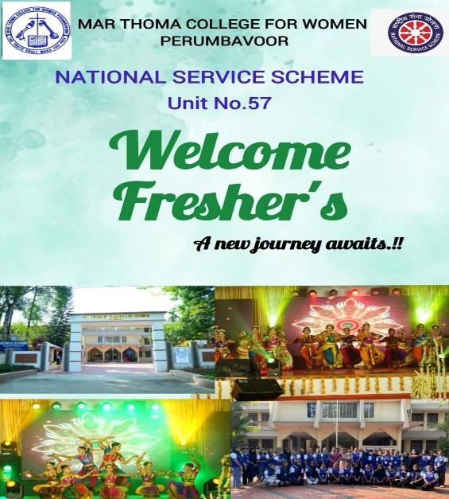

**8. NSS ORIENTATION PROGRAM FOR FRESHERS**

|  |  |
| --- | --- |
| Programme | NSS Orientation Program |
| Organizer | NSS |
| Associating Partner |  |
| Beneficiary | 1st Years |
| Date And Time | 05 July 2024,11:15am |
| Duration | 2 Hrs |
| Objective | To Familiarize New Students With The College's Academic, Extracurricular, And Support Systems, Ensuring A Smooth Transition And Successful Integration Into College Life. |
| Outcome | Freshers Developed A Sense Of Social Responsibility, Gained Awareness About NSS Activities, And Got Motivated To Participate In Community Service And Volunteer Work. |
| No: Of Participants | 150 |

SUMMARY

On July 5th, 2024, the NSS Unit No. 57 of Mar Thoma College for Women, Perumbavoor, conducted an orientation programme for the freshers. The session was led by our esteemed resource person, Mr. Jobin George, who provided a comprehensive introduction to NSS, its objectives, and its impact on society.

The session was highly interactive, with engaging discussions and a variety of fun and insightful games that helped students understand the essence of community service. The enthusiastic participation of the freshers made the programme a resounding success.

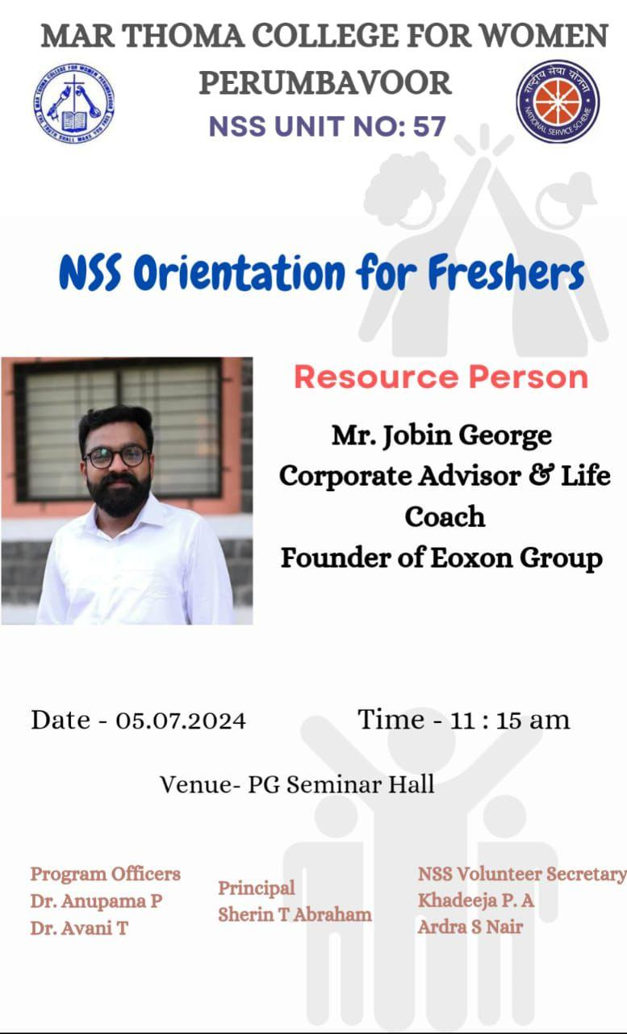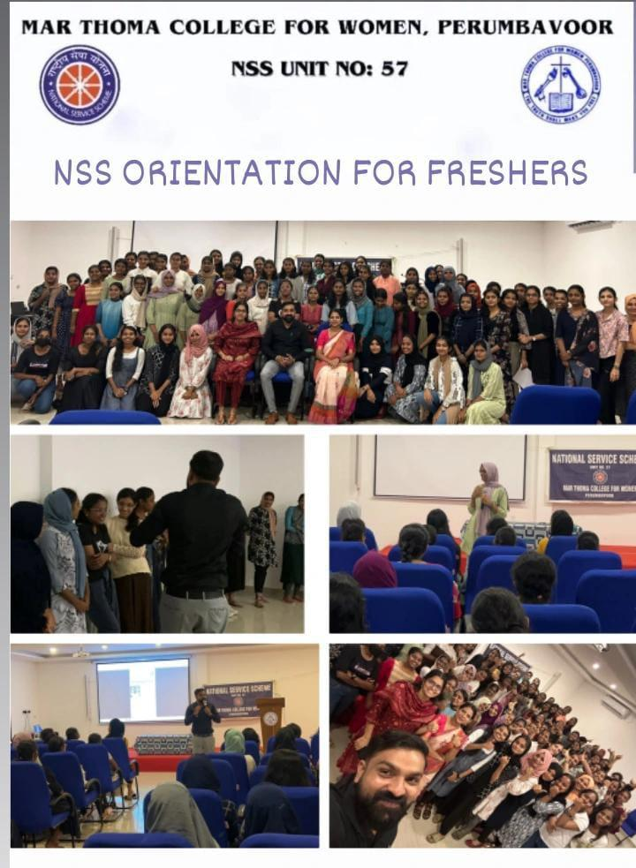

**9.WORLD DAY FOR INTERNATIONAL JUSTICE**

|  |  |
| --- | --- |
| Programme | World Day For International Justice Program |
| Organizer | NSS Unit |
| Associating Partner | Taluk Legal Committee |
| Beneficiary | NSS Volunteers |
| Date And Time | 17 July 2024,2:30pm |
| Duration | 1.5hrs |
| Objective | Promote Access To Justice For All Vulnerable Populations. |
| Outcome | Increased Awareness And Access To Justice For Marginalized Communities. |
| No: Of Participants | 90 |

SUMMARY

The NSS Unit No. 57 of Mar Thoma College for Women, Perumbavoor, in association with the Taluk Legal Service Committee (TLSC), Kunnathunadu, organized a programme on World Day for International Justice on 17th July 2024 at the PG Seminar Hall.

The event was inaugurated by our Chief Guest, Smt. Smitha George, who highlighted the importance of justice in society. A resource person conducted an insightful session on the significance of justice and legal awareness.

With the active participation of NSS volunteers, Programme Officers, and TLSC members, the programme was a meaningful and successful initiative.

**10. OUSHADHA UDHYANAM**

|  |  |
| --- | --- |
| Programme | Oushadha Udhyanam |
| Organiser | NSS Unit |
| Associating Partner | Nagarjuna Ayurveda |
| Beneficiary | Students Of Mtcw |
| Date And Time | 23 July 2024,10am |
| Duration | 1.5hrs |
| Objective | Establish A Medicinal Garden For Education And Research Purposes. |
| Outcome | Enhanced Biodiversity, Aesthetic Appeal, And Hands-On Learning Opportunities Created. |
| No: Of Participants | 70 |

**SUMMARY**

The NSS Unit No. 57 of Mar Thoma College for Women, Perumbavoor, in association with Nagarjuna Ayurveda, organized a special program,inauguration of medicinal garden, featuring Adv. Eldhose Kunnappilly (MLA, Perumbavoor) as the Chief Guest.

To mark the occasion, our Chief Guest planted a medicinal plant on the college campus, emphasizing the importance of traditional medicine and sustainability. Following this, a session was conducted in the PG Seminar Hall, providing valuable insights on Ayurveda and wellness. As part of the event, Nagarjuna Group hosted an engaging quiz competition, in which several NSS volunteers emerged as winners and received prizes. Later, NSS volunteers actively participated in planting medicinal plants in the college garden, contributing to environmental conservation. With enthusiastic participation from students and faculty, the program was a resounding success

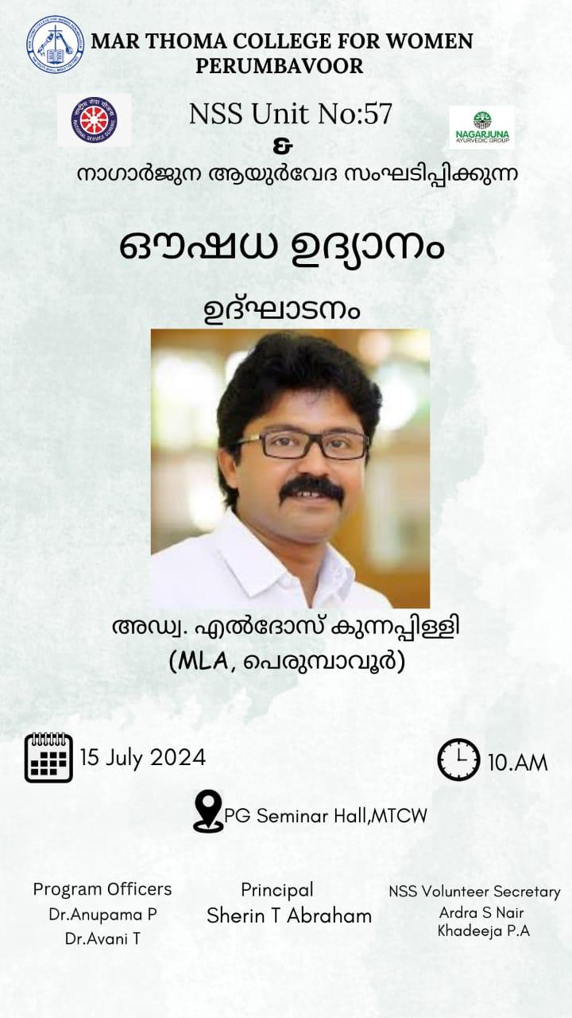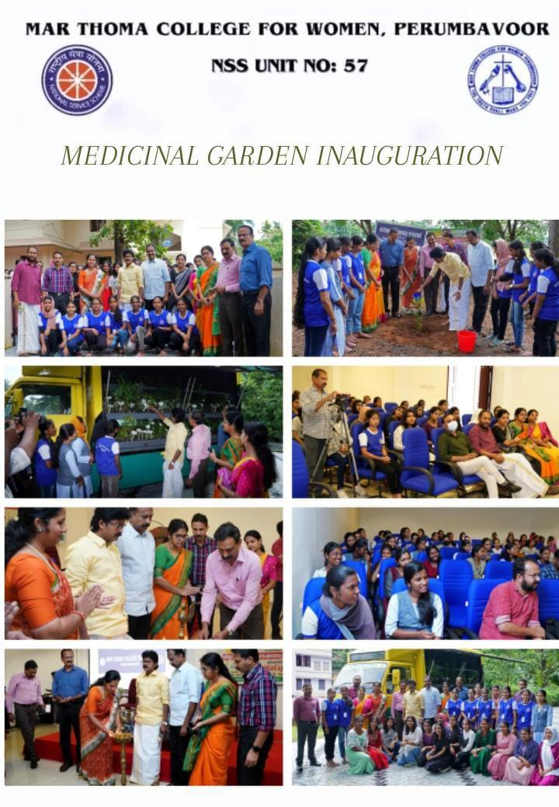

**11.DIGI KERALA SURVEY**

|  |  |
| --- | --- |
| Programme | DIGI-KERALA SURVEY |
| Organiser | NSS UNIT |
| Associating Partner | Govt. Of Kerala |
| Beneficiary | STUDENTS |
| Date And Time | 1st Aug-30th Aug |
| Duration | 30 DAYS |
| Objective | To Achieve 100% Digital |
| Outcome | 54 Volunteers Completed 30 House Each |
| No: Of Participants | 54 |

**SUMMARY**

In August 2024, the Government of Kerala, through its "DigiKerala" initiative, aimed to enhance digital literacy among its citizens. NSS (National Service Scheme) volunteers associated with Perumbavoor Municipality actively participated in this campaign. They conducted surveys to identify residents lacking digital literacy and provided training to bridge this gap.

Similarly, the NSS Unit of Mar Thoma College for Women, Perumbavoor, organized an orientation program for first-year volunteers on August 30 and September 4, 2024. The program aimed to equip volunteers with the necessary skills to assist in various community services, including digital literacy initiatives. Volunteers were divided into groups, each assigned to survey and assist 30 households, completing the task within a week.

marthomacollege.ac.in

These efforts align with the state's goal of fostering digital inclusion and ensuring that all citizens are equipped with essential digital skills.  
**12.INDEPENDENCE DAY**

|  |  |
| --- | --- |
| Programme | Independence Day |
| Organiser | College |
| Associating Partner | NSS&NCC |
| Beneficiary | Students |
| Date And Time | 15th August 2024,08:30am |
| Duration | 2hrs |
| Objective | To Commemorate India's Freedom From British Rule And Celebrate Its Sovereignty And Independence. |
| Outcome | Patriotic Fervor And National Pride Ignited, Fostering Unity And Gratitude Among Citizens For India's Hard-Won Independence. |
| No: Of Participants | 46 |

**SUMMARY**

Mar Thoma College for Women, Perumbavoor, proudly celebrated the 78th Independence Day with great enthusiasm in front of the college. Principal Miss Sherin T. Abraham hoisted the national flag, marking the significance of the day.

As part of the celebrations, NSS volunteers sang the NSS song, distributed chocolates, and performed a vibrant dance, adding to the patriotic spirit of the event.

With active participation from students and faculty, the program was a grand success, fostering a sense of unity and national pride.

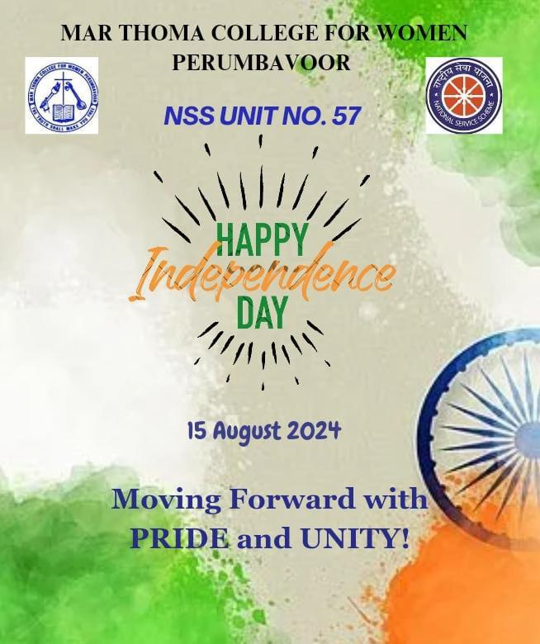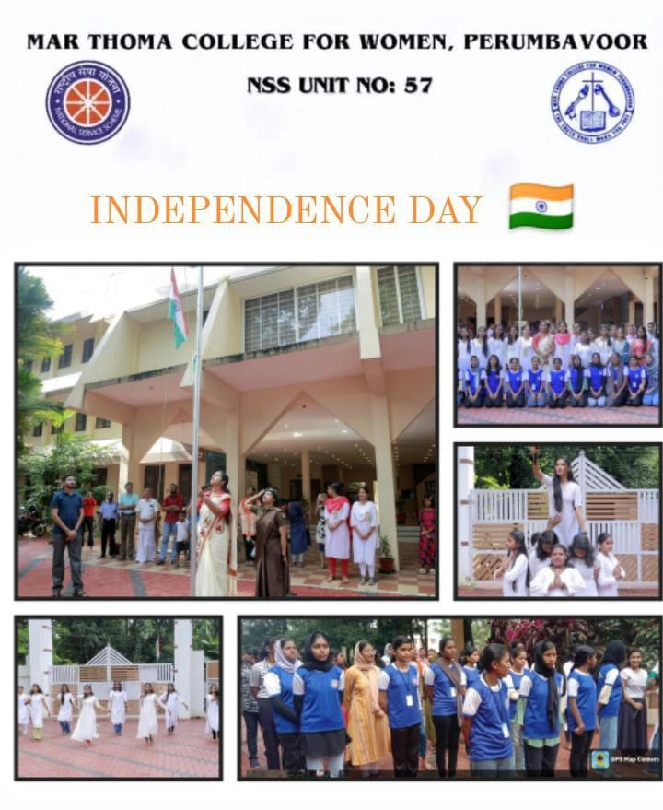

**13.ANTI-RAGGING DAY**

|  |  |
| --- | --- |
| Programme | Anti-Ragging Awareness Mahoutsav |
| Organiser | NSS Unit No:57 |
| Associating Partner | Iic |
| Beneficiary | Students |
| Date And Time | 12th August 2024,11 Am |
| Duration | 2hrs |
| Objective | Create Awareness On Antiragging |
| Outcome | Raising Awareness About The Negative Impacts Of Ragging, Promoting A Culture Of Respect, Empathy, And Inclusivity Among Students. |
| No: Of Participants | 51 |

**SUMMARY**

The NSS Unit No. 57 of Mar Thoma College for Women, Perumbavoor, organized the Anti-Ragging Awareness Mahotsav on 12th August 2024 at 11 AM.

The event aimed to raise awareness about the importance of creating a safe and inclusive campus environment. Through informative sessions and interactive activities, students were educated on the consequences of ragging and the significance of fostering mutual respect and harmony.

With the active participation of NSS volunteers, faculty, and students, the program successfully reinforced the college’s commitment to maintaining a ragging-free campus.

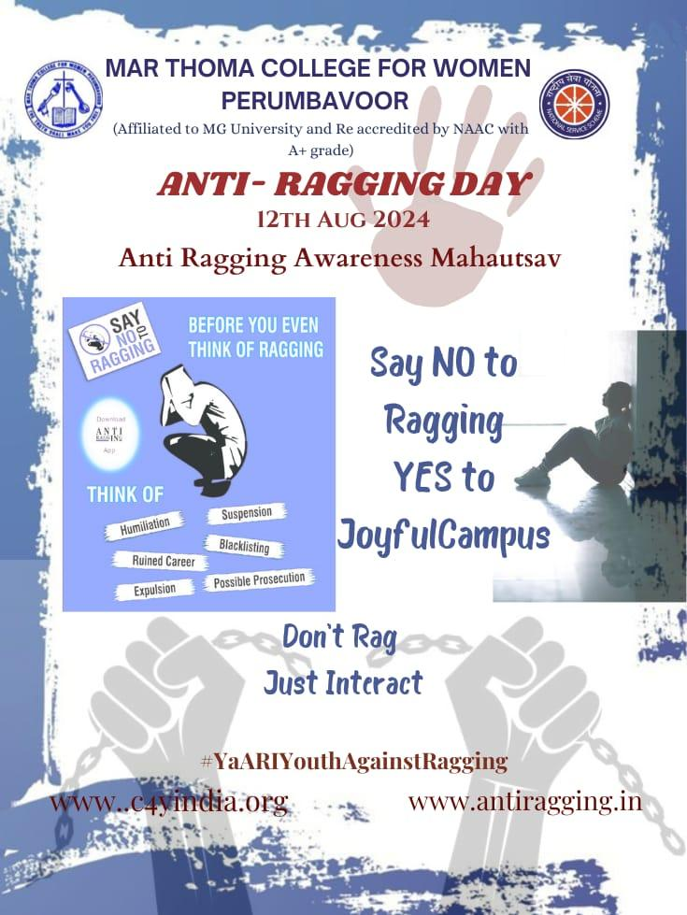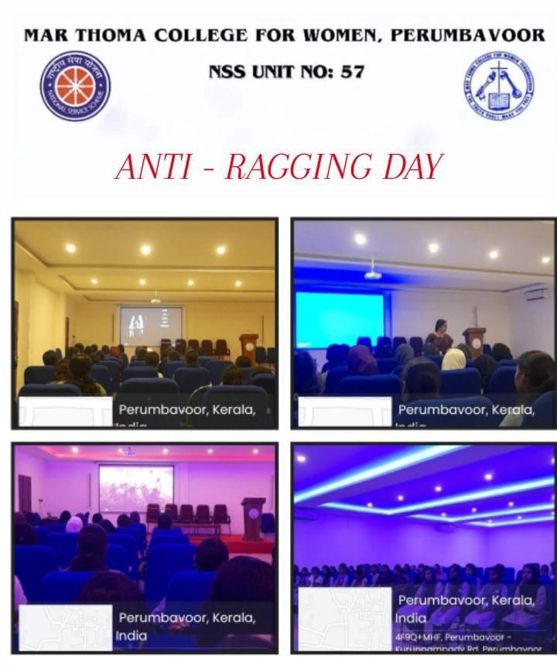

**14.THANMUDRA REGISTRATION**

|  |  |
| --- | --- |
| Programme | Thanmudhra Registration |
| Organiser | NSS Unit No:57 |
| Associating Partner | Vayomithram |
| Beneficiary | Public Especially Disabled |
| Date And Time | 30th August 2024,12:30pm |
| Duration | 1hrs |
| Objective |  |
| Outcome |  |
| No: Of Participants | 15 |

**SUMMARY**

The NSS Unit No. 57 of Mar Thoma College for Women, Perumbavoor, conducted a training programme for Thanmudra Registration on 30th August 2024.

The session was led by Mrs. Sincy Issac, Vayomithram Project Coordinator, who provided detailed guidance on the Thanmudra Registration process. The training equipped NSS volunteers with the necessary knowledge to assist in the registration process efficiently.

Later, the required documents for registration were distributed to the volunteers, ensuring a smooth and organized workflow.

With active participation, the programme was a valuable and informative experience for all attendees.

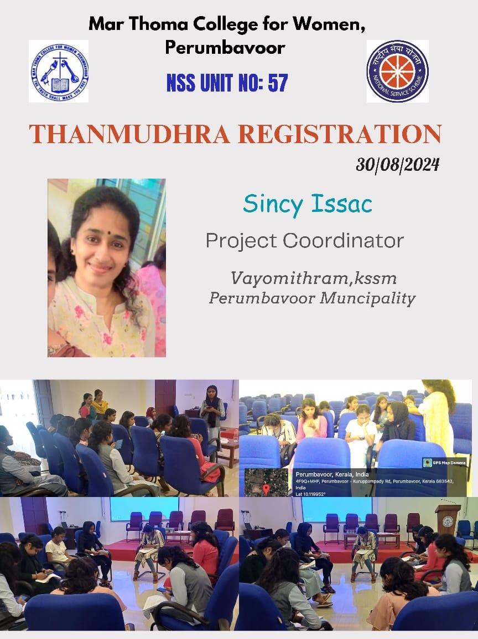

**15. ORIENTATION PROGRAMME FOR FRESHERS**

|  |  |
| --- | --- |
| Programme | Orientation Programme |
| Organiser | NSS Unit No:57 |
| Associating Partner |  |
| Beneficiary | Freshers |
| Date And Time | 30th August 2024,2pm |
| Duration | 2.5hrs |
| Objective | To Familiarize New Students With The College's Academic, Extracurricular, And Support Systems, Ensuring A Smooth Transition And Successful Integration Into College Life. |
| Outcome | Freshers Developed A Sense Of Social Responsibility, Gained Awareness About NSS Activities, And Got Motivated To Participate In Community Service And Volunteer Work. |
| No: Of Students | 46 |

**SUMMARY**

The NSS Unit No. 57 of Mar Thoma College for Women, Perumbavoor, conducted an orientation programme for freshers on 30th August 2024.

The session was led by Fr. Eldhose K. Joy, Assistant Professor, Department of Psychology, St. Kuriakose College, Kuruppampady, who provided valuable insights to the new NSS volunteers. The interactive and informative session helped the freshers understand the vision, mission, and responsibilities of NSS.

With active participation and engaging discussions, the programme was a great success.

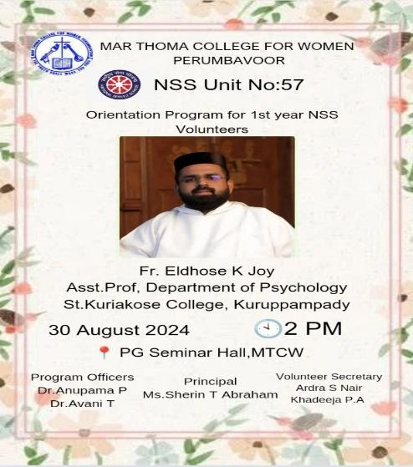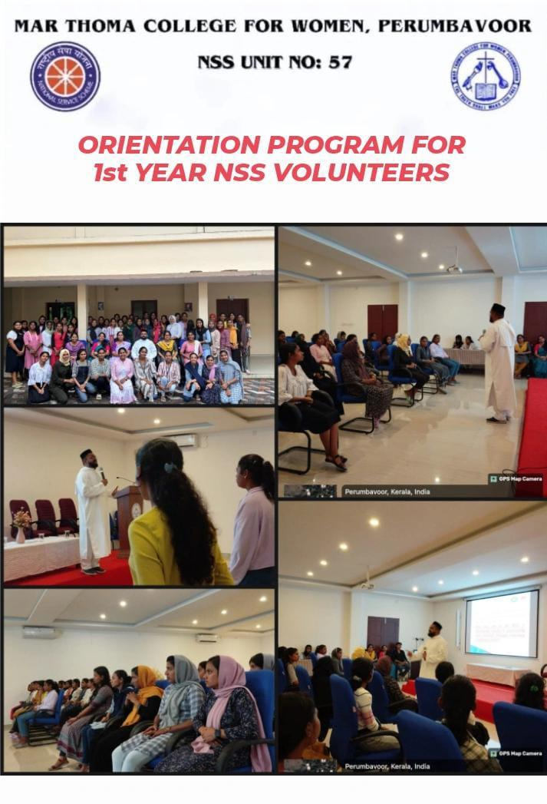

**16.FUND RAISING PROGRAM**

|  |  |
| --- | --- |
| Programme | Fund Raising Programme(Landslide) |
| Organiser | NSS |
| Associating Partner |  |
| Beneficiary | Needy People |
| Date And Time |  |
| Duration | 2 Weeks |
| Objective | For Helping The People Of Wayanad |
| Outcome | Helped The Needy People |
| No: Of Students | 40 |

**SUMMARY**

The NSS Unit No. 57 of Mar Thoma College for Women, Perumbavoor, organized a Saree Sale and Chips Sale in the college as a fundraising initiative to support those affected by the recent landslide.

The sale, which lasted for about two weeks, was open not only to students and faculty but also to the general public, ensuring greater participation. Through this initiative, the unit successfully collected sufficient funds to extend support to the affected individuals, reflecting the spirit of community service and compassion.

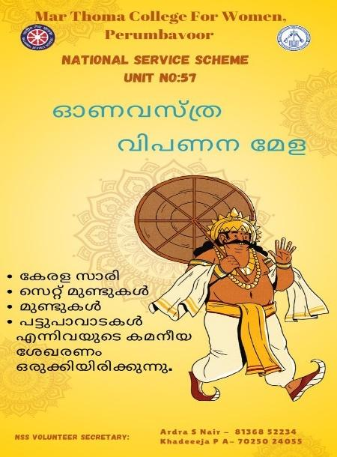

**17.TEACHERS DAY**

|  |  |
| --- | --- |
| Programme | Teachers Day |
| Organiser | NSS |
| Associating Partner |  |
| Beneficiary |  |
| Date And Time | 05th Sep 2024,12:30pm |
| Duration | 3hrs |
| Objective | To Honor And Appreciate Teachers' Dedication, Hard Work, And Contributions To Shaping Young Minds. |
| Outcome | Boosted Teacher Morale, Strengthened Student-Teacher Bonds, And Acknowledged Educators' Vital Role In Society. |
| No: Of Students | 45 |

**SUMMARY**

On 5th September, the NSS Unit organized a special Teachers' Day celebration to honor and appreciate the hard work and dedication of the faculty members. Teachers' Day, celebrated annually in India on the birthday of Dr. Sarvepalli Radhakrishnan, is a day to recognize the contributions of educators in shaping the future of students and society..

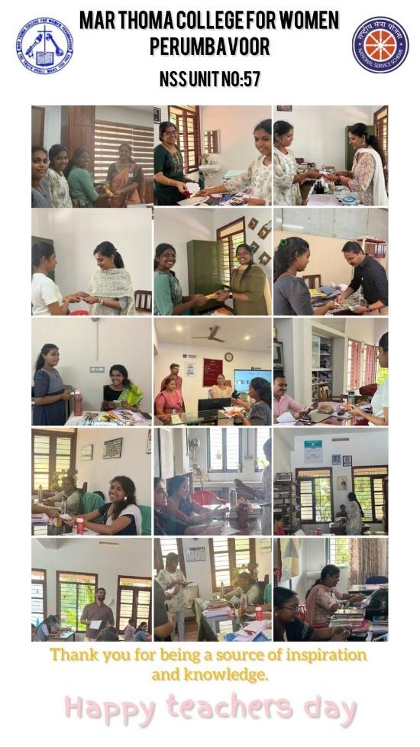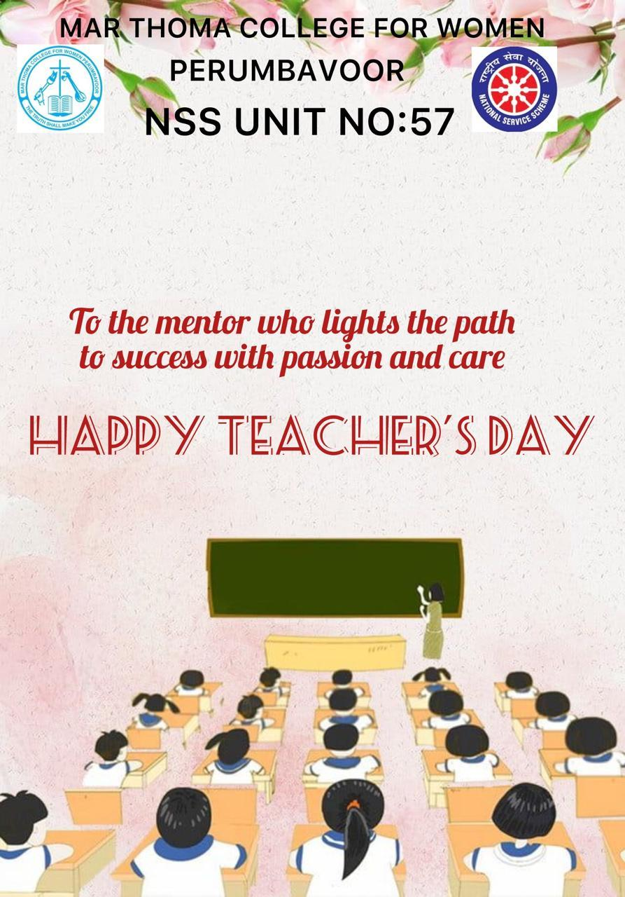

**18.ANNAM**

|  |  |
| --- | --- |
| Programme | Annam |
| Organiser | NSS |
| Associating Partner |  |
| Beneficiary | Needy People |
| Date And Time | Once In Every Month |
| Duration |  |
| Objective | To Provide Sustenance And Support To Underprivileged Individuals, Alleviating Hunger And Promoting Well-Being. |
| Outcome | Relief And Satisfaction Among The Needy, Alleviating Hunger And Promoting Dignity. |
| No: Of Students | 50 |

**SUMMARY**

The NSS Unit of Mar Thoma College has launched a noble initiative titled **'Annam'**, aimed at providing food to those in need. This initiative was officially started on **24th September** and is a part of the college's ongoing commitment to social welfare and community service. The 'Annam' project focuses on helping the underprivileged by distributing free meals on the streets of **Perumbavoor**.

**19.SWACHHATA HI SEVA**

|  |  |
| --- | --- |
| Programme | Swachhata Hi Seva |
| Organiser | NSS |
| Associating Partner |  |
| Beneficiary |  |
| Date And Time | 17th Sept 2024 |
| Duration | 17th Sept-2nd Oct 2024 |
| Objective | For Making The Environment Clean And Increasing Awareness |
| Outcome | Cleaner Environments, Improved Public Health, And Increased Community Awareness About Sanitation And Hygiene. |
| No: Of Students | 80 |

**SUMMARY**

Under the banner of **Swachhata Hi Seva 2024**, the NSS Unit of Mar Thoma College organized a mega cleaning drive to promote cleanliness and environmental awareness. This initiative aimed to honor the principles of Mahatma Gandhi, who advocated for a clean and healthy environment. The event took place from **17th September to 2nd October**, culminating on **Gandhi Jayanti**. The cleaning drive covered three key areas: the college campus, **Asram LP School**, and the **local municipality**. Additionally, a rally was organized to spread the message of cleanliness and sanitation.

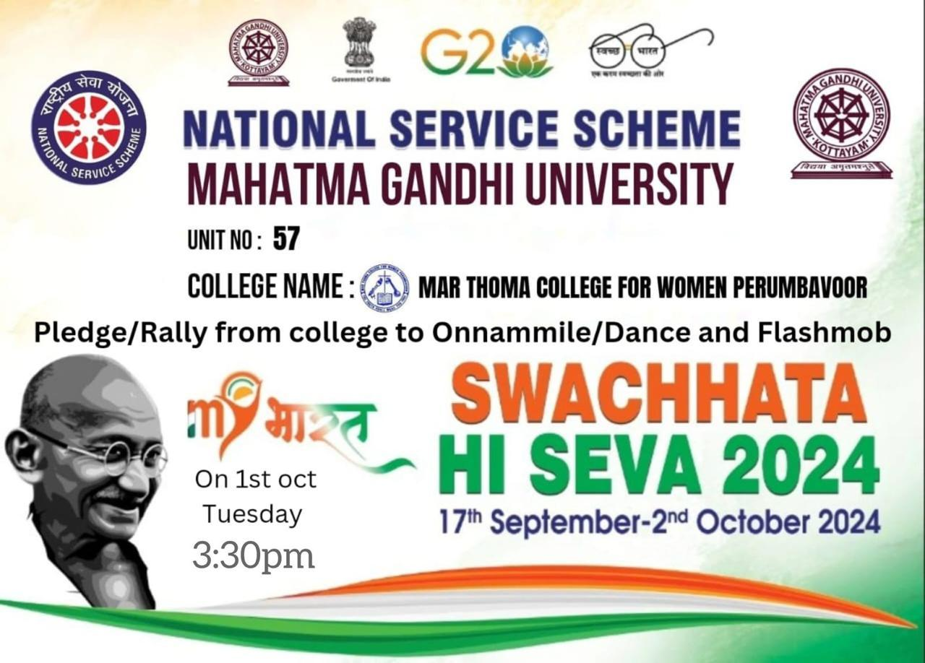

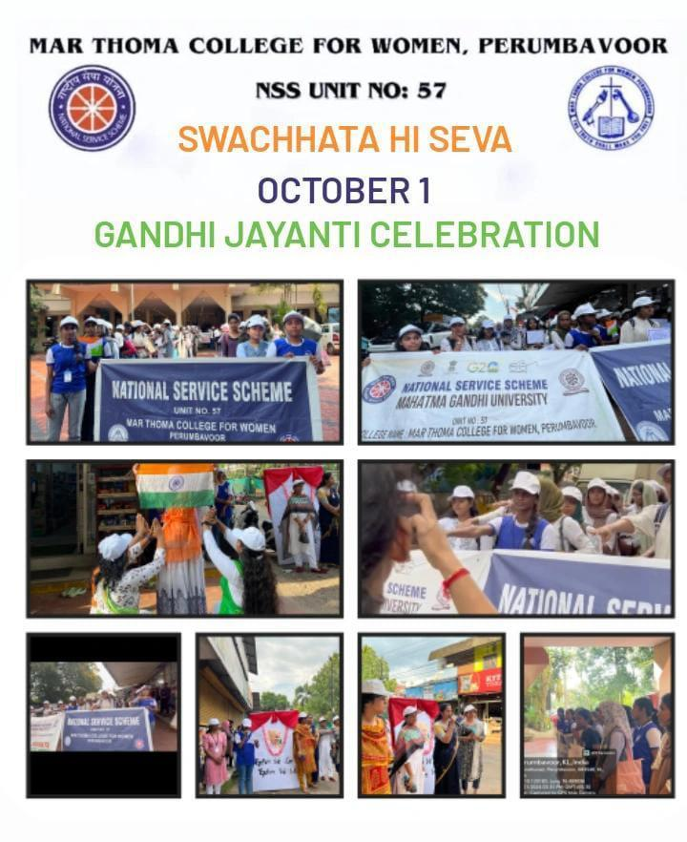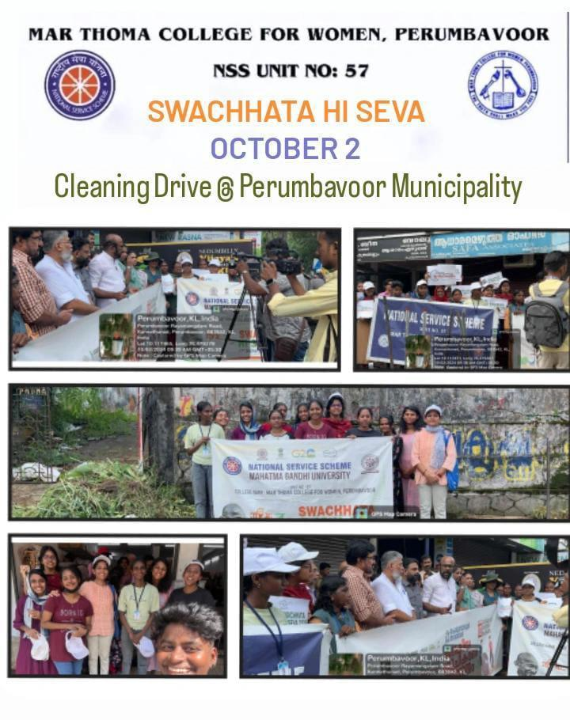

**20.PALLIATIVE CARE**

|  |  |
| --- | --- |
| Programme | Pakalveedu Visit |
| Organiser | NSS Unit |
| Associating Partner |  |
| Beneficiary | People Of Pakalveed |
| Date And Time | 1st Oct 2024,11:30am |
| Duration | 2hrs |
| Objective | To Honor, Respect, And Recognize The Contributions, Wisdom, And Experiences Of Elderly Individuals. |
| Outcome | Increased Recognition, Appreciation, And Support For Elderly Individuals, Promoting Their Dignity, Well-Being, And Social Inclusion. |
| No: Of Students | 30 |

**SUMMARY**

To celebrate **International Day of Older Persons** on **1st October**, the NSS Unit of Mar Thoma College organized a special visit to **Pakalveed**, a home for the elderly, located in **Perumbavoor**. This initiative aimed to honor and appreciate the elderly members of society, fostering a sense of respect and care for senior citizens. The volunteers planned and participated in a series of engaging activities to bring joy and positivity to the elderly residents.

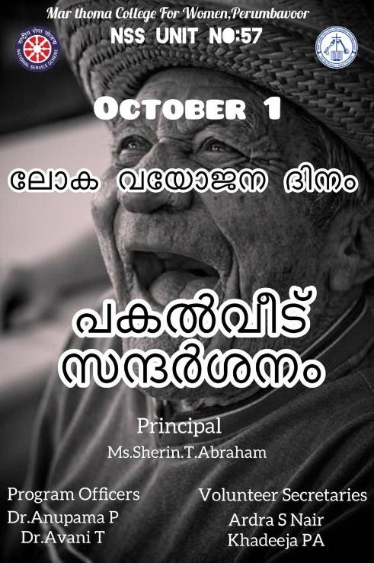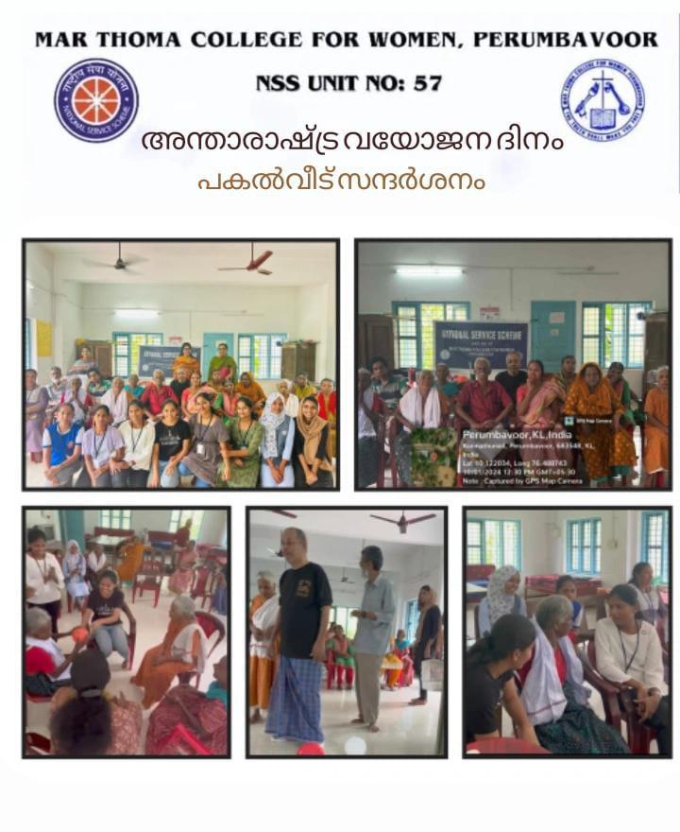

**21.TECHNICAL SESSION**

|  |  |
| --- | --- |
| Programme | Brochure Making Class |
| Organiser | NSS |
| Associating Partner |  |
| Beneficiary |  |
| Date And Time | 10th Oct 2025,3:30pm |
| Duration | 1hr |
| Objective | To Educate And Empower Volunteers To Create Effective Brochures That Promote Awareness, Advocacy, And Community Engagement. |
| Outcome | Creative And Informative Brochures Designed By Volunteers . |
| No: Of Students | 70 |

**SUMMARY**

The NSS Unit of Mar Thoma College organized an insightful technical session for its volunteers on the topic, **"How to Make a Professional Brochure."** The session was aimed at enhancing the volunteers' skills in designing brochures, which are an essential tool for communicating information in a visually appealing and professional manner. The resource person for the session was **Ms. Anuradha K**, a professional in graphic design and communication

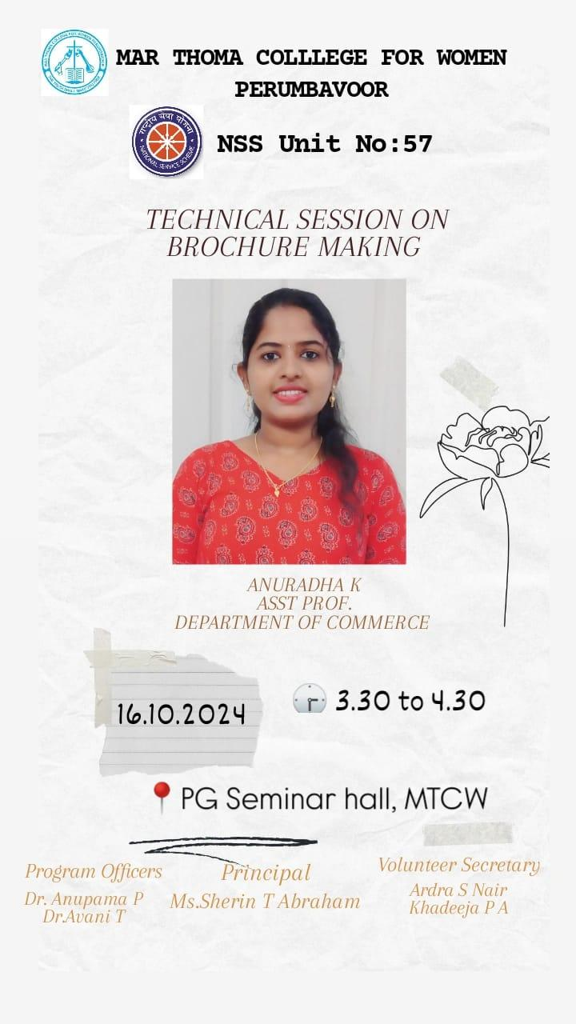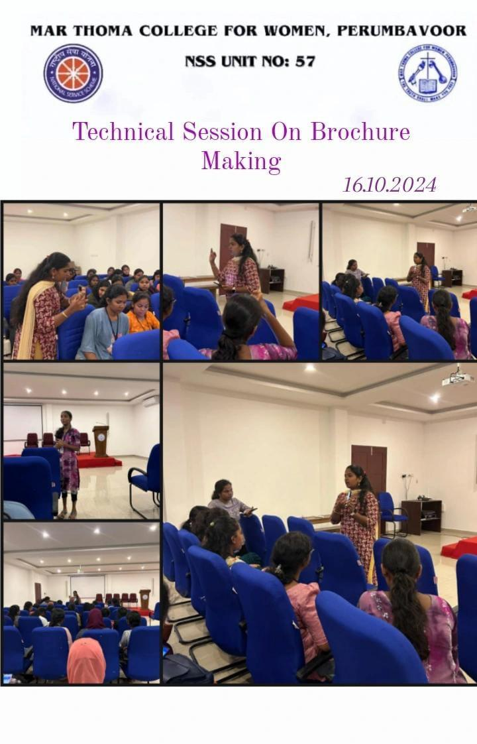

**22.DENTAL CAMP AND BLOOD SCREENING**

|  |  |
| --- | --- |
| Programme | Dental Camp And Blood Screening |
| Organiser | NSS Unit |
| Associating Partner | Sri Bhavani Foundation |
| Beneficiary | Students And Outsiders |
| Date And Time | 21st October 2024,10am |
| Duration | 6hrs |
| Objective | To Provide Free Dental And Blood Screening Services, Promote Oral Health And Disease Prevention, And Facilitate Early Detection And Treatment Of Health Issues. |
| Outcome | Improved Oral Health And Overall Well-Being Of The Community, Increased Awareness About Health And Hygiene, And Early Detection And Treatment Of Dental And Blood-Related Disorders. |
| No: Of Students | 120 |

**SUMMARY**

On **21st October 2024**, the **NSS Unit of Mar Thoma College**, in association with **Sri Bhavani Foundation**, organized a **Free Dental and Blood Screening Camp** at the college auditorium. The camp was aimed at providing free health checkups for both students and the general public. This initiative was part of the NSS Unit's continuous efforts to promote health awareness and provide accessible healthcare services to the community.

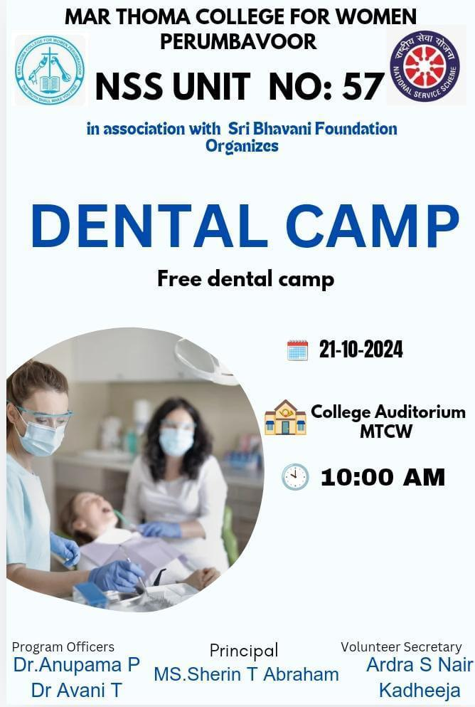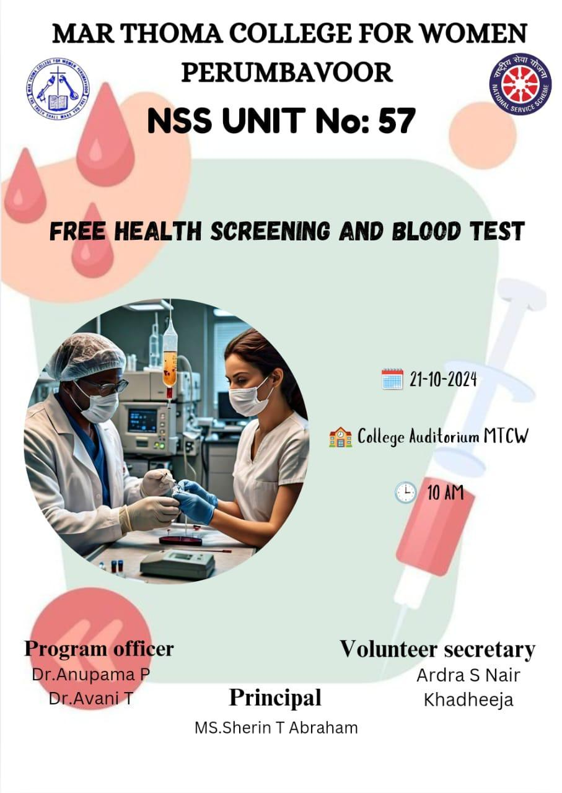

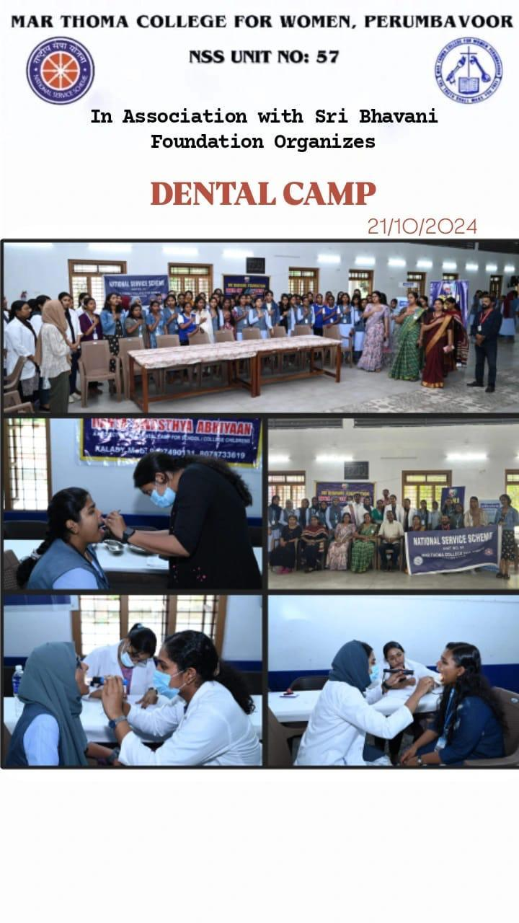

**23.DIWALI WITH MY BHARAT**

|  |  |
| --- | --- |
| Programme | My Bharath |
| Organiser | NSS Unit |
| Associating Partner | Govt Of Kerala,Nyks |
| Beneficiary | Students And Outsiders |
| Date And Time | 27th Oct-30th Oct |
| Duration | - |
| Objective | To Maintain Cleanliness, Ensure Smooth Traffic Flow, Reduce Congestion, And Promote A Safe And Orderly Environment. |
| Outcome | A Cleaner, Safer, And More Organized Community With Reduced Traffic Congestion, Improved Air Quality, And Enhanced Overall Quality Of Life. |
| No: Of Students | 60 |

**SUMMARY**

As part of the **Diwali with My Bharat Initiative**, the NSS Unit of Mar Thoma College organized a series of community service activities aimed at promoting social responsibility and civic engagement. The event focused on two main activities: **traffic management** and a **cleaning drive** at **Pakalveedu**. These activities were designed to enhance the safety of the public and contribute to maintaining cleanliness in the community.

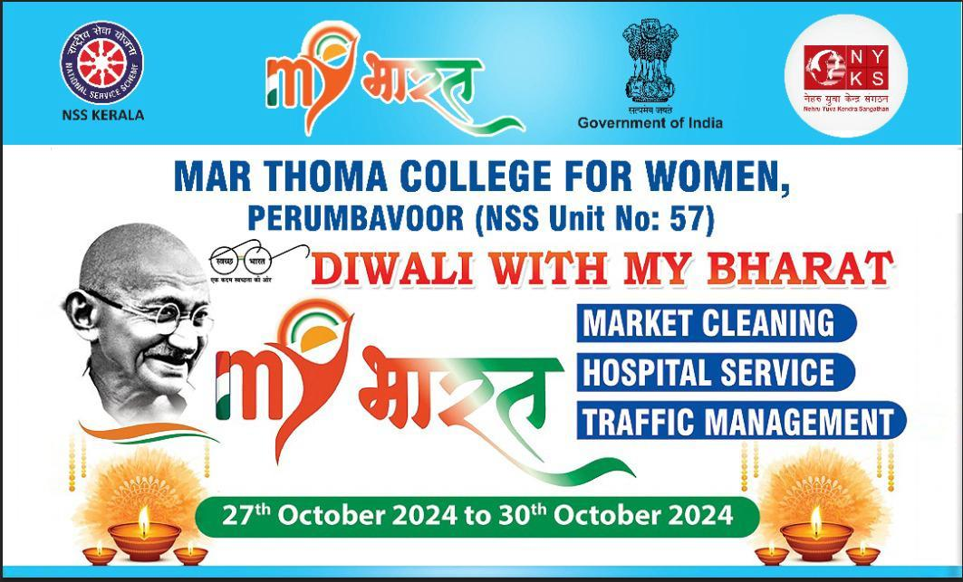

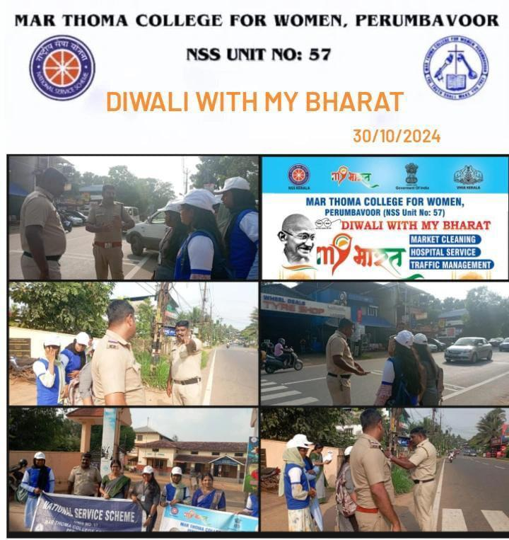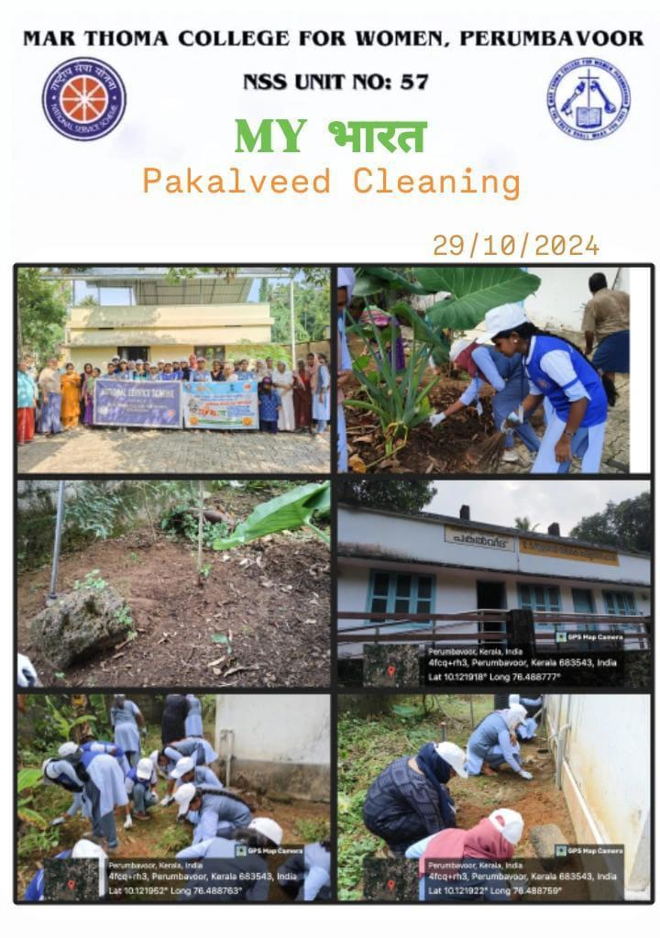

**24.WELCOMING OUR NEW PRINCIPAL**

|  |  |
| --- | --- |
| Programme | Welcoming Our New Principal |
| Organiser | NSS |
| Associating Partner |  |
| Beneficiary |  |
| Date And Time | 06th Nov 2024,3:30pm |
| Duration | 1hr |
| Objective | A Positive And Inclusive School Culture, A Strong And Motivated Leadership, And A Sense Of Community And Collaboration Among Students, Teachers, And Staff. |
| Outcome | A Smooth Transition Of Leadership, Boosted Staff Morale, And A Positive Impression On The New Principal, Setting The Tone For A Productive And Successful Tenure. |
| No: Of Students | 50 |

**SUMMARY**

On **6th November 2024**, the **NSS Unit** of **Mar Thoma College** organized a **welcoming ceremony** to honor and introduce the new principal, **Dr. Letha P Cherian**. The event provided an excellent opportunity for both NSS volunteers and faculty members to interact with the new principal, offering a warm welcome as she began her journey at the college.

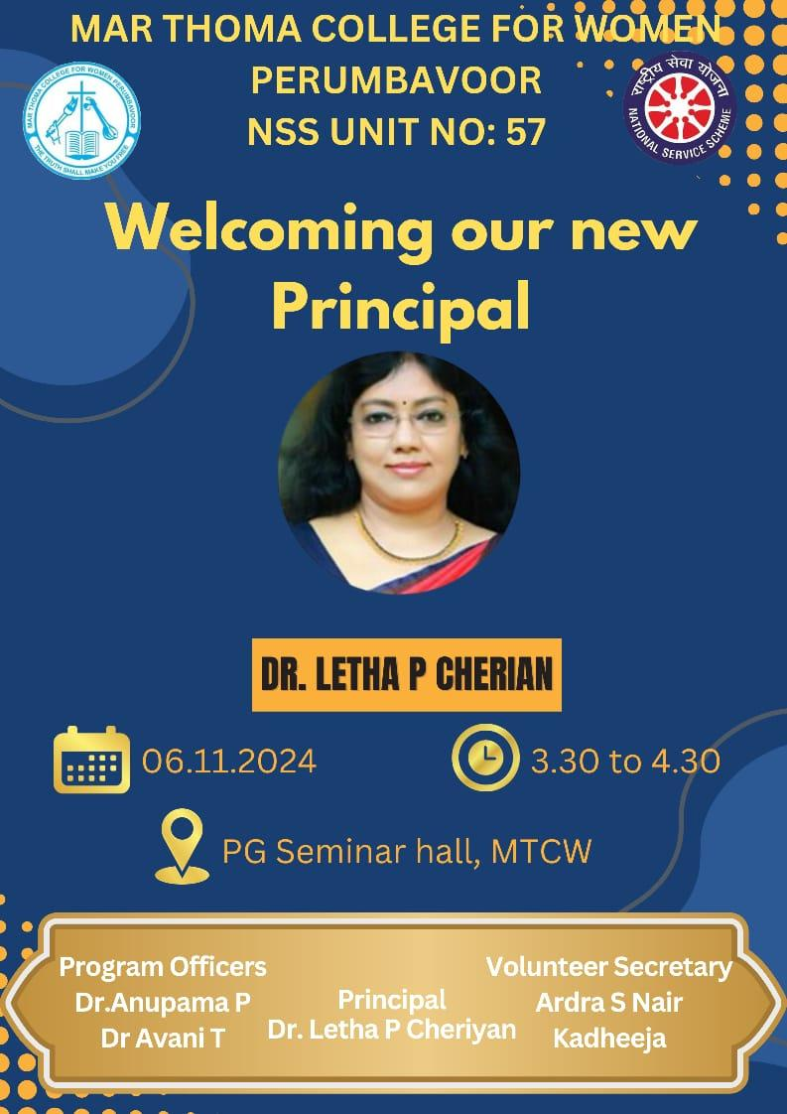

**25.CANCER AWARNESS CLASS FOR WOMEN**

|  |  |
| --- | --- |
| Programme | Cancer Awareness Class |
| Organiser | NSS |
| Associating Partner |  |
| Beneficiary |  |
| Date And Time | 13th Nov 2025,3:15pm |
| Duration | 1hr 15 Min |
| Objective | To Educate And Empower Women With Knowledge About Cancer Prevention, Early Detection, And Treatment Options, Promoting Healthy Lifestyles And Informed Decision-Making. |
| Outcome | Increased Knowledge, Reduced Stigma, And Enhanced Awareness Among Women, Leading To Improved Health-Seeking Behaviors, Early Detection, And Better Cancer Outcomes. |
| No: Of Students | 55 |

**SUMMARY**

On **13th November 2024**, the **NSS Unit of Mar Thoma College** organized an informative **Cancer Awareness Class** aimed at educating students and faculty members about the critical aspects of cancer. The session was led by **Dr. Revathy K**, an esteemed Assistant Professor from **Nangelil Ayurveda Medical College & Hospital, Kothamangalam**. The session focused on providing comprehensive knowledge regarding the causes, symptoms, diagnosis, treatment, and prevention of cancer.

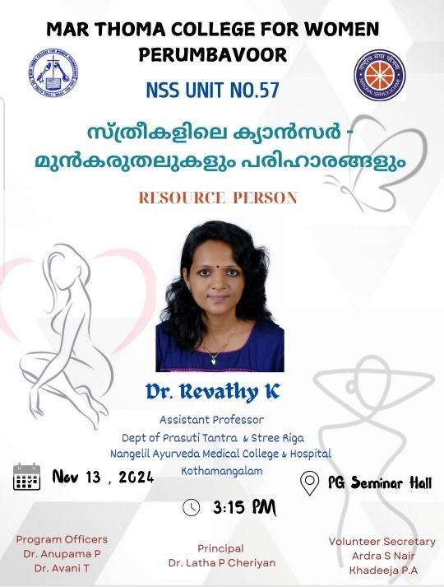

**26.BLOOD SCREENING**

|  |  |
| --- | --- |
| Programme | Blood Screening |
| Organiser | NSS |
| Associating Partner | Sri Bhavani Foundation |
| Beneficiary | Students And Staff |
| Date And Time | 21st Nov 2025,11am |
| Duration | 3hrs |
| Objective | To Detect And Identify Potential Health Risks, Promote Early Intervention And Treatment, And Foster A Healthy And Aware Student Community Through Voluntary Blood Screening. |
| Outcome | Early Detection Of Health Issues, Improved Student Health, And Enhanced Awareness About Preventive Measures, Leading To A Healthier Campus Community. |
| No: Of Students | 60 |

**SUMMARY**

On **21st November 2024**, the **NSS Unit of Mar Thoma College** organized a **blood screening camp** in collaboration with the **Kerala Social Security Mission** and **Malabar Gold and Diamonds**. The primary goal of this initiative was to provide free blood screening tests to students, staff, and faculty members, promoting health awareness and encouraging the early detection of blood-related disorders.

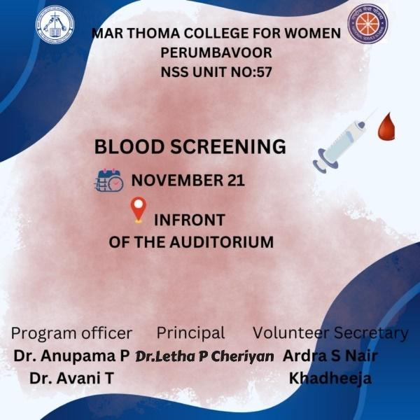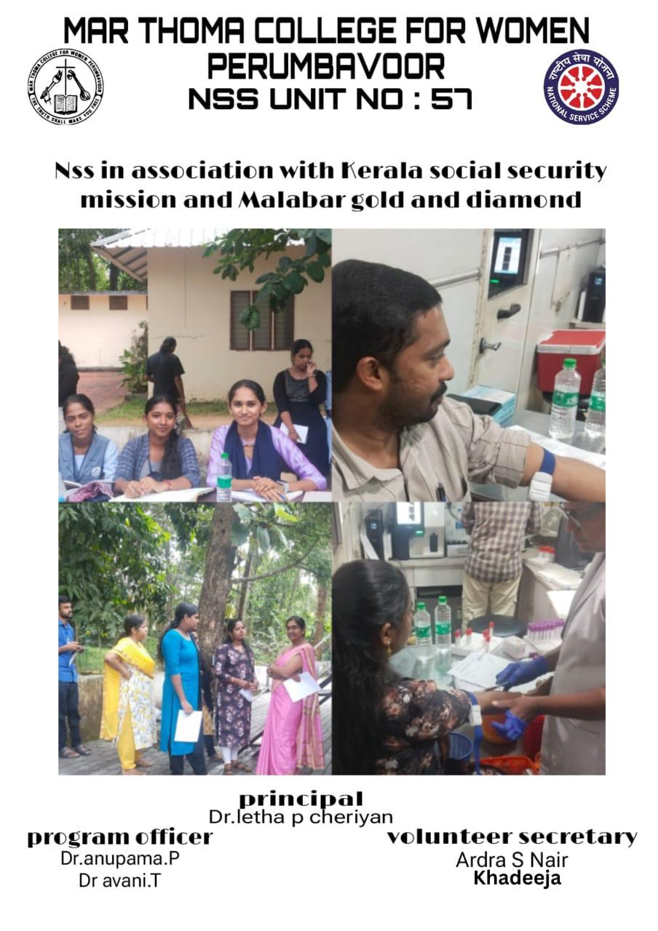

**26.7-DAY SPECIAL CAMP**

|  |  |
| --- | --- |
| Programme | 7 Day Special Camp |
| Organiser | NSS |
| Associating Partner |  |
| Beneficiary |  |
| Date And Time | 20th Dec-26th Dec 2025 |
| Duration | 7 Days |
| Objective | To Foster Community Engagement, Promote Social Responsibility, And Develop Leadership Skills Among Students Through A Week-Long Immersion In Community Service And Outreach Activities. |
| Outcome | Empowered Students, Strengthened Community Bonds, And Positive Social Impact Through Service, Education, And Outreach Activities, Promoting A Culture Of Volunteerism And Social Responsibility. |
| No: Of Students | 100 |

**SUMMARY**

The **NSS Unit** of **Mar Thoma College For Women, Perumbavoor** organized a **7-day NSS camp**, titled **"Sparsham"**, at the **Diet Lab School, Kurupampady**, from **20th December 2024 to 26th December 2024**. The camp aimed to enhance the community service initiatives of the volunteers while also fostering **social awareness**, **leadership skills**, and promoting **cultural exchange** among the participants. The volunteers actively engaged in a variety of activities throughout the week, contributing to the community and gaining valuable experience.

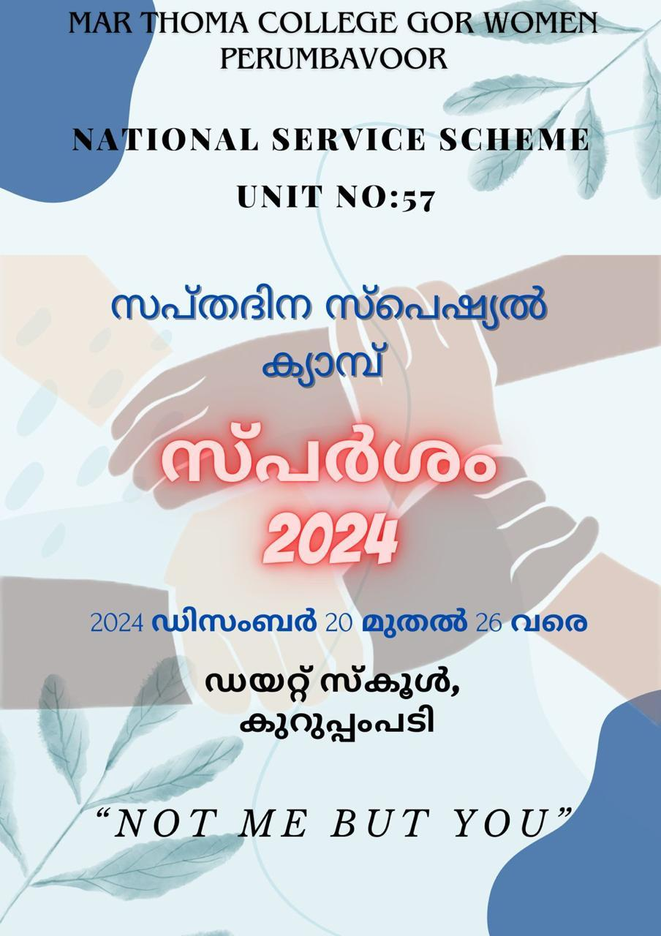

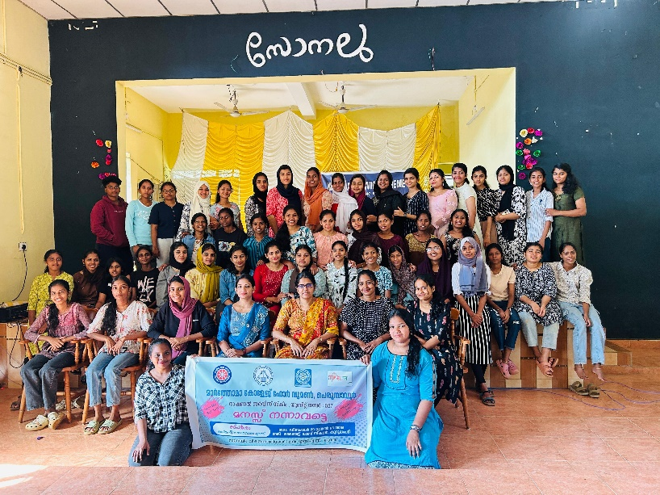

**27.GOONJ- Collection drive**

|  |  |
| --- | --- |
| Programme | Goonjit |
| Organiser | NSS |
| Associating Partner | Goonj |
| Beneficiary | Needy People |
| Date And Time | 20th Jan-24th Jan |
| Duration | 4 Days |
| Objective | For Collecting Necessary Items For Distribution To The Needy |
| Outcome | Successfully Collected And Handed Over To Goonj |
| No: Of Students | 50 |

**SUMMARY**

The **NSS Unit of Mar Thoma College For Women, Perumbavoor** organized a **GOONJ Collection Drive** from **20th January 2025 to 24th January 2025**. This initiative aimed to collect **clothing, household items, and educational materials** for the benefit of marginalized and rural communities. The drive sought to promote social responsibility and community engagement, encouraging both students and faculty to contribute to a noble cause.

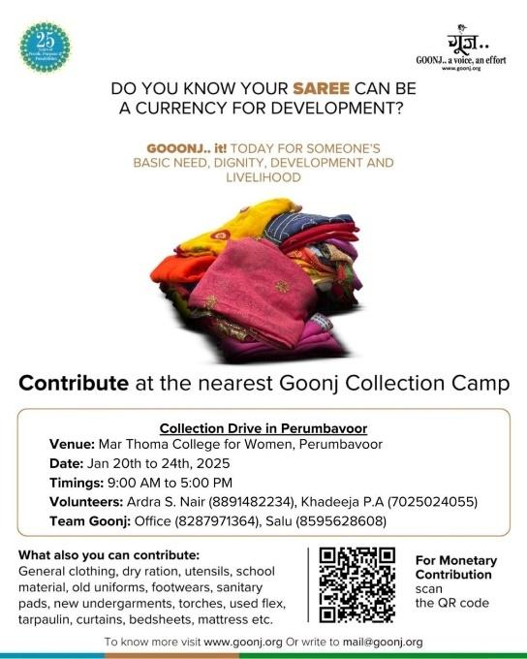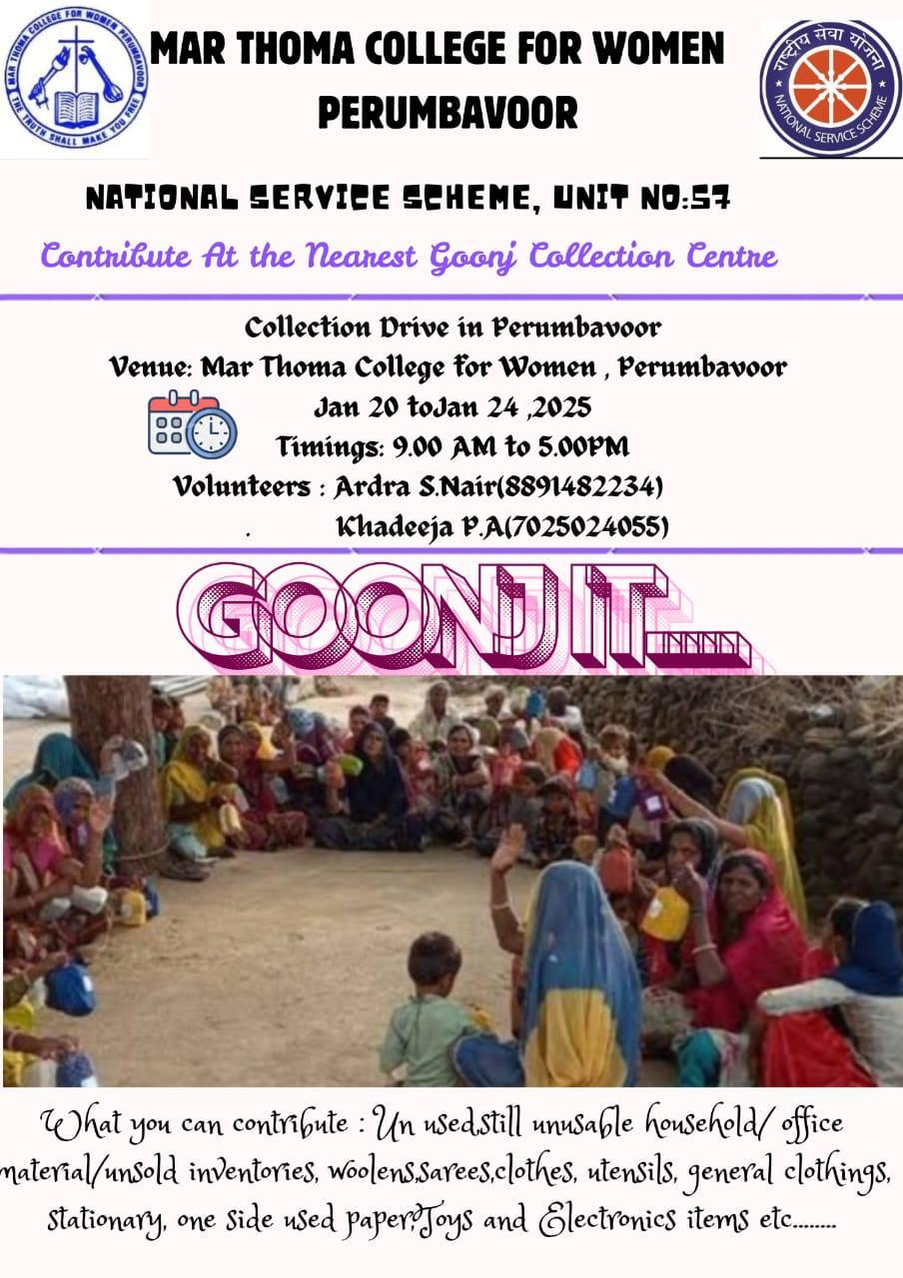

**28.”SMALL STEPS,BIG IMPACTS”**

|  |  |
| --- | --- |
| Programme | Awareness Class |
| Organiser | College |
| Associating Partner | NSS&IQAC |
| Beneficiary | Students |
| Date And Time | 21st Jan 2025,9:30am |
| Duration | 3hrs |
| Objective | To Educate And Sensitize Individuals On The Importance Of Proper Waste Management Practices, Promoting Environmentally Responsible Behaviors And Sustainable Lifestyles. |
| Outcome | Increased Awareness, Changed Attitudes, And Adoption Of Eco-Friendly Habits, Leading To Reduced Waste, Improved Recycling, And A Cleaner, Healthier Environment. |
| No: Of Students | 700 |

**SUMMARY**

On **21st January 2025**, the **NSS Unit of Mar Thoma College For Women, Perumbavoor**, in association with **Kudumbashree** and **Haritha Karmasena**, organized an **awareness class** on **Waste Management in Daily Life**. The session aimed to educate students, faculty, and staff about the importance of effective waste management and the simple practices that can be adopted to reduce, reuse, and recycle waste in their daily lives.

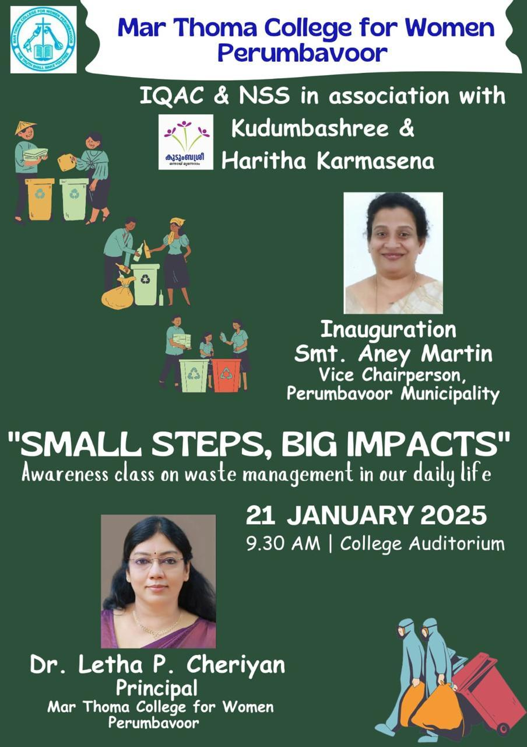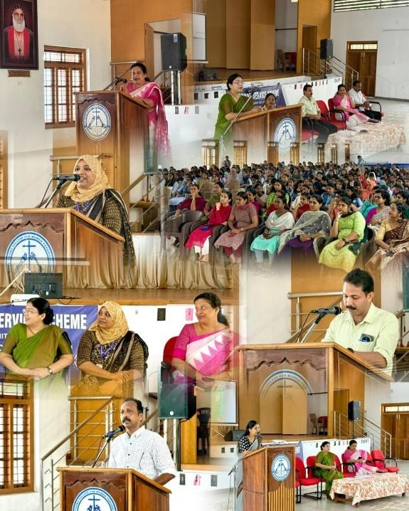

**29.PERSONAL DEVELOPMENT AND WOMEN’S HYGIENE**

|  |  |
| --- | --- |
| Programme | Awareness Class |
| Organiser | NSS Unit No:57 |
| Associating Partner | Y Connect |
| Beneficiary | Volunteers |
| Date And Time | 22nd Jan 2025,2:30pm |
| Duration | 2hrs |
| Objective | To Educate And Empower Men And Women With Knowledge And Skills On Personal Hygiene, Menstrual Health, And Overall Well-Being, Promoting Healthy Habits And Dignity. |
| Outcome | Improved Self-Awareness, Enhanced Personal Hygiene Practices, And Empowered Individuals, Particularly Women, With Knowledge And Confidence To Maintain Their Physical And Emotional Well-Being. |
| No: Of Students | 50 |

**SUMMARY**

On **22nd January 2025**, the **NSS Unit** of **Mar Thoma College For Women, Perumbavoor** organized a **Personality Development & Women's Hygiene session** in association with **Y Connect**. The session, conducted by **Miss Fathima Shamna K**, a **Life Skill Master Trainer** from **NaITER**, aimed to empower students with the necessary knowledge and practical skills to enhance their personality and maintain proper hygiene, particularly focusing on women’s health and well-being.

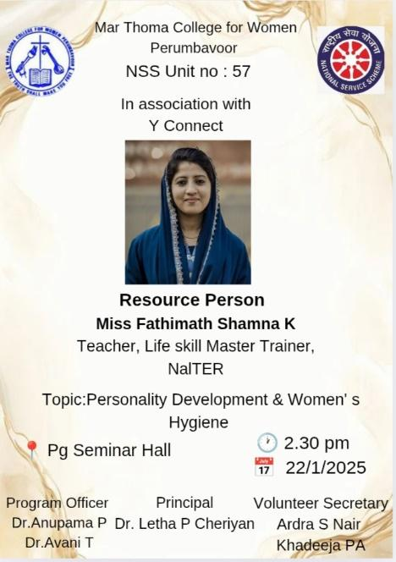

**30.WORLD CANCER AWARENESS DAY**

|  |  |
| --- | --- |
| Programme | Cancer Awareness Class |
| Organiser | NSS |
| Associating Partner |  |
| Beneficiary | Students |
| Date And Time | 4th Feb 2025,11am |
| Duration | 1hr |
| Objective | To Educate And Empower Women With Knowledge About Cancer Prevention, Early Detection, And Treatment Options, Promoting Healthy Lifestyles And Informed Decision-Making. |
| Outcome | Increased Knowledge, Reduced Stigma, And Enhanced Awareness Among Women, Leading To Improved Health-Seeking Behaviors, Early Detection, And Better Cancer Outcomes. |
| No: Of Students | 55 |

**SUMMARY**

As part of **World Cancer Day**, the **NSS Unit** of **Mar Thoma College For Women, Perumbavoor** organized a **Cancer Awareness Session** on **4th February 2025**. The session was conducted by the **NSS volunteer secretaries**, **Ardra S Nair** and **Khadeeja P.A.** The aim of the session was to educate students on **cancer prevention**, the importance of **early detection**, and available treatment options, in order to raise awareness about the disease and promote healthier, proactive lifestyle choices.

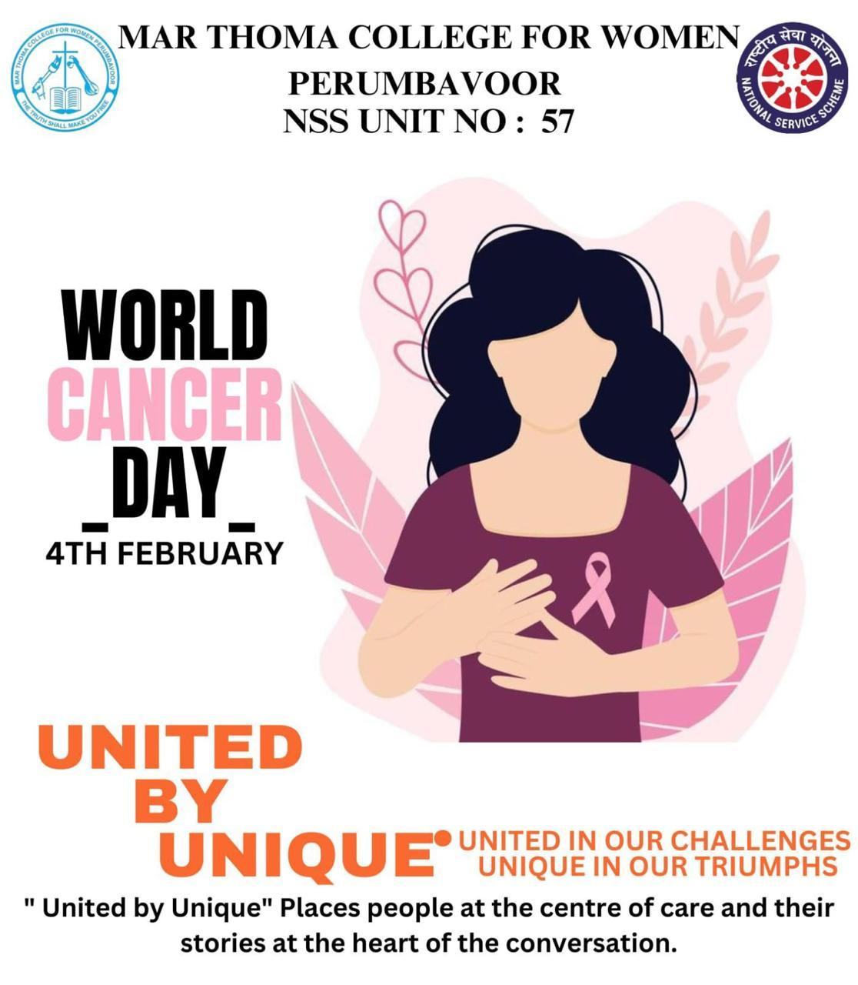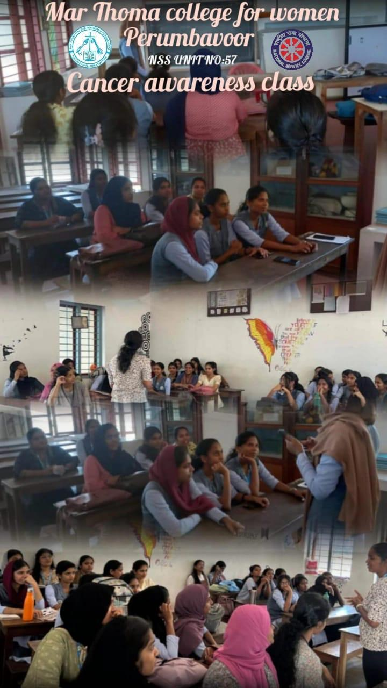

**31.EYE CAMP**

|  |  |
| --- | --- |
| Programme | Eye Camp |
| Organiser | NSS Unit No:57 |
| Associating Partner | Lf Hospital& Sri Bhavani Foundtion |
| Beneficiary | Needy People |
| Date And Time | 15th Feb 2025,9 Am To 1:30pm |
| Duration | 4.5hrs |
| Objective | To Make Our State Cataract Free |
| Outcome | Helped The Needy People To Undergo A Free Cataract Surgery |
| No: Of Students | 50 |

**SUMMARY**

On **15th February 2025**, the **NSS Unit** of **Mar Thoma College For Women, Perumbavoor** successfully organized a **one-day eye treatment camp** in collaboration with **Sri Bhavani Foundation, Kalady** and **LF Hospital, Angamaly**. The camp aimed to provide free eye care services, focusing on **cataract surgeries**, eye check-ups, and spreading awareness about **eye hygiene** and the importance of **regular eye care**.

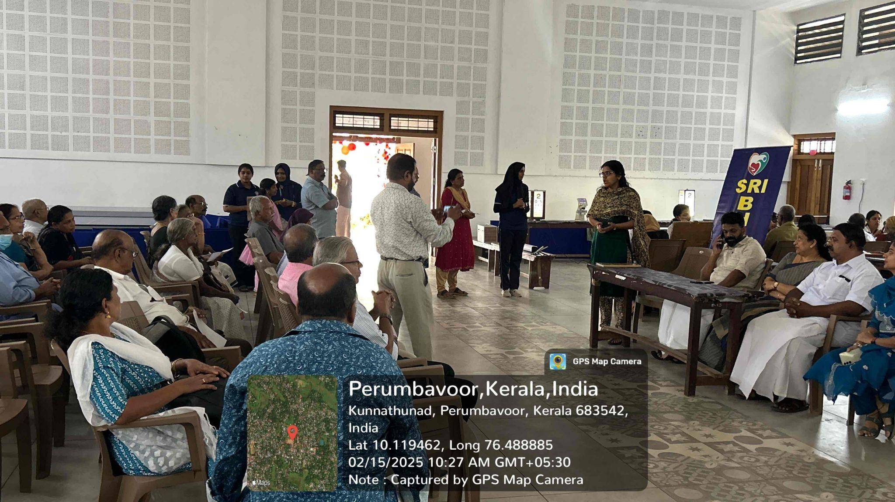

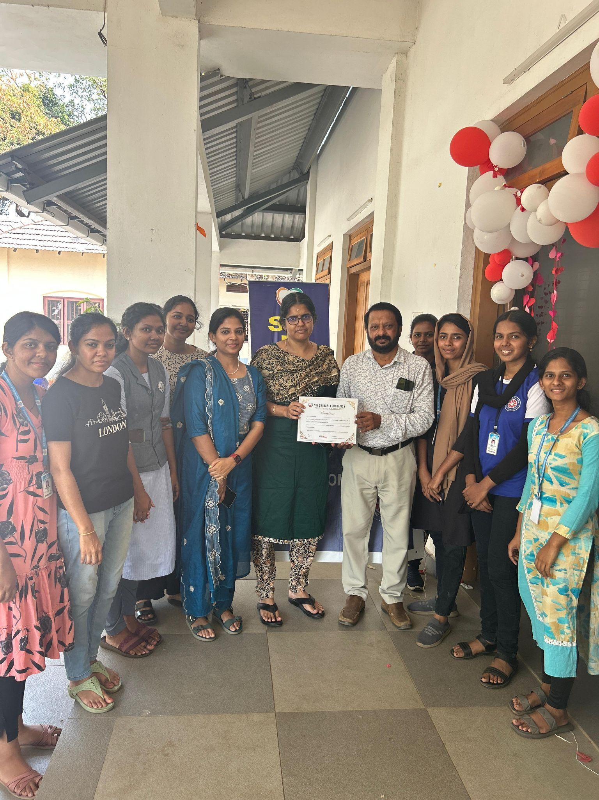

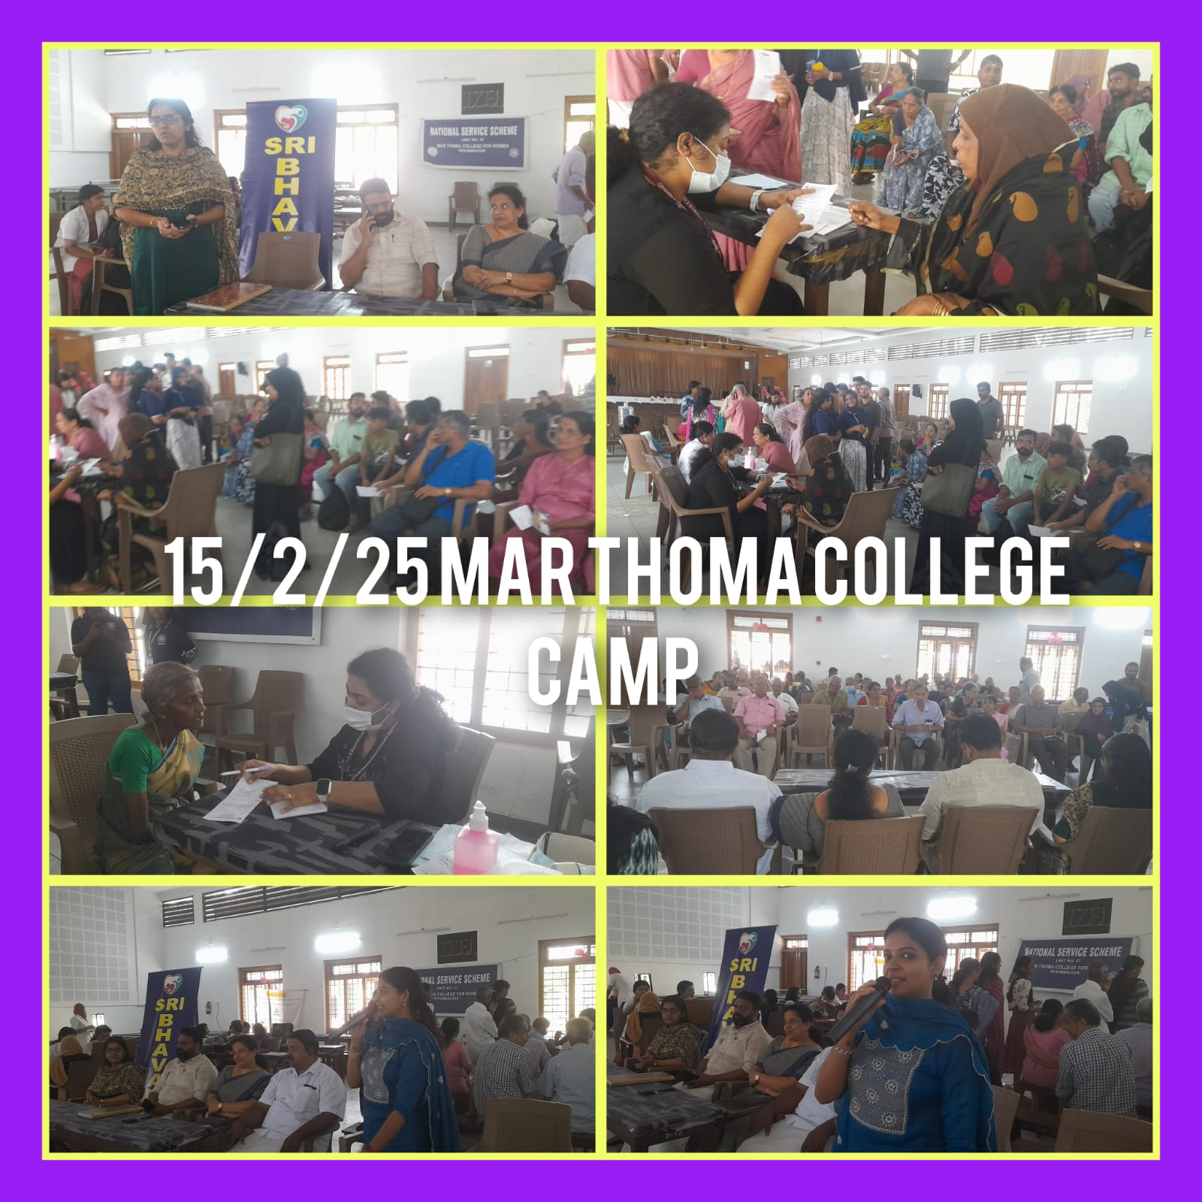

**31.EMERGENCY FIRST AID TRAINING AND DEMONSTRATION**

|  |  |
| --- | --- |
| Programme | Emergency First Aid Training And Demonstration |
| Organiser | NSS Unit No:57 |
| Associating Partner |  |
| Beneficiary | Volunteers |
| Date And Time | 12th Bfeb 2025,3pm |
| Duration | 2hrs |
| Objective | To Equip Participants With Essential Knowledge And Skills To Respond Confidently And Effectively In Emergency Situations, Providing Timely And Life-Saving First Aid Interventions. |
| Outcome | Enhanced Emergency Response Skills, Increased Confidence, And Ability To Provide Timely And Effective First Aid, Saving Lives And Reducing Injuries. |
| No: Of Students | 50 |

**SUMMARY**

On **12th February 2025**, the **NSS Unit** of **Mar Thoma College For Women, Perumbavoor** organized an **Emergency First Aid and Demonstration session** to equip students, faculty, and staff with the essential skills and knowledge to handle emergency situations effectively. The session was conducted by **Mr. Pradeep**, the **Junior Health Inspector** from **Thaluk Hospital, Perumbavoor**. The primary goal was to promote a culture of safety and ensure that participants could respond appropriately in case of emergencies.

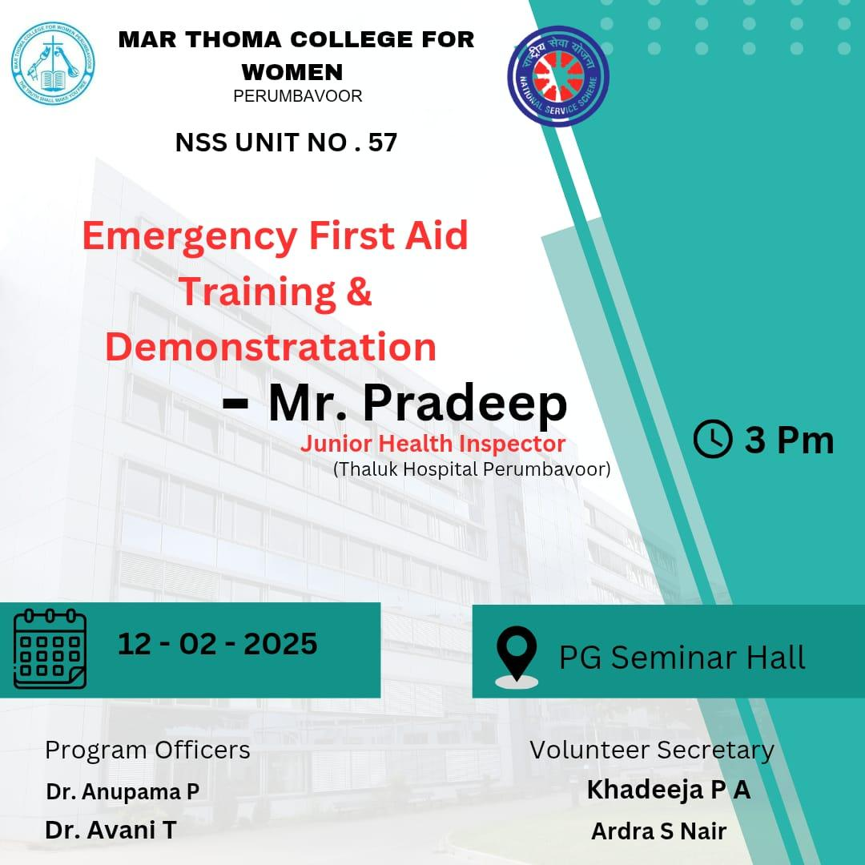

**32.AWARENESS PROGRAM ON PALLIATIVE CARE**

|  |  |
| --- | --- |
| Programme | Awareness Class |
| Organiser | IQAC,Yrc,NSS |
| Associating Partner | Govt Taluk Hospital&Perumbavoor Municipality |
| Beneficiary | Students |
| Date And Time | 21st Feb 2025,2:45pm |
| Duration | 1hr |
| Objective | To Sensitize And Educate The Community On The Importance Of Palliative Care, Promoting Compassionate And Holistic Support For Individuals With Life-Limiting Illnesses And Their Families. |
| Outcome | Increased Awareness, Reduced Stigma, And Improved Understanding Of Palliative Care, Leading To Enhanced Support And Care For Patients And Families, And Improved Quality Of Life. |
| No: Of Students | 600 |

**SUMMARY**

On **21st February 2025**, the **NSS Unit** of **Mar Thoma College For Women, Perumbavoor** organized an **awareness program on Palliative Care** at the college campus. The session aimed to educate the college community on the importance of **palliative care** and how it plays a significant role in improving the **quality of life** for patients with life-limiting illnesses. The session was conducted by **Mr. Jomon Kuriakose**, a **Palliative Nurse** from **Govt. Taluk Hospital, Perumbavoor**, and **Ms. Khadeeja K.E.**, the **Nursing Officer** and **Palliative Care In-Charge** at the same hospital.

