Student Achievements
Nivedidta Velayudhan of third BSc Zoology bagged the first prize in the Collage Presentation Contest organized in connection with World Environment Day on June 5, 2025. Her creative expression and thoughtful representation of environmental concerns stood out among numerous participants.
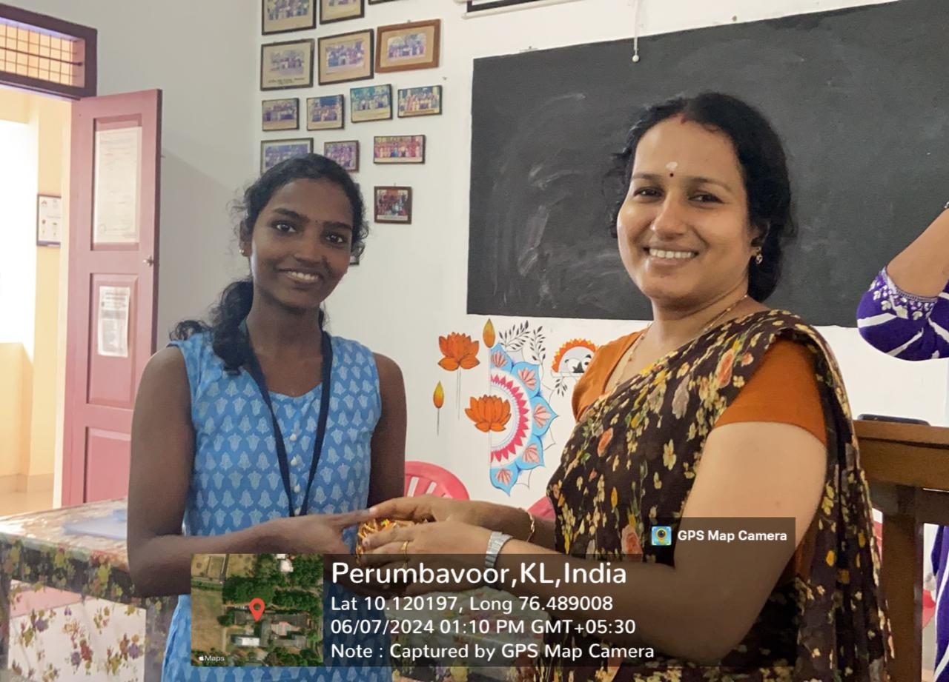

Sneha Mohan UP and Neehara M.S of third BSc Zoology cleared the prelims of a quiz contest conducted by the Mahatma Gandhi Foundation, Kerala, in connection with Gandhi Jayanti. The event was held at Nirmala College, Muvattupuzha, on October 4, 2024, showcasing their excellent general awareness and teamwork.
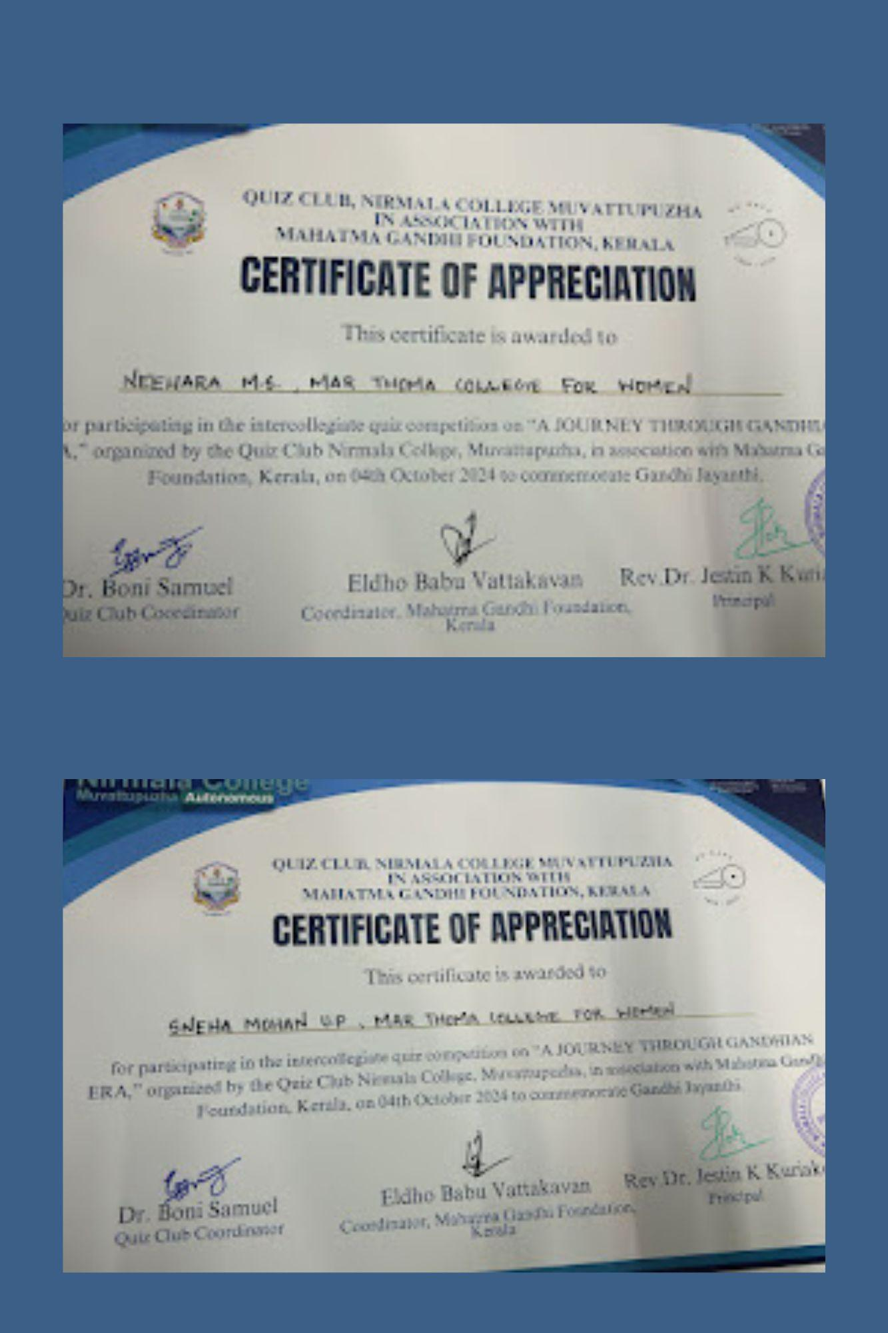

Sneha Mohan UP of third BSc Zoology secured the first prize for her innovative concept titled "Online App Idea for the Elderly", in the Solution Sprint Hackathon organized by the Institution's Innovation Council (IIC), Innovation and Entrepreneurship Development Centre (IEDC), and the ED Club on August 22, 2025. Lakshmi P.B and Khadeeja P.A. of 2nd B.Sc. Zoology won the third prize for their creative and eco-conscious project, the "Solar Plastic Terminator Idea". The event recognized their originality, problem-solving skills, and collaborative spirit.
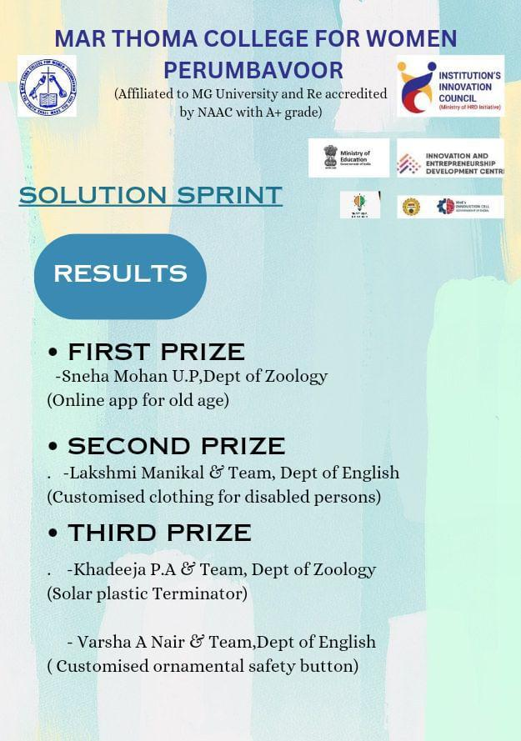

Sandhra Sunil, of 1st B.Sc. Zoology, bagged the first prize in the Digital Poster Making Contest conducted in connection with the Anti-Ragging Awareness Mahotsav on August 21, 2025. Her design was praised for its clarity, visual appeal, and strong messaging, earning her top honors in the competition.
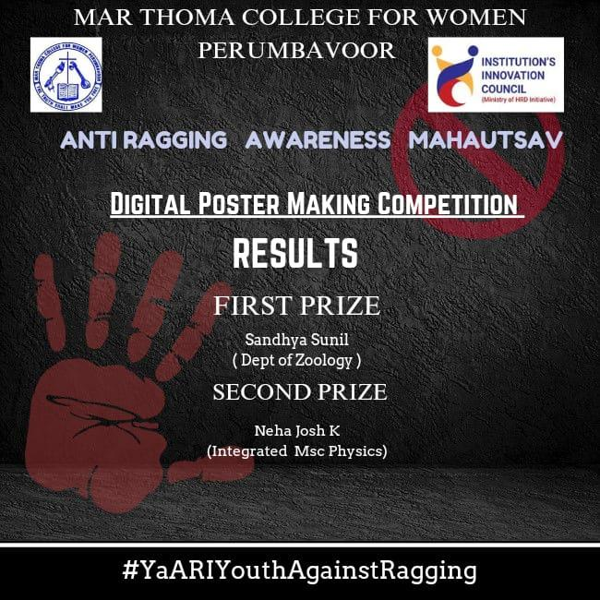
Lakshmi P. B and Annmariya Shaji of second BSc Zoology secured second prize in the All Kerala Intercollegiate Presentation Contest on “Digital Innovation in Wildlife Conservation,” hosted by Morning Star Home Science College, Anamaly, on October 7, 2024. Their presentation was appreciated for its originality and relevance.
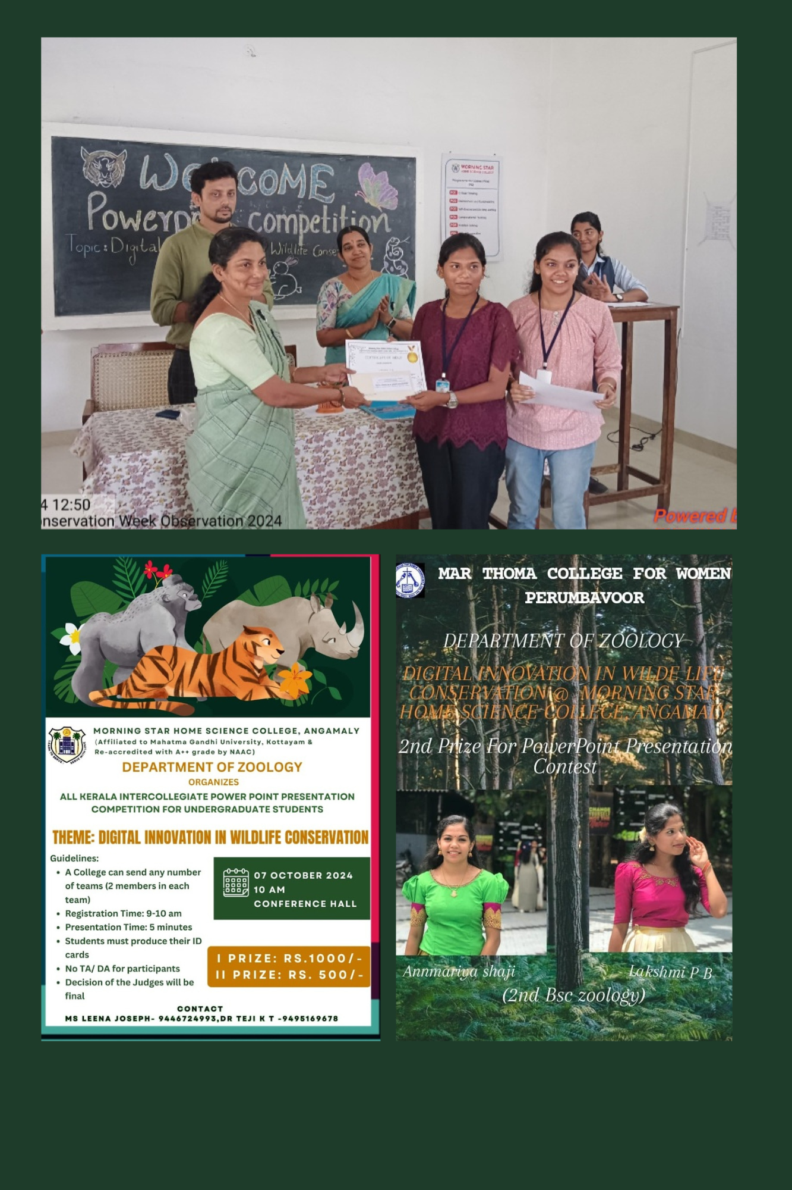
Sneha Mohan UP of third BSc Zoology achieved successful placement at Accenta Education as a Communicative English Trainer, highlighting her proficiency in communication skills and her potential as an educator.
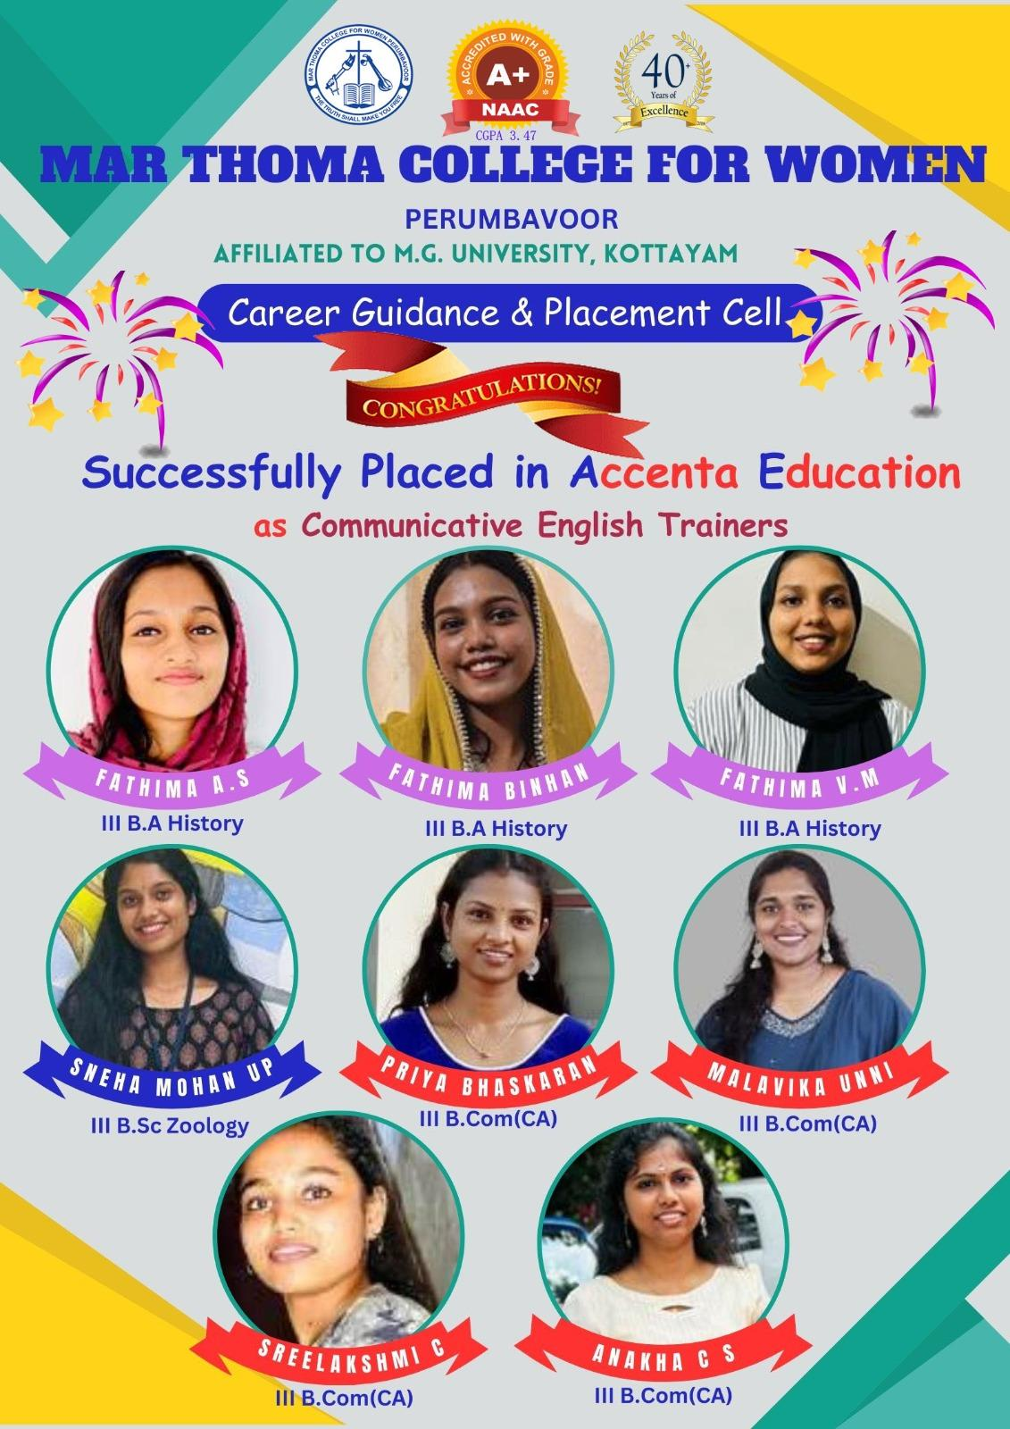
Lakshmi P. B and Devika Rajesh of second BSc Zoology won the first prize in the SciNova Puzzle Contest organized by the Science Club in connection with National Science Day observance. Their analytical thinking and problem-solving abilities were instrumental in their victory.
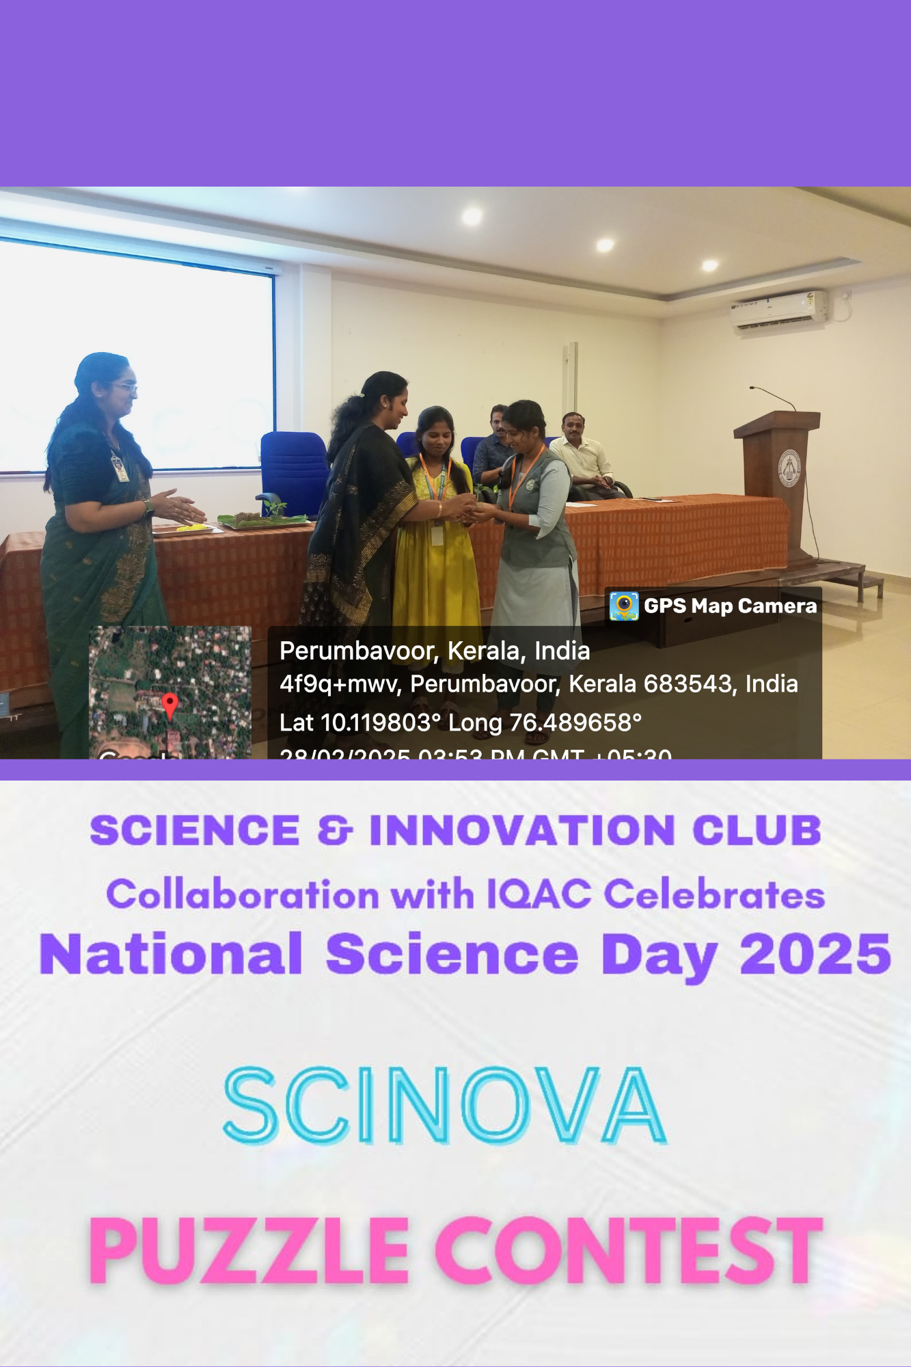

The Zoology Department won first prize in the Group Song (Folk) event at the College Youth Festival, Kalayattam 2025. The performance was lauded for its energy, coordination, and cultural richness.
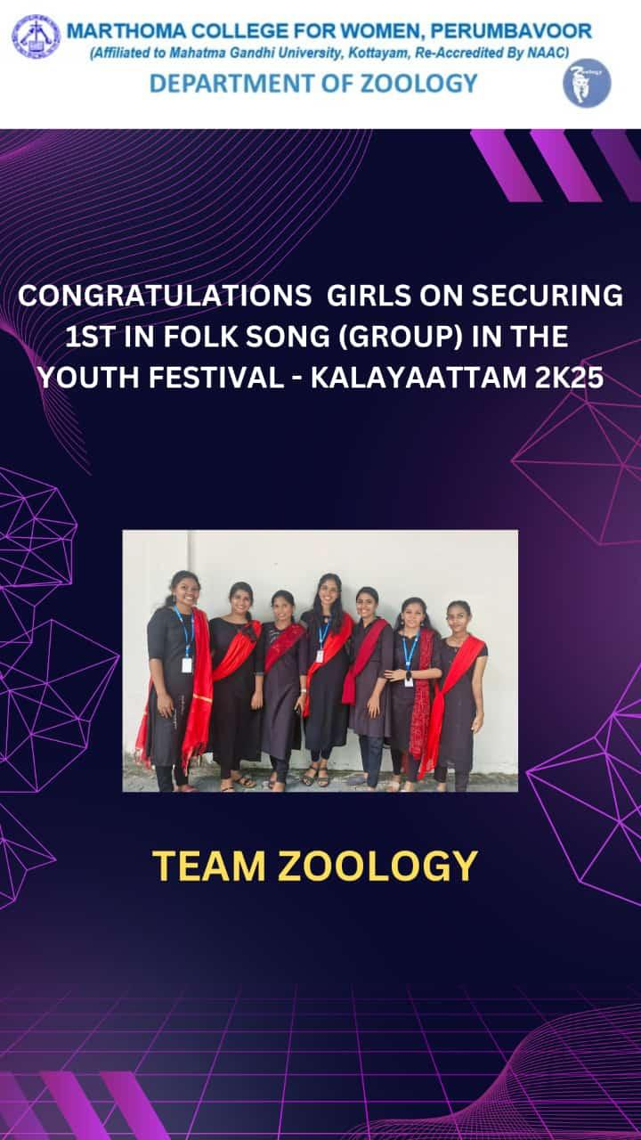
The Zoology-Chemistry Department once again bagged the prestigious “Best Pookalam” ever-rolling trophy, maintaining their winning streak and upholding the tradition of excellence in Onam floral design.
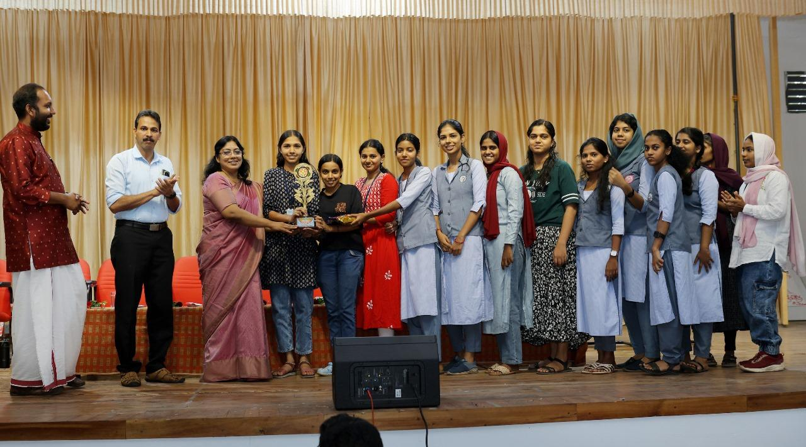

Sneha Mohan UP of third BSc Zoology secured third prize in the Interdepartmental Presentation Contest organized jointly by the Language and Literary Club, Brains Trust, and the Zoology Department, in connection with World Wetlands Day. Her presentation reflected depth in research and confident delivery.
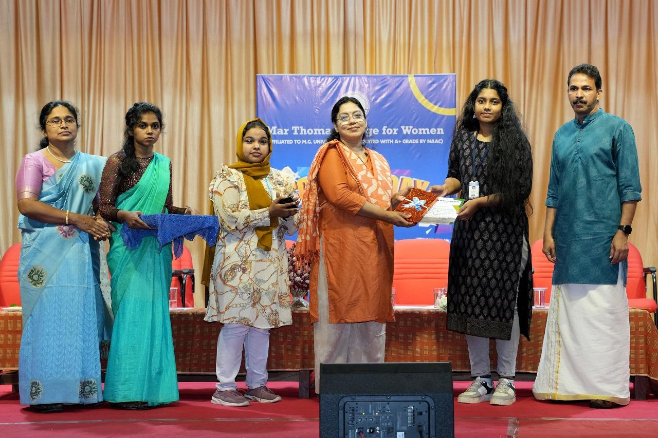

Sneha Mohan UP, Asna Beegum, and Neehara M.S of third BSc Zoology achieved a rare feat by securing the first, second, and third prizes respectively in the “Find the Book” contest organized by the College Library. Their familiarity with library resources and quick thinking led them to this clean sweep.
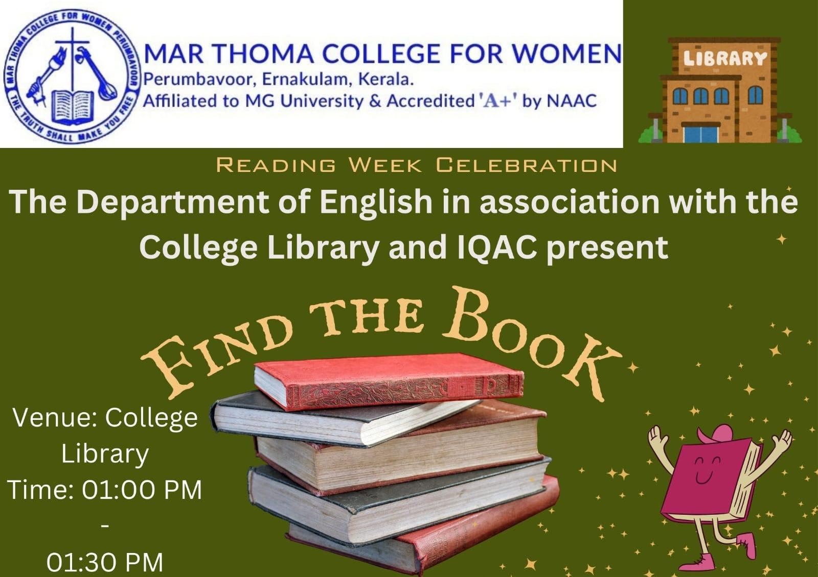

The NSS Appreciation Award was received by the NSS volunteers and NSS Programme Officers of the college in recognition of their dedicated service and active involvement in various community initiatives. Among the awardees was Khadeeja P.A. from second BSc Zoology, whose contributions exemplified the spirit of volunteerism and social responsibility upheld by the department.
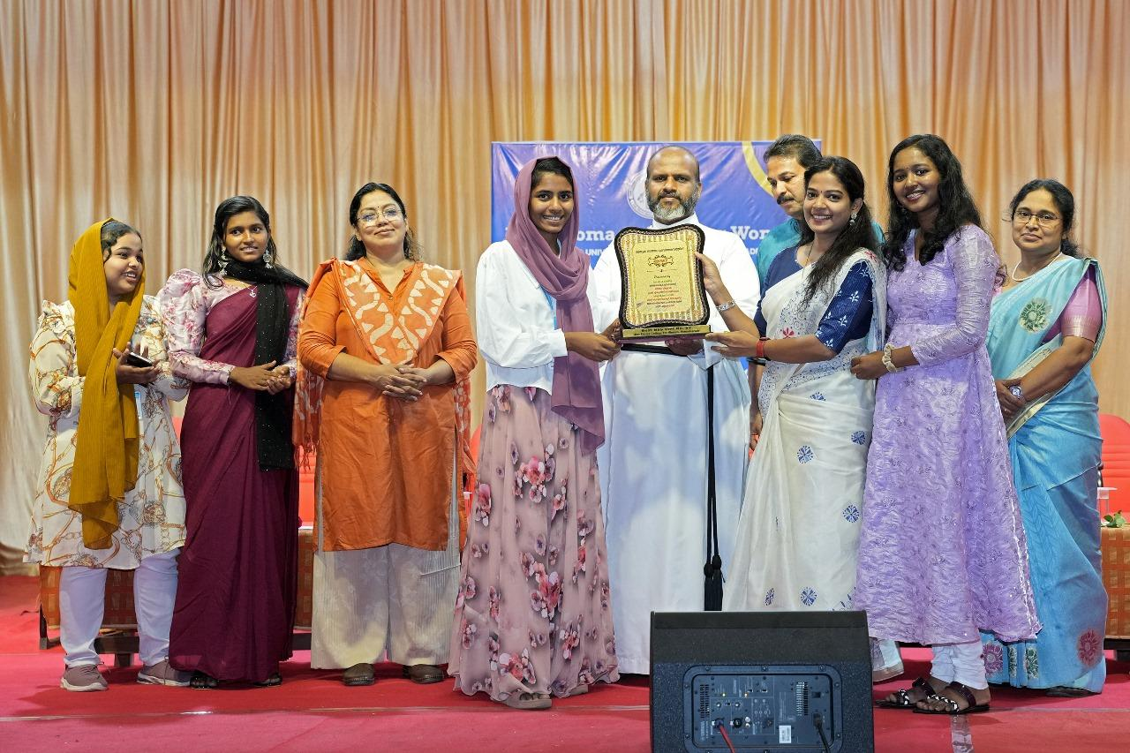

Nazrin Usman (2024 pass out) and Shabna Kareem (2022 pass out), under the guidance of their supervising teacher, achieved the remarkable feat of publishing their undergraduate project work in reputed UGC-CARE journals during the current academic session. Shabna Kareem, along with co-author Reemy Sara Mathai, published their research in the Archives of Medicine and Health Sciences (UGC-CARE/Web of Science), while Nazrin Usman, also in collaboration with Reemy Sara Mathai, published in the Indian Journal of Preventive and Social Medicine (UGC-CARE). In recognition of this outstanding academic accomplishment, the Mar Thoma Research Foundation honored them during the College Day celebrations.
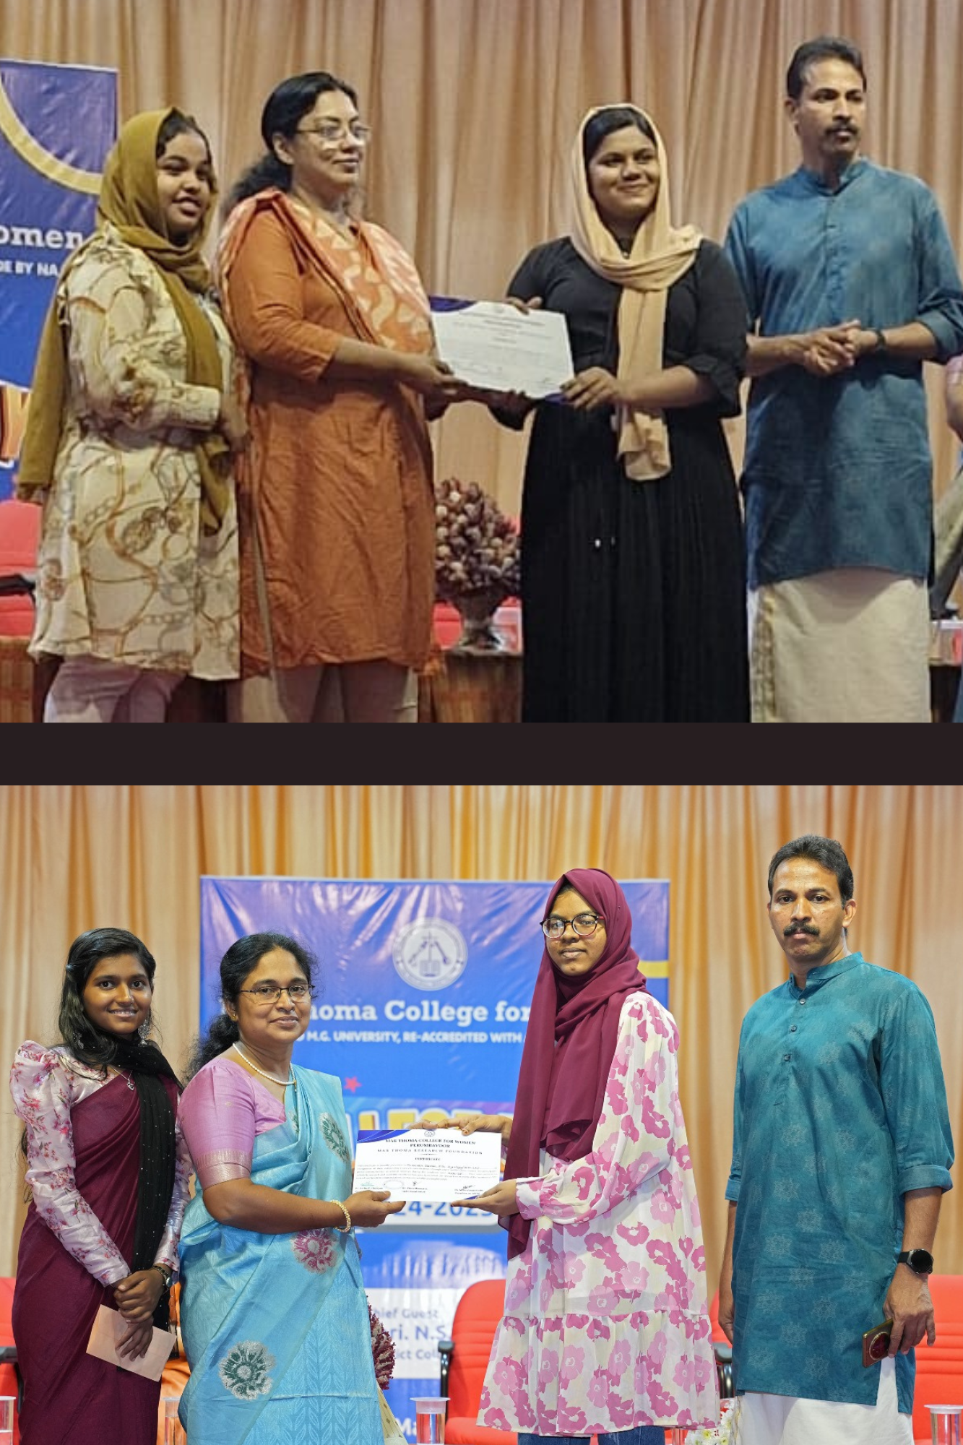
Faculty Achievements
Ms. Smrithy P. S., faculty member of the Department of Zoology, published her research paper titled "Comparison of Natural Agar-Based Bioplastic with Other Starch-Based Bioplastics: A Green Attempt for a Sustainable Environment" in the Indian Journal of Natural Sciences (Web of Science Indexed), Volume 88, February 2025. This publication underscores her dedication to sustainable innovations and contributes meaningfully to the field of eco-friendly materials.
Reemy Sara Mathai, faculty member of the Department of Zoology, successfully guided two undergraduate student research projects that were published in reputed UGC-CARE journals during the academic year. The first paper, titled "An Indian Case Study on Mitochondrial Neurogastrointestinal Encephalomyopathy," was published in the Archives of Medicine and Health Sciences (UGC-CARE/Web of Science), Volume 12(2), May–August 2024. The second, "Prevalence and Impact of Work-Related Musculoskeletal Disorders: A Case Study from Perumbavoor Municipality, Kerala, India," appeared in the Indian Journal of Preventive and Social Medicine (UGC-CARE), Volume 55(3), July–September 2024. These publications reflect the department’s strong focus on promoting undergraduate research and academic excellence under expert mentorship.
Ms. Reemy Sara Mathai, Assistant Professor in the Department of Zoology, received the Best Paper Award for her presentation titled "Sodium Chloride: From Essential Mineral to DNA Damager" at the International Conference organized by Chinmaya Vishwa Vidyapeeth, held from August 10–12, 2024.
Ms. Reemy Sara Mathai presented a research paper at the national conference Gyan Samavesh held at Nirmala College in December 2024. Her participation contributed to the academic discourse at the national level and showcased the department’s ongoing engagement with scholarly events.
In addition to her conference presentation, Ms. Reemy Sara Mathai served as a peer reviewer for three research papers in reputed international journals during the current academic session. Her role as a reviewer highlights her expertise and active involvement in maintaining academic quality in global research publications.
Ms. Smrithy P. S. presented three research papers at different national conferences during the present academic year. Her active participation in multiple academic platforms reflects her dedication to knowledge dissemination and continued contribution to her field of study.
Ms. Reemy Sara Mathai and Ms. Smrithy P.S. attended the 6day FDP on Emerging trends of Research in Molecular medicine from 10-15 March, 2025 organised by Department of Zoology, GVG Visalakshi College for Women, Udumalpet under DBT Star Programme.

