MAR THOMA COLLEGE FOR WOMEN, PERUMBAVOOR
ACTIVITY REPORT OF WOMEN CELL 2024- 2025
- The Inaugural Ceremony of Women Cell was held on 22 August 2024 in the College Auditorium. The Chief Guest Ms. Anjana G. Das, an entrepreneur and alumnae, B. Com. Finance and Taxation (2013-’16) inaugurated Women Cell activities and Dr. Sheeba K.M., Professor and Head, Department of History, Sree Sankaracharya University of Sanskrit, Kalady, delivered the keynote address on Imagining Democratic Relationships: Feminisms in Everyday Life.
Ms. Chaithanya Elsa Achankunju, Faculty in Charge, Women Cell, welcomed the gathering and presented the role of Women Cell as envisaged by UGC and KSWDC. Dr. Vineed Kumar K., IQAC Coordinator conveyed felicitation and Ms. Sanjana S., III B.A. English proposed vote of thanks.
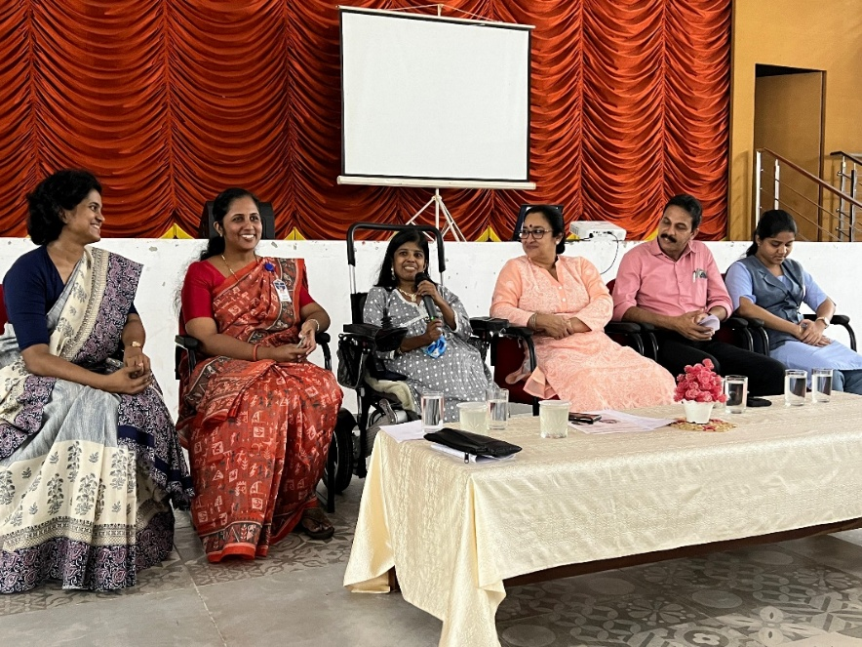
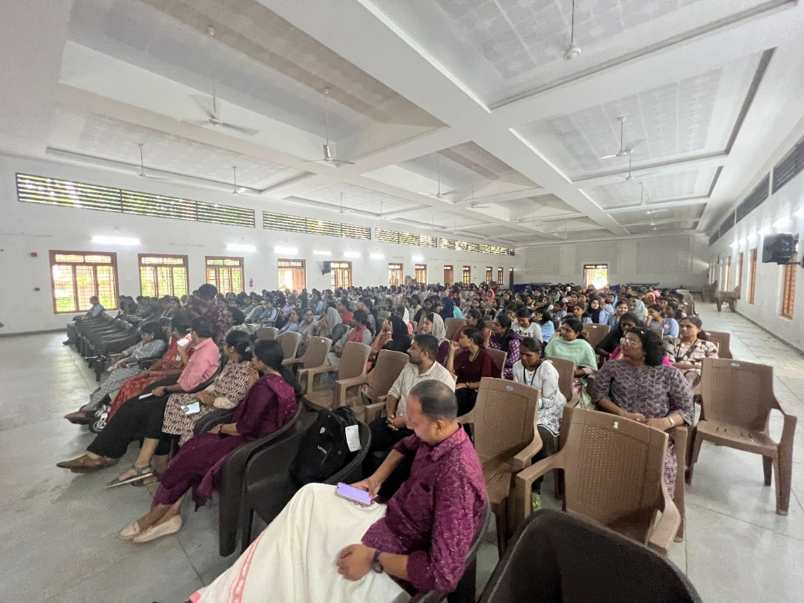

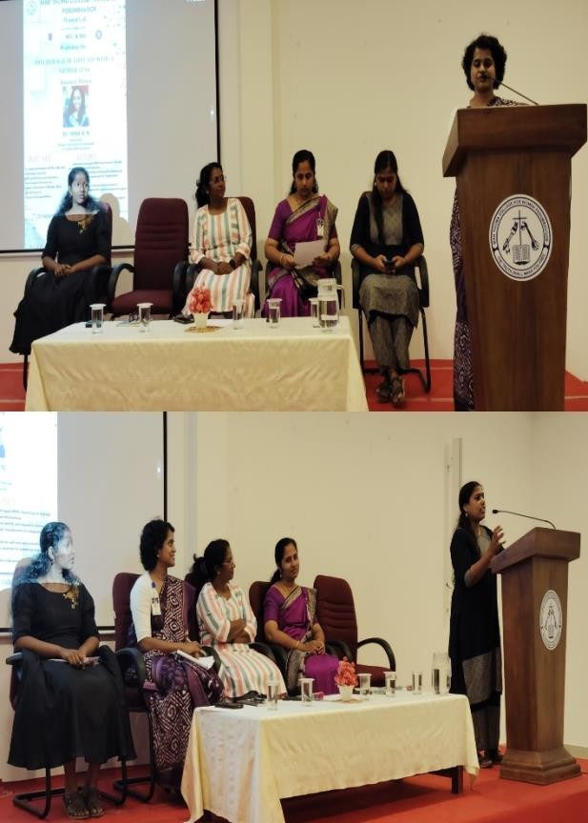
- One Day Workshop on ‘Psychological First Aid with a Gender Lens’ was organized in association with Dhisha Kerala and NSS & NCC units of the college on 28 September 2024. Dr. Hena N.N., Psychologist, Diversity and Inclusion Professional led the session. Ms. Sherin T. Abraham, Principal in Charge, inaugurated the workshop.

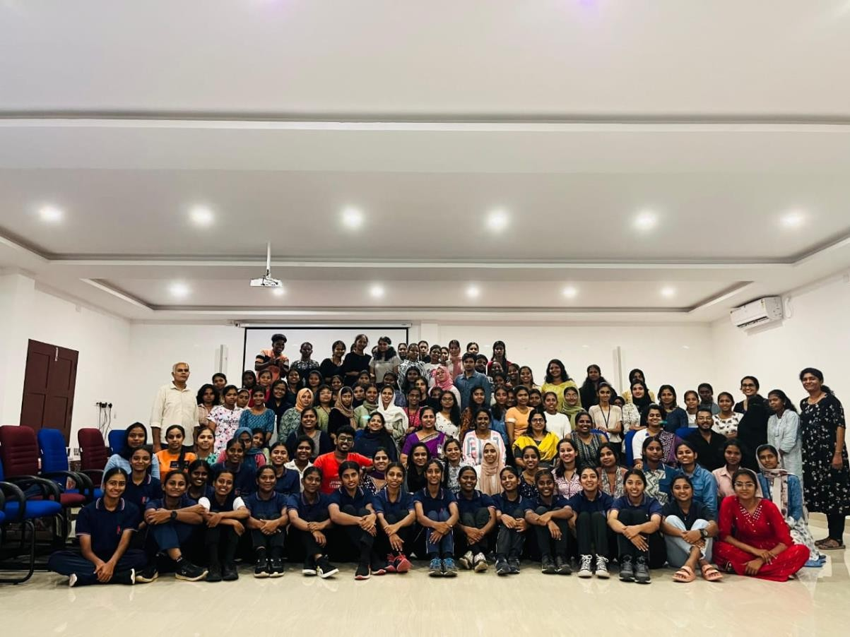
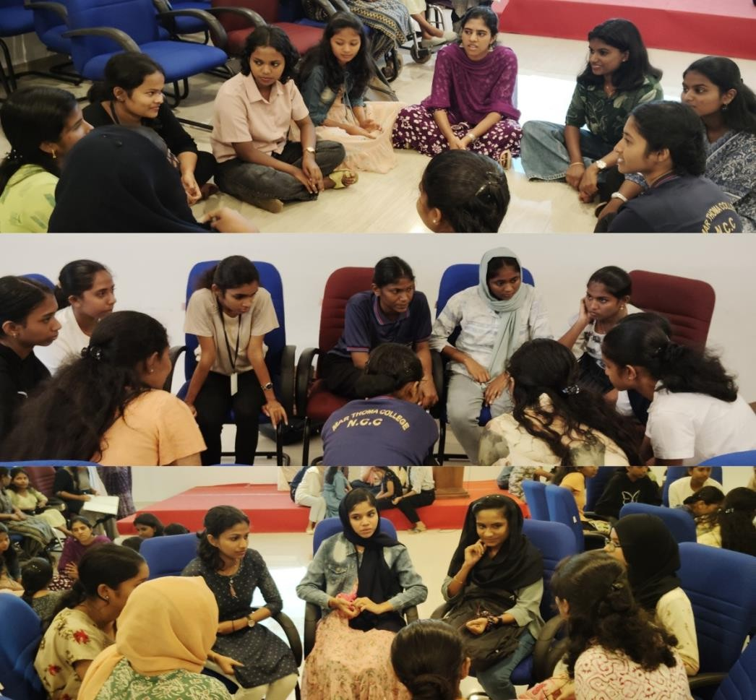
- As part of Observance of Breast Cancer month an Inter-collegiate Power Point Presentation Competition on Breast Cancer was organized on 29 October 2024. Ms. Sherin T. Abraham, Principal in Charge inaugurated the competition. Thirteen teams from seven colleges participated in the event. Cash prize and certificates were given to the participants.

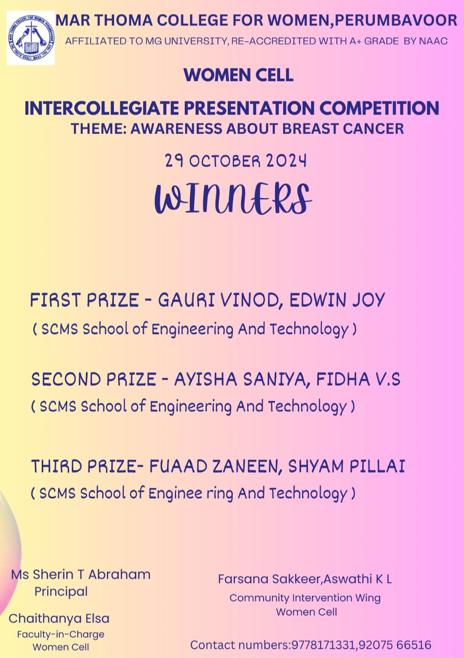
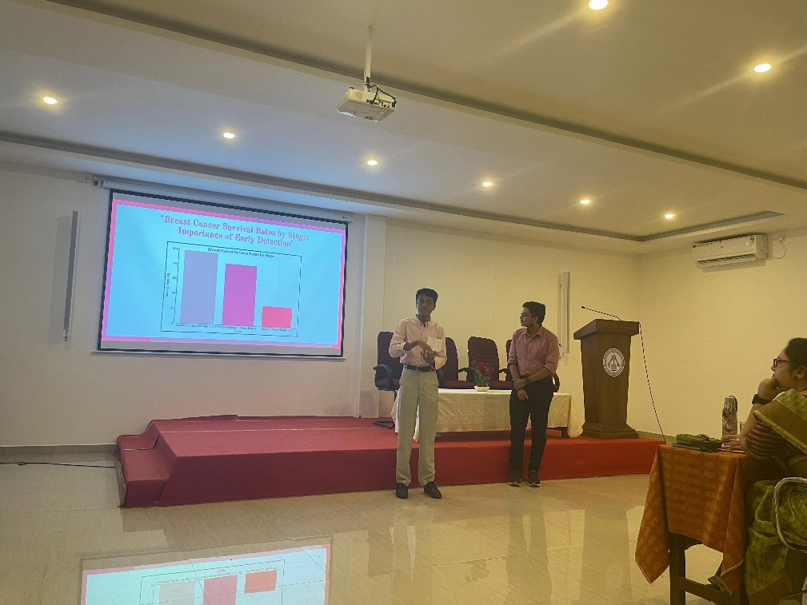
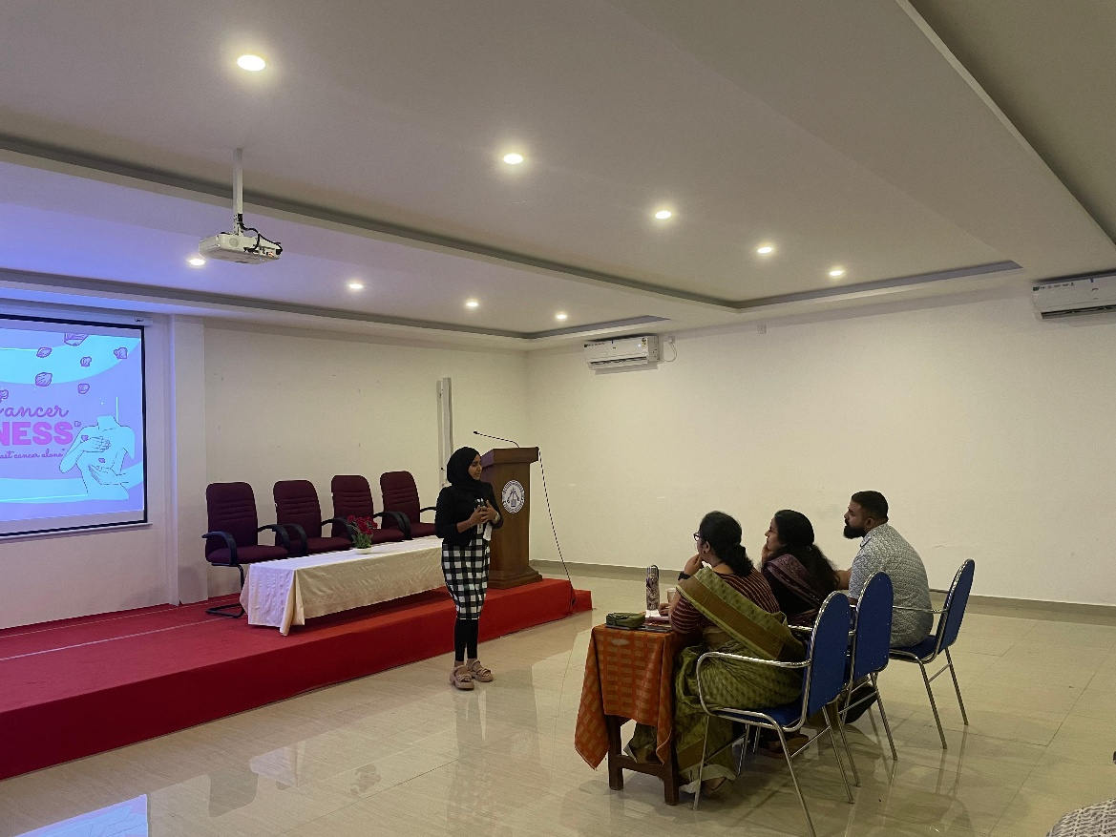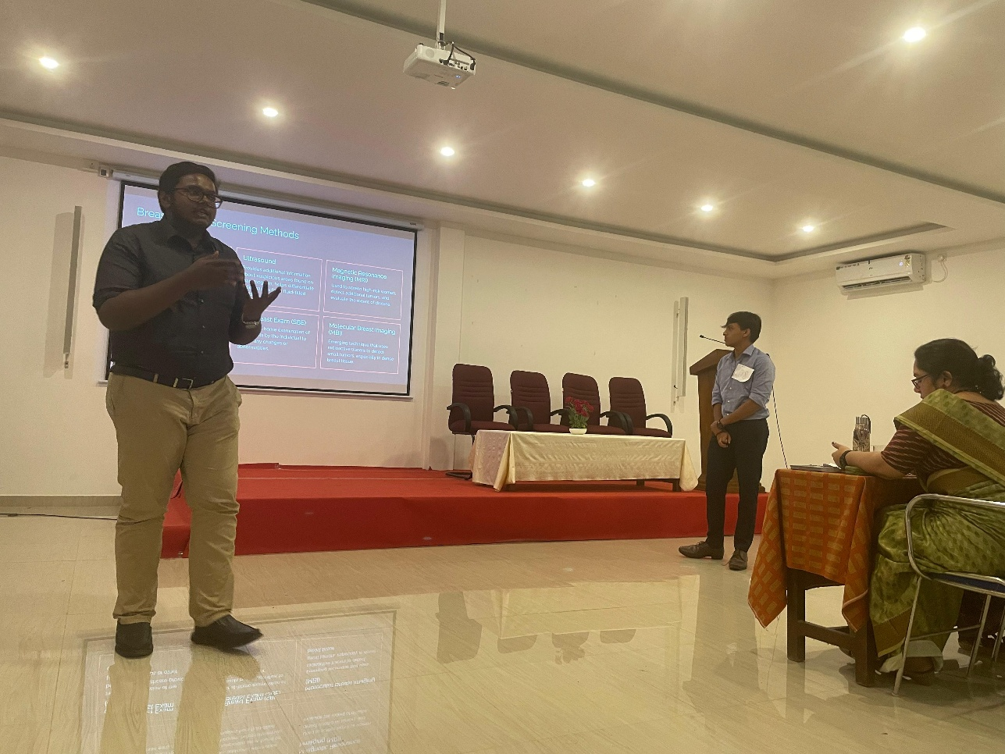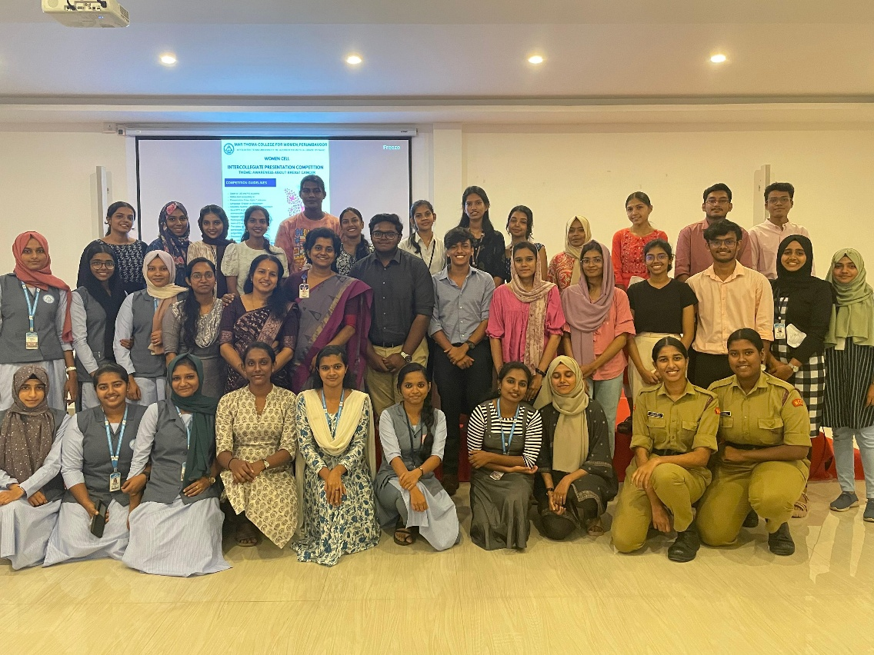

- Inspirational Women Presentation Series- I on Mathangi Hasra, Freedom fighter was done by Ms. Minnu George, I B.A. English, on 24 October 2024 at 1 p.m. in the P.G. Seminar Hall. Ms. Minnu presented the hardships and the efforts Ms. Hasra undertook in her life as well as in participating in the freedom struggle.
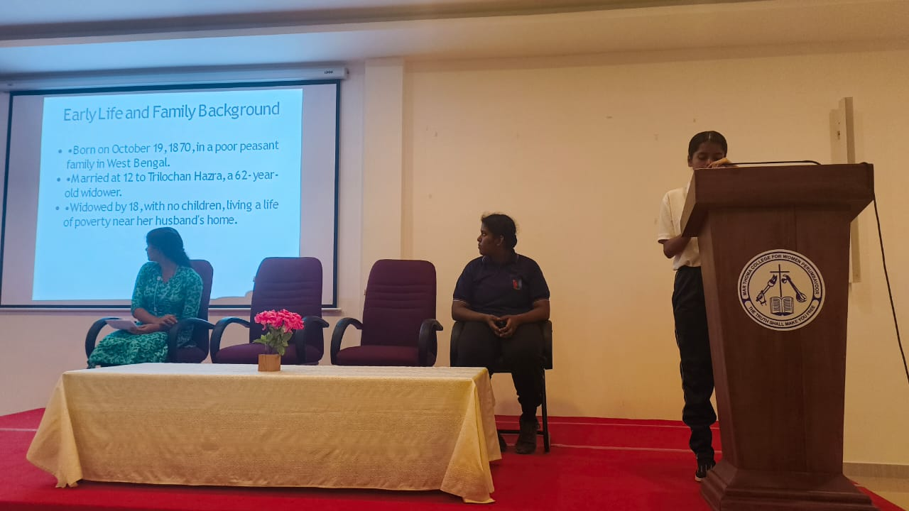
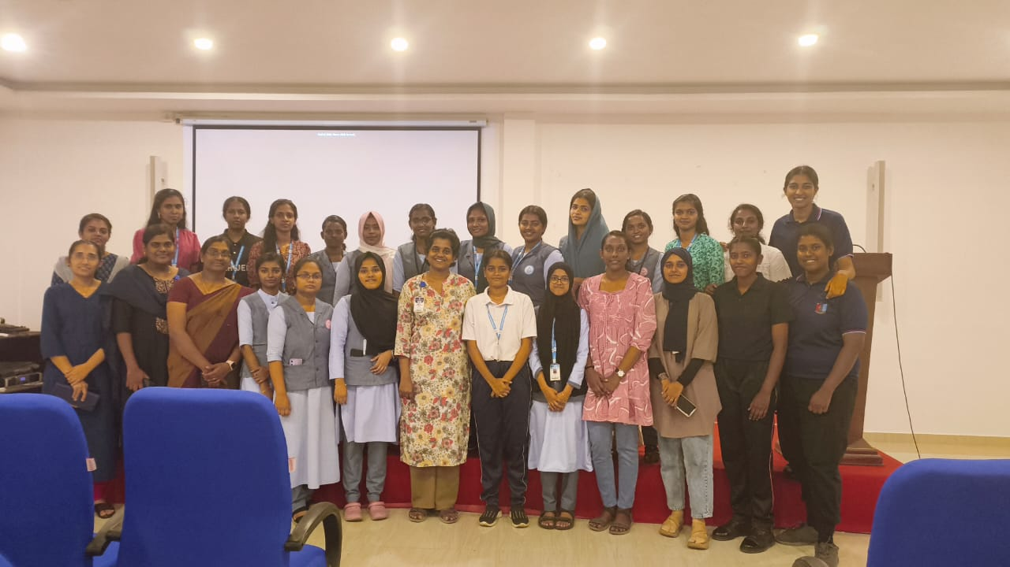
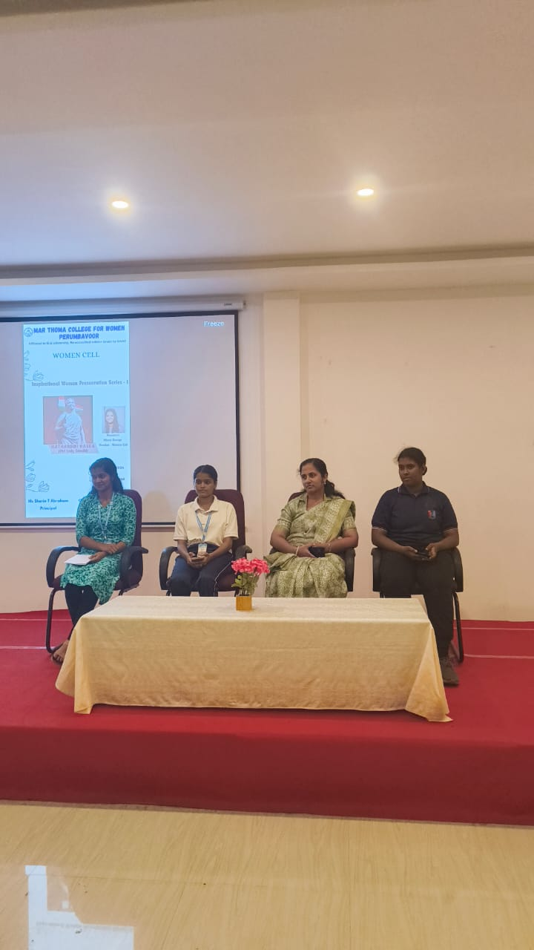

- A Presentation on Breast Cancer was organized on 07 November 2024 at 1 p.m. in the P.G. Seminar Hall. Krishnapriya V.R., Fathima Thanha V.N., III B. Sc. Chemistry led the awareness session. The presenters explained the different types of breast cancer self-examination that can be done, various medical solutions, etc. related to breast cancer.

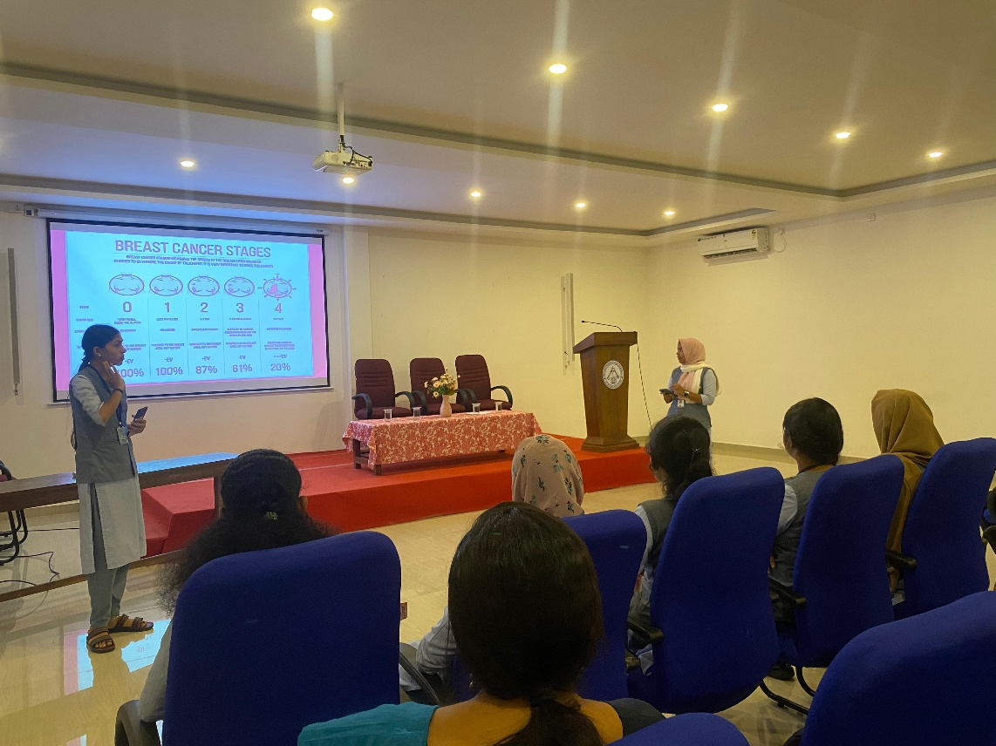
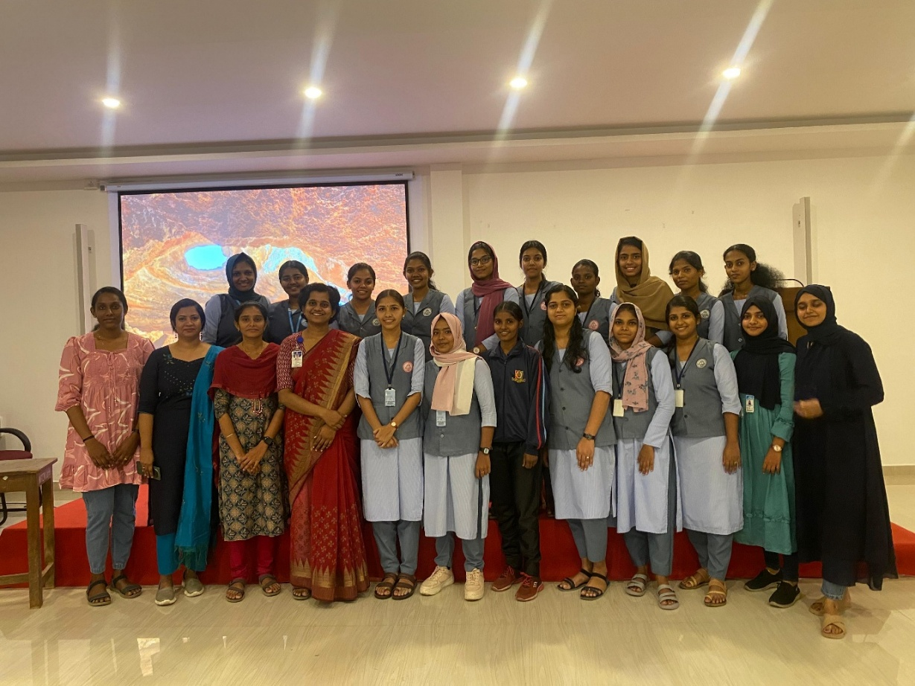
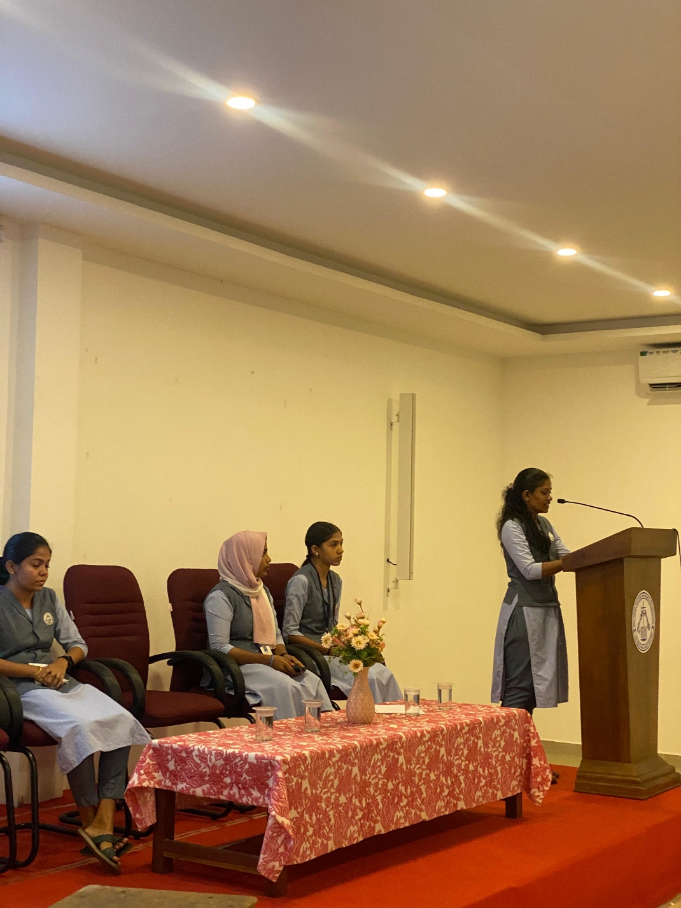

- A Drawing Competition on Rights of Children in connection to International Human Rights Day was organized on 12 March 2024. Certificates were distributed to the prize winners.
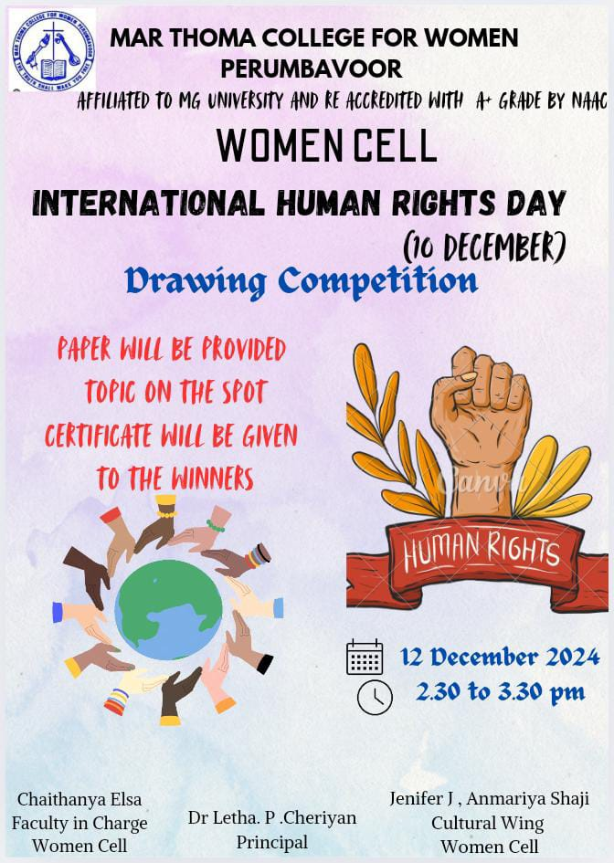
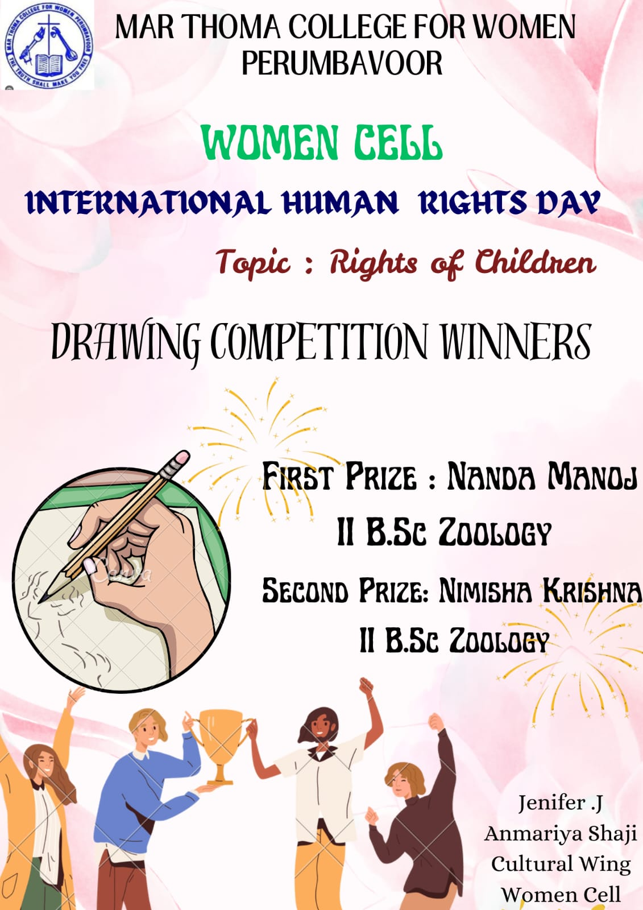

- Community Intervention Programme on Menopause was organized in association with Perumbavoor Municipality and Aster Medcity Ernakulam on 22 February 2025.
Ms. Annie Martin, Vice Chairperson, Perumbavoor Municipality inaugurated the programme. The first session ‘Talk on Menopause’ was led by Dr. Preethi Nair, Specialist- Gynaecology and Obstetrics, Aster Medcity, Ernakulam. The second session on ‘Navigating Menopause: Emotional Wellbeing and Selfcare Strategies’ was led by Dr. Hena N.N., Psychologist, Co-Founder-Sex Education Kerala.
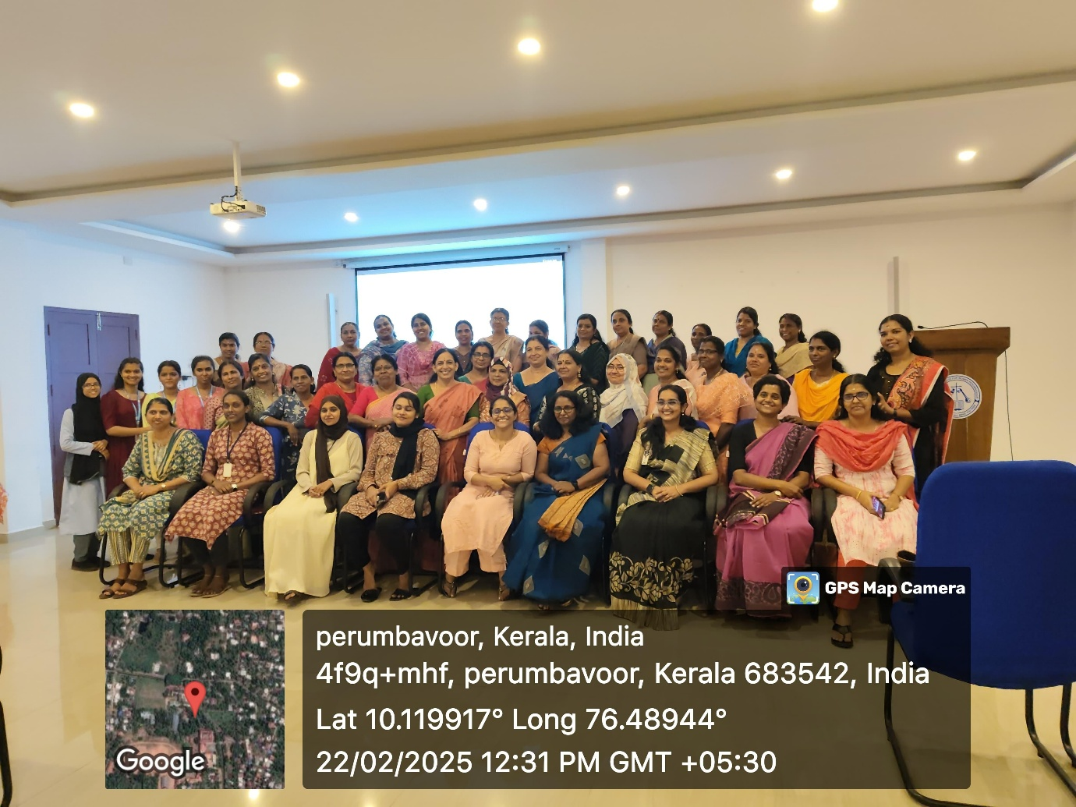
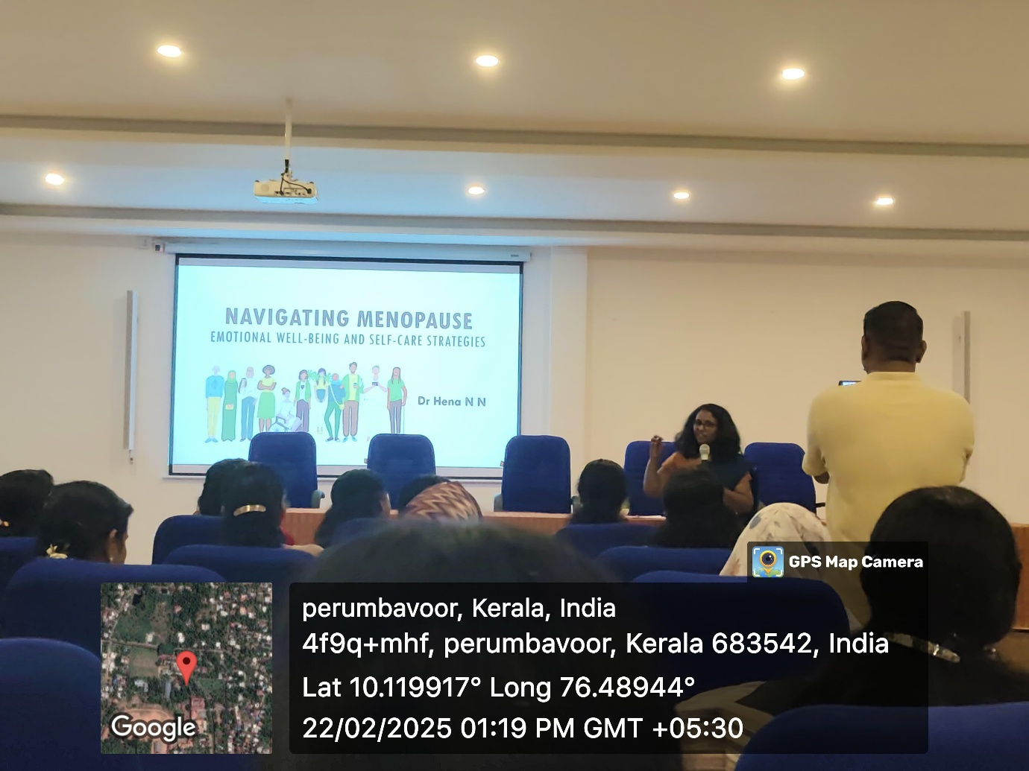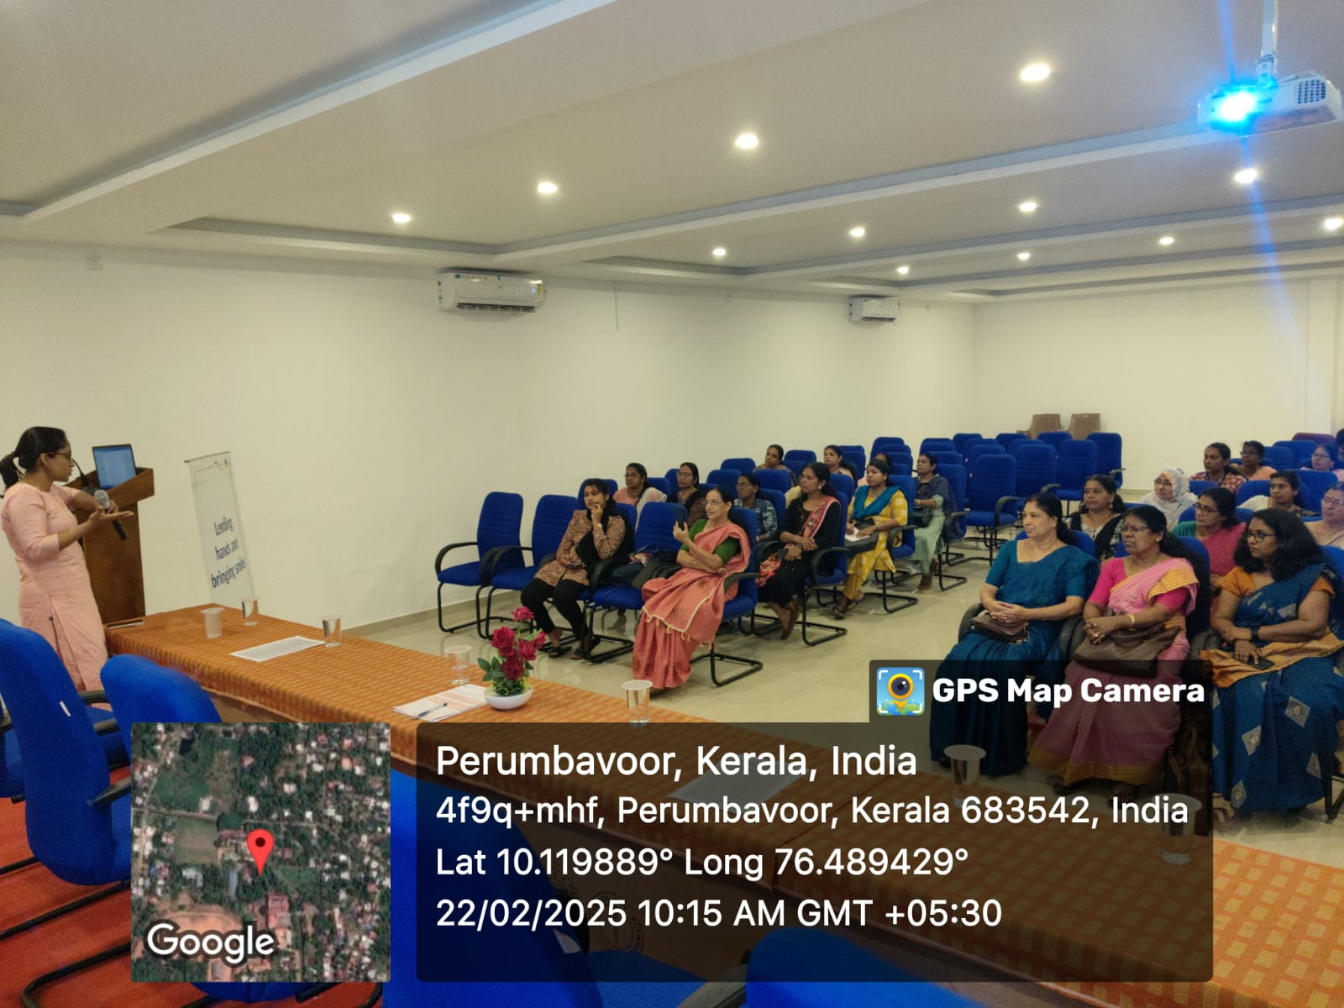

- A Flashmob was organized on 06 March 2025 in relation to International Women’s Day (March 8).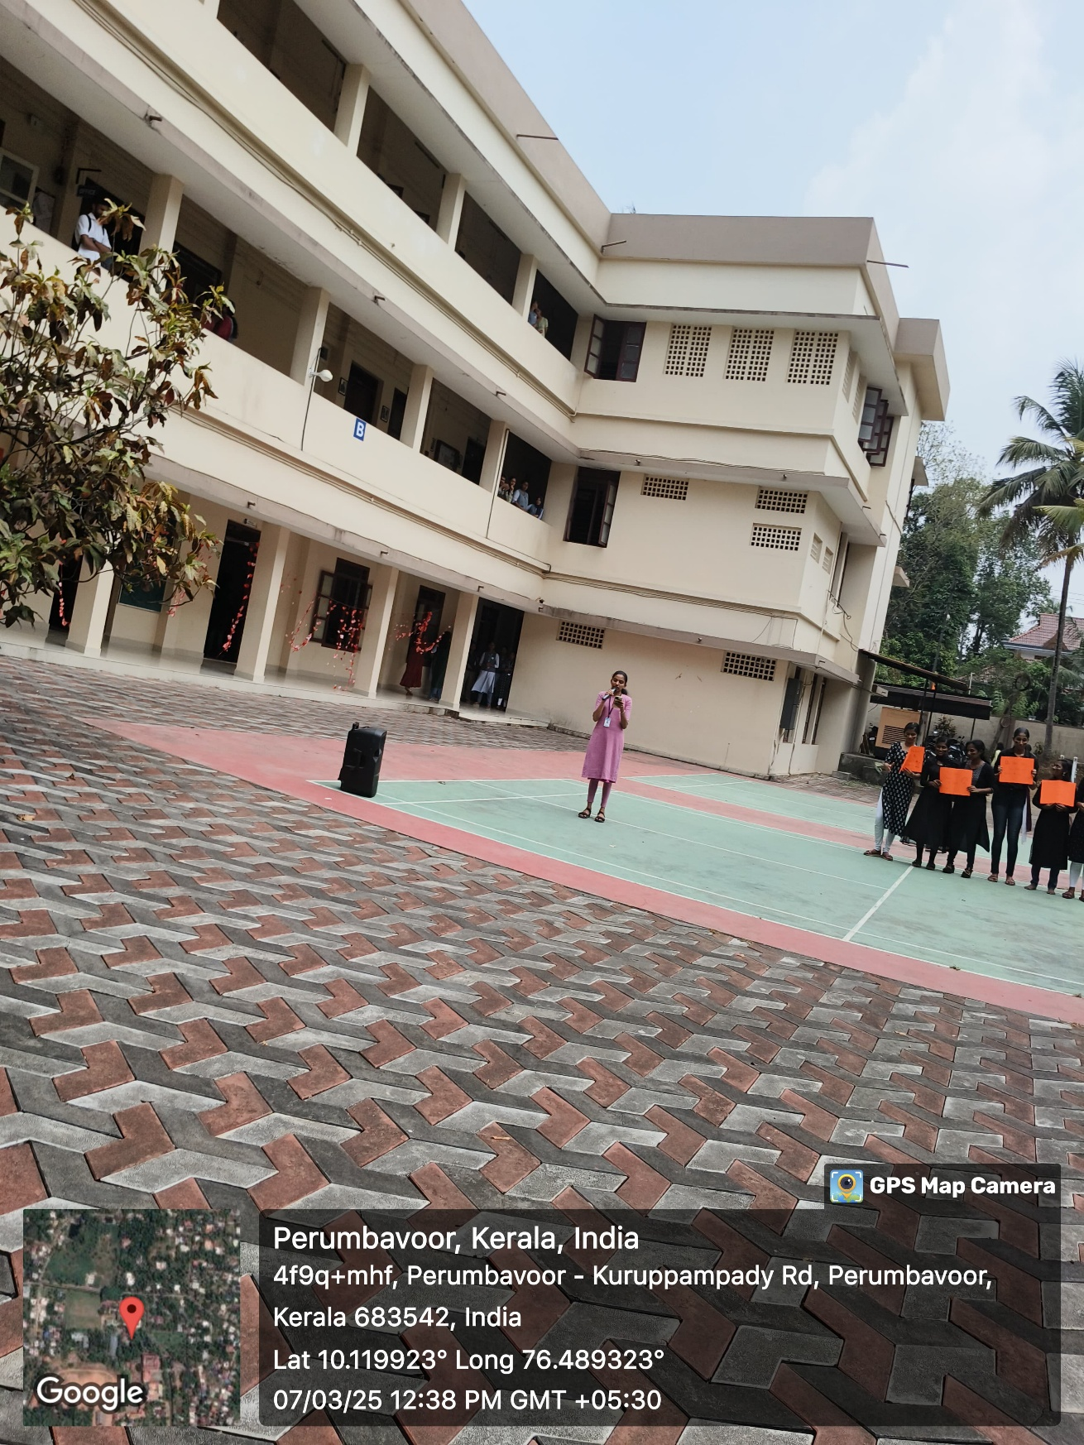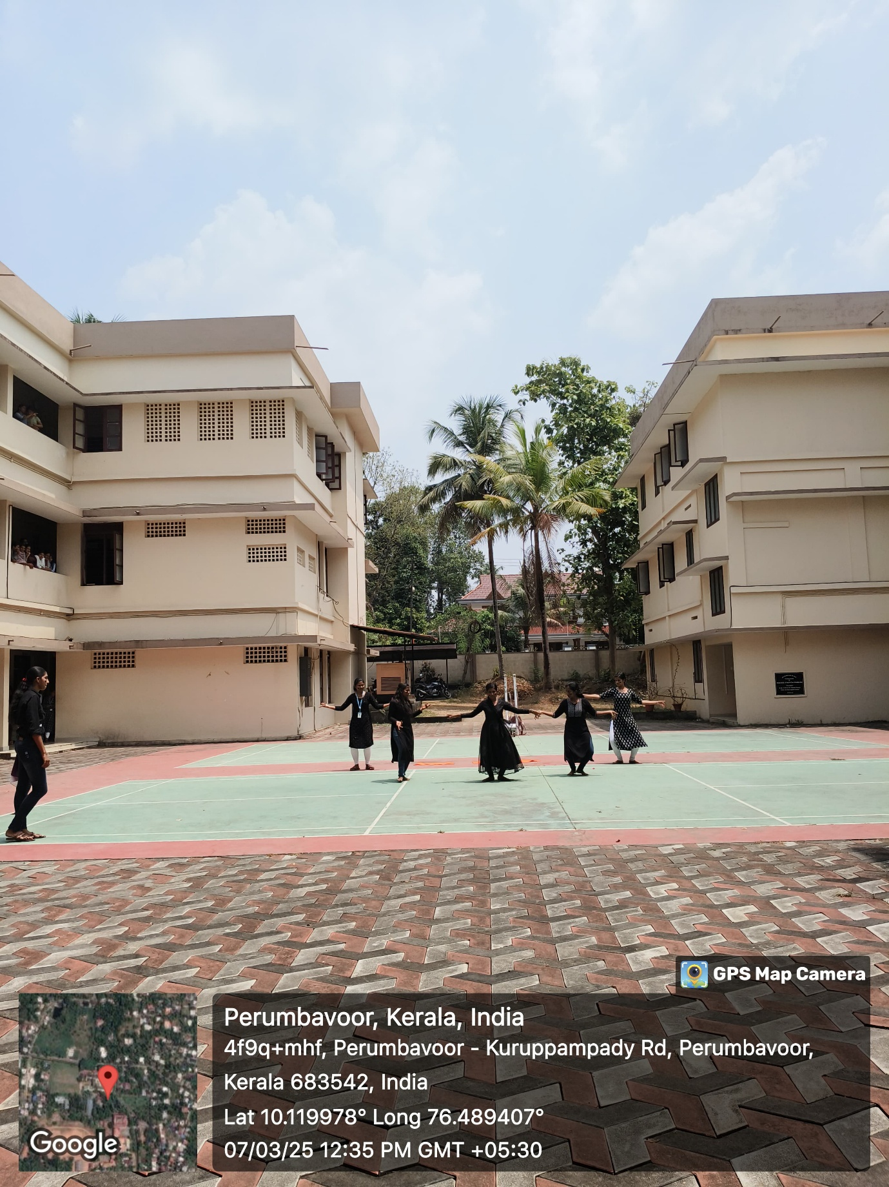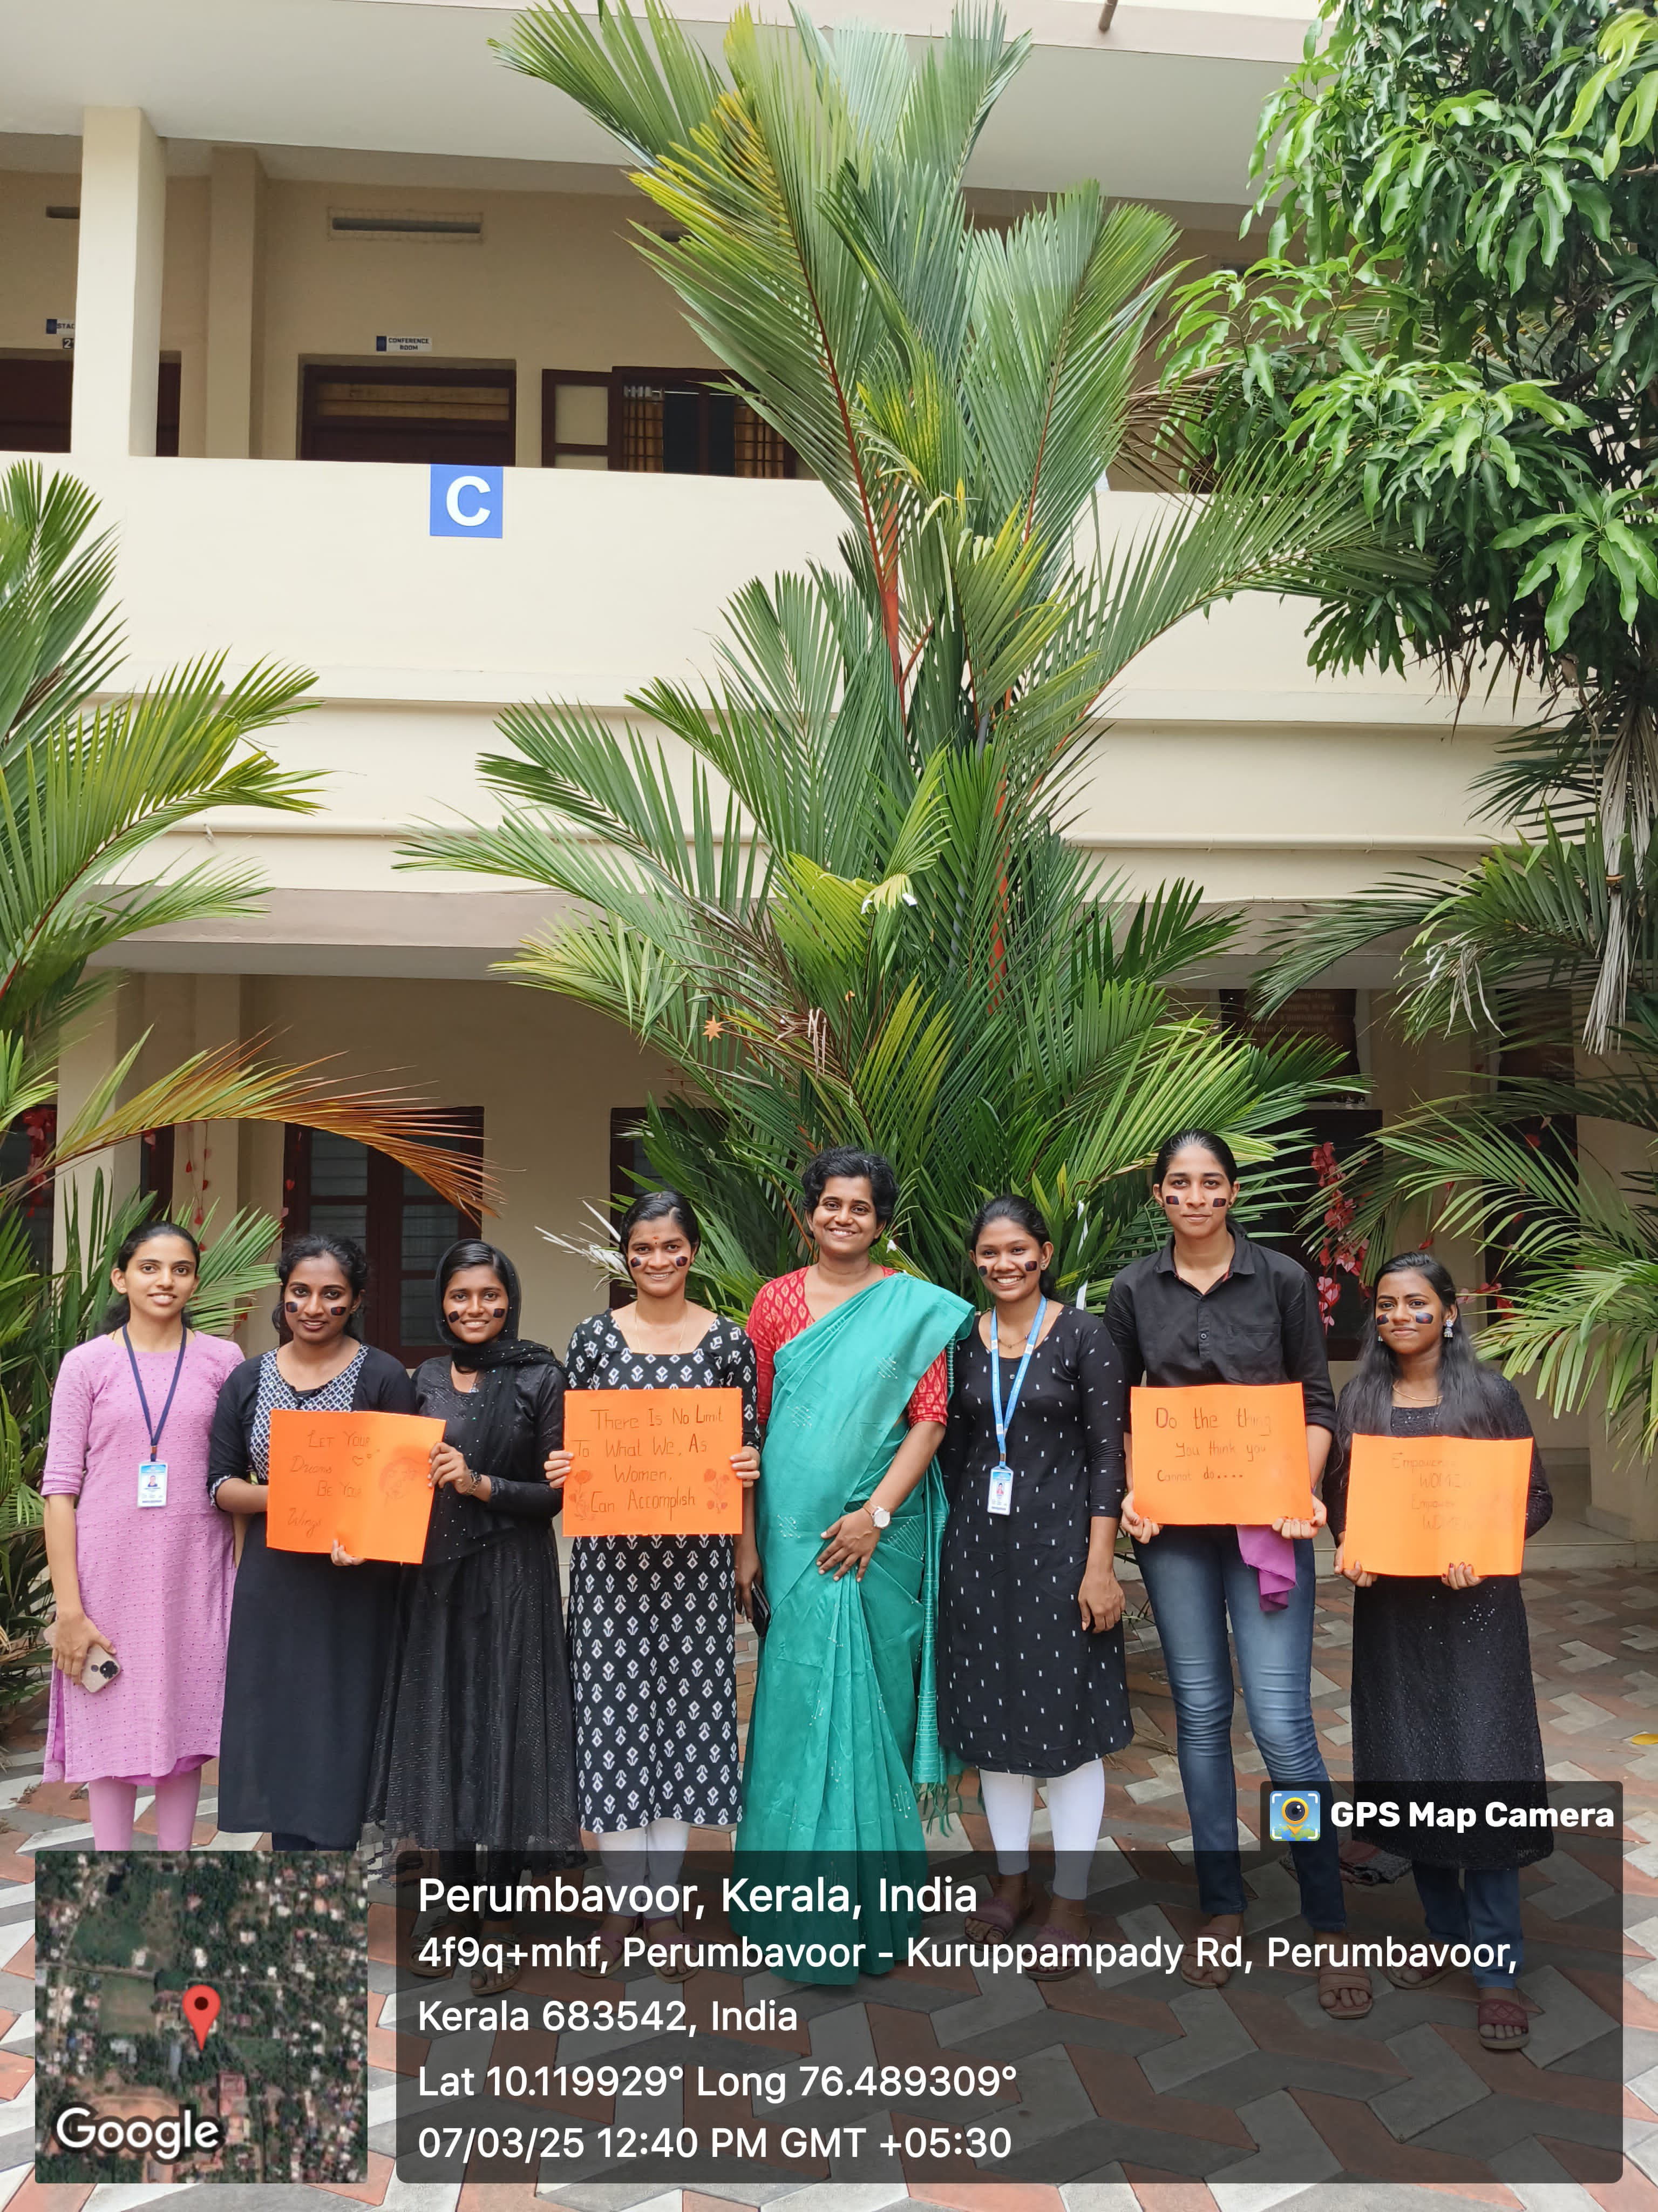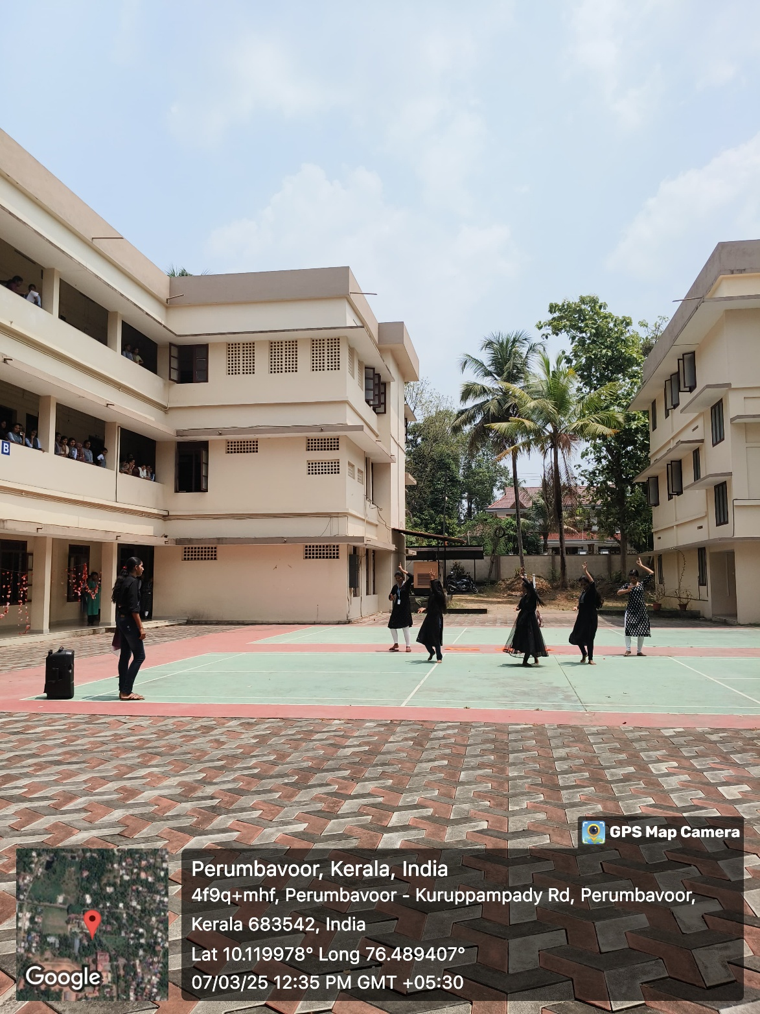

- An Orientation class on Gender and Sexuality was held on 13 March 2025 at 2 p.m. Dr. Hena N.N., Psychologist, Co-Founder-Sex Education Kerala led the session.

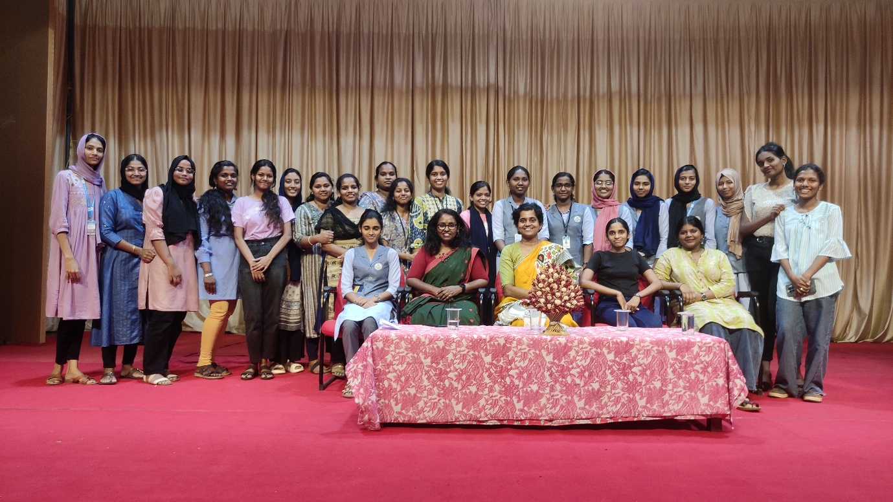
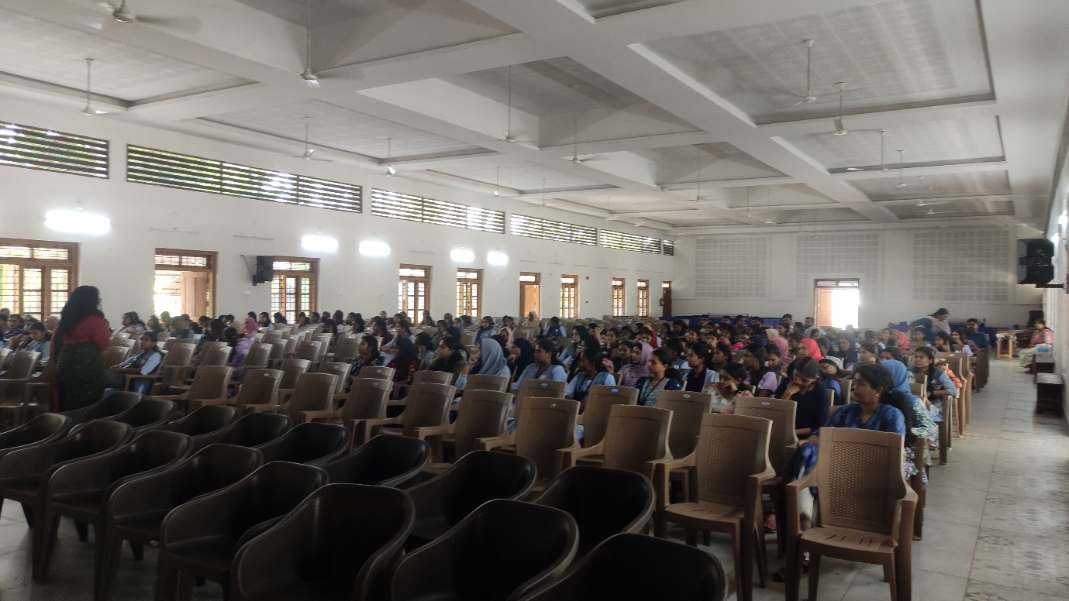
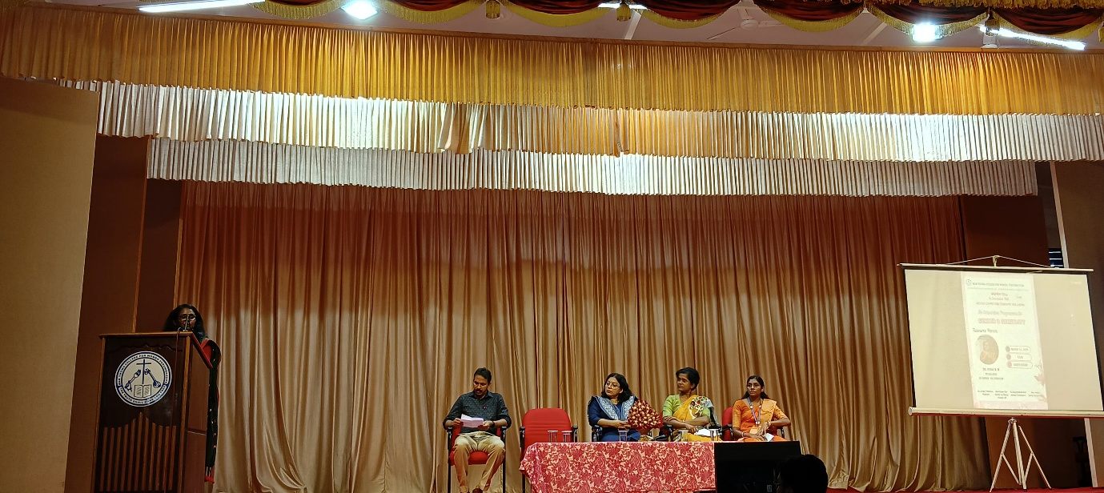

- Ms. Chaithanya Elsa Achankunju attended the workshop on Gender Audit in Educational Institutions conducted by the Dakshayani Velayudhan Centre for Women’s Studies, Sree Sankaracharya University of Sanskrit, Kalady, on 29 March 2025.

Women Cell was able to function effectively fulfilling its responsibilities towards the stakeholders of the College and the community. Nine programmes were organized by the Cell during the academic year in addition to certain critical interventions in the campus.
Ms. Chaithanya Elsa Achankunju, Assistant Professor, Department of English, served as the Faculty in Charge. Ms. Fathima Sakeer, Ms. Aswathy K.L. (II M.Sc. Maths). Ms. Jennifer J., Ms. Annmariya Shaji (II B.Sc. Zoology) served as the student leaders. Women Cell received the wholehearted support of the Institution in organizing various programmes.

