Departmental Activities: 2024–2025

Lecture on “The Representation of Gender in Media”
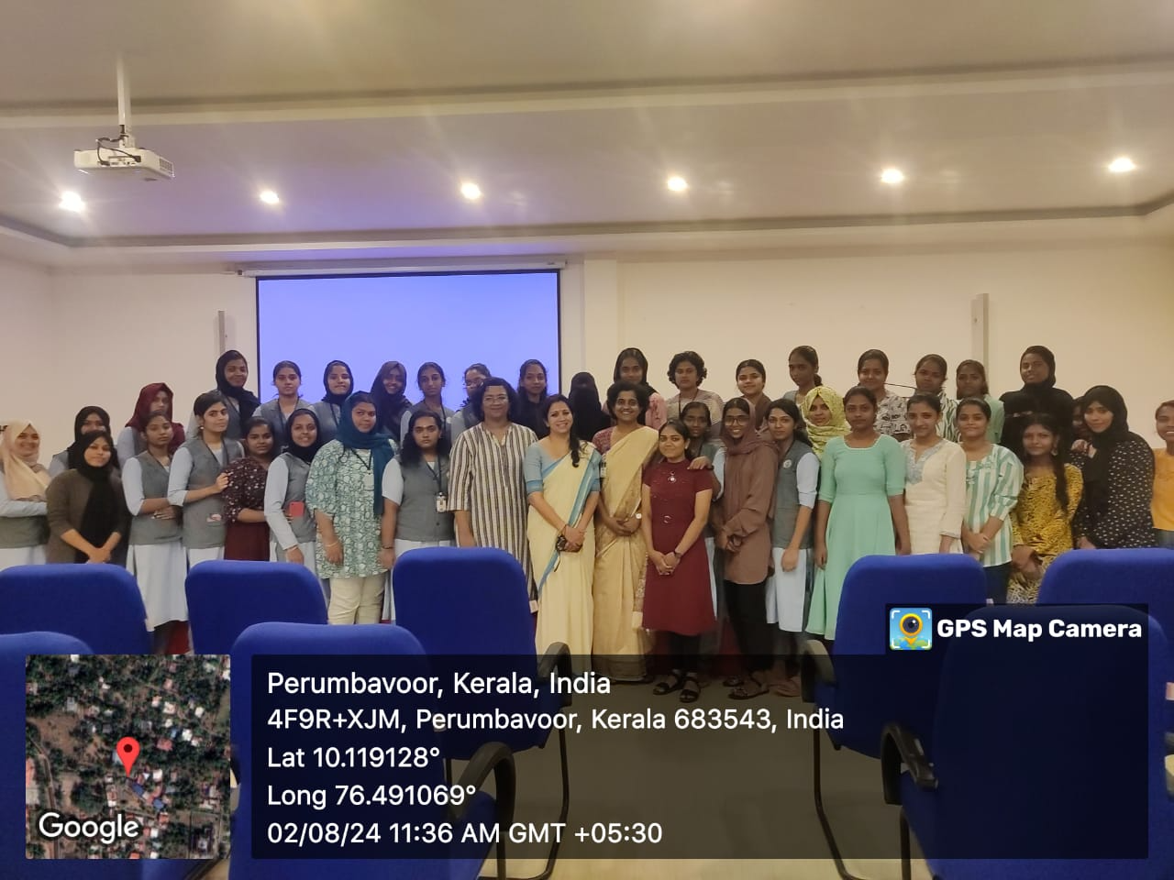
📅 3 July 2024
The Centre for Women's Studies of the Department of English, in association with the IQAC and the Mar Thoma Research Foundation, organized a lecture on “The Representation of Gender in Media.” Dr. Preethi Kumar, Assistant Professor and Head, Department of English, St. Teresa's College (Autonomous), Ernakulam, served as the resource person.

“Realise, Revive, Lead Your Life: Two-Day Leadership Enabling Programme
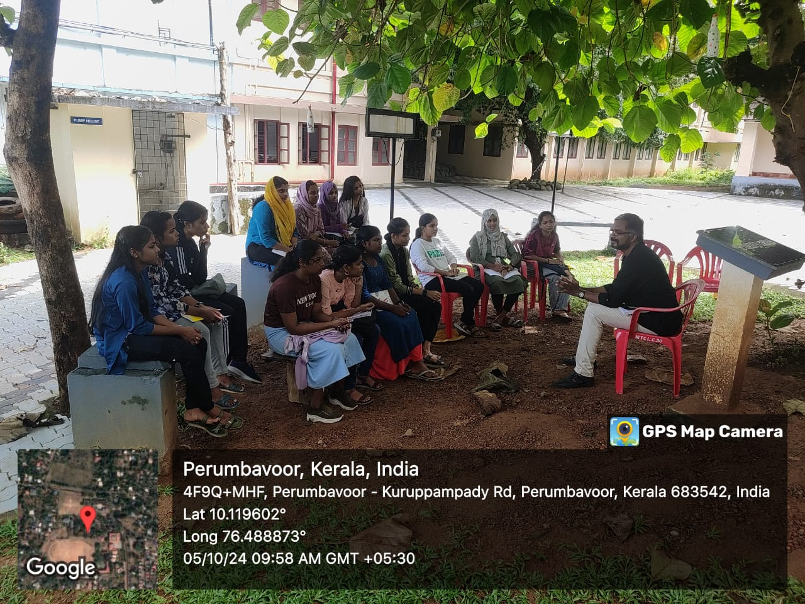
📅 18 July 2024
The Department of English conducted a Two-Day Leadership Enabling Programme
for undergraduate students. Mr. Lovewin Cherian, Mission Facilitator, Chola, was the resource person.

Study Visit to Fort Kochi
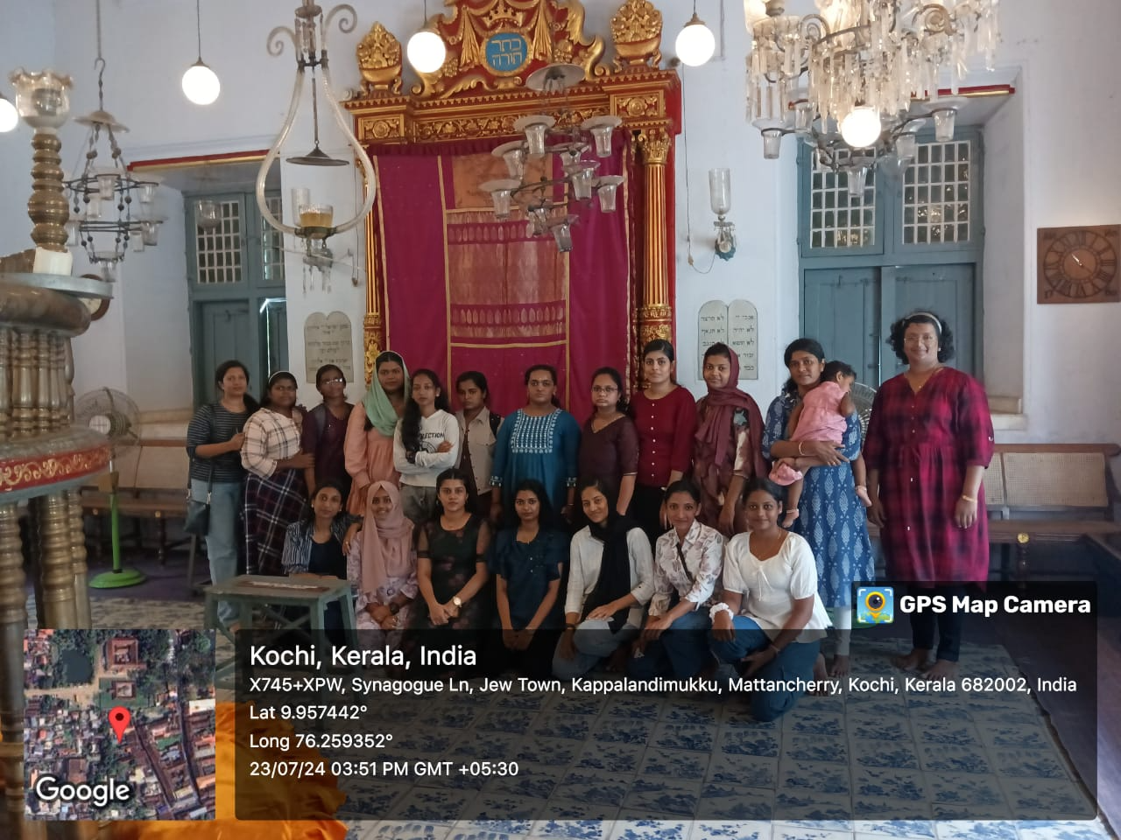
📅 23 July 2024
The English Association organized a study visit to Fort Kochi, offering students experiential insights into the colonial and cultural history of the region.
Invited Lecture: “Shakespeare Today”
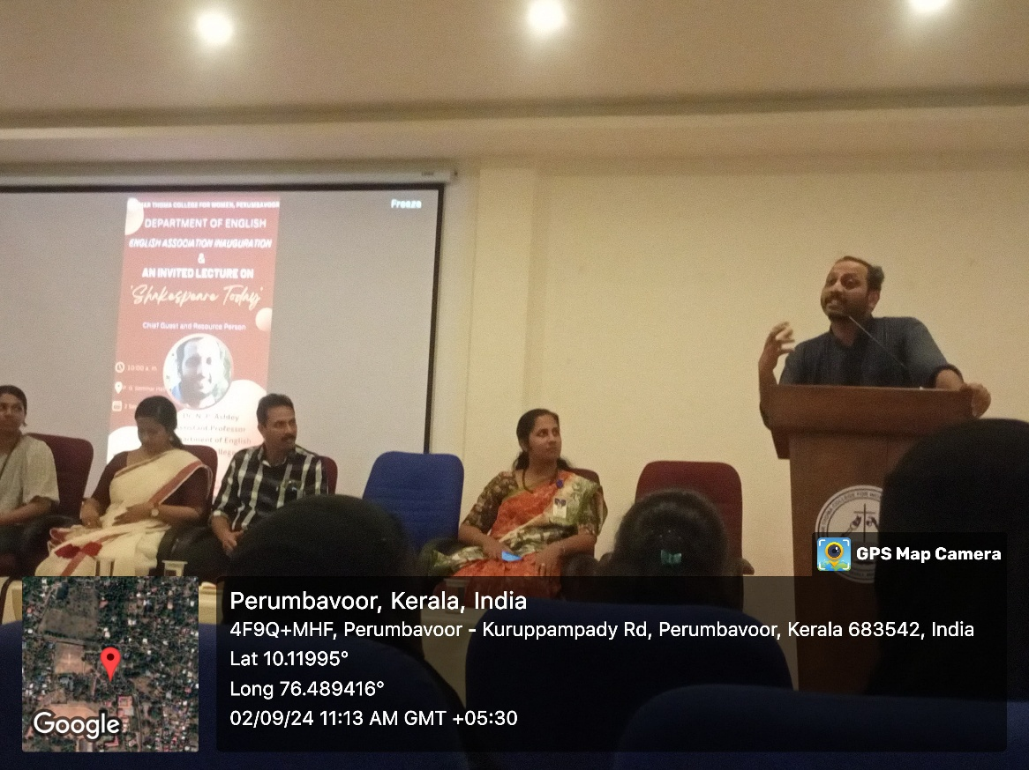
📅 2 September 2024
The English Association hosted an invited lecture on “Shakespeare Today.”
Dr. N.P. Ashley, Assistant Professor, Department of English, St. Stephen’s College, Delhi, served as the resource person.
Halloween Day Celebration: “Horror Chamber”
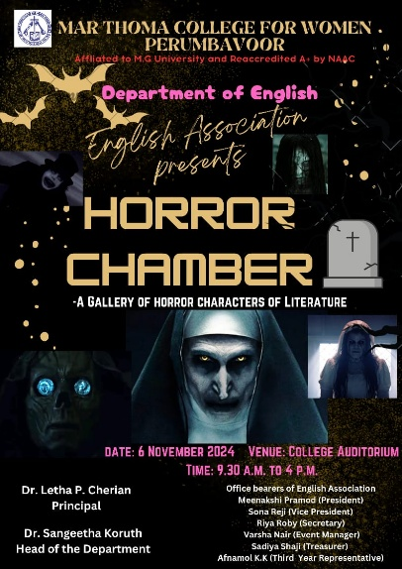

📅 6 November 2024
As part of the Halloween Day celebrations, the English Association created a “Horror Chamber” in the College Auditorium, bringing to life iconic scary and horror characters from literature and cinema.

Fairy Castle Model Display
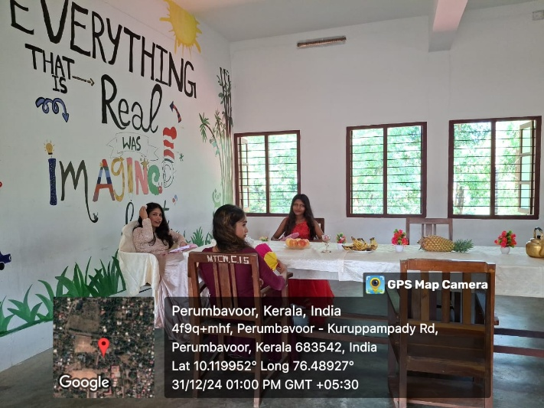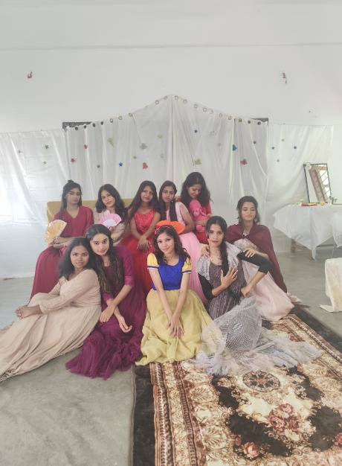
📅 31 December 2024
As part of ‘Sparkles- The Christmas Carol Competition’, the English Association designed a “Fairy Castle” inside the classroom. The model celebrated timeless fairy tale characters and their significance in literary traditions.
Drama Performance: The Quest
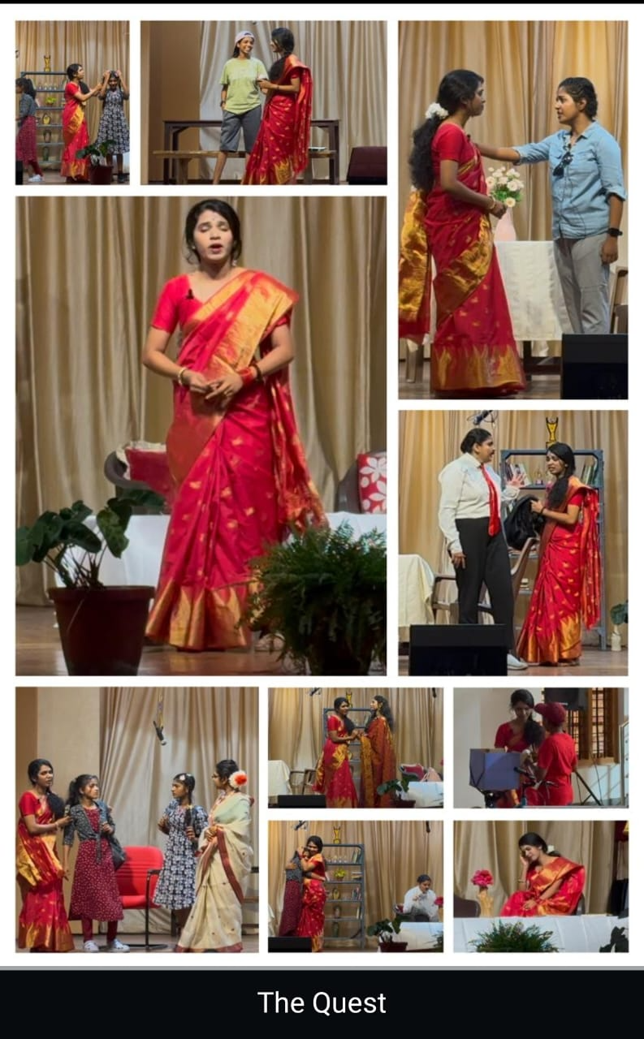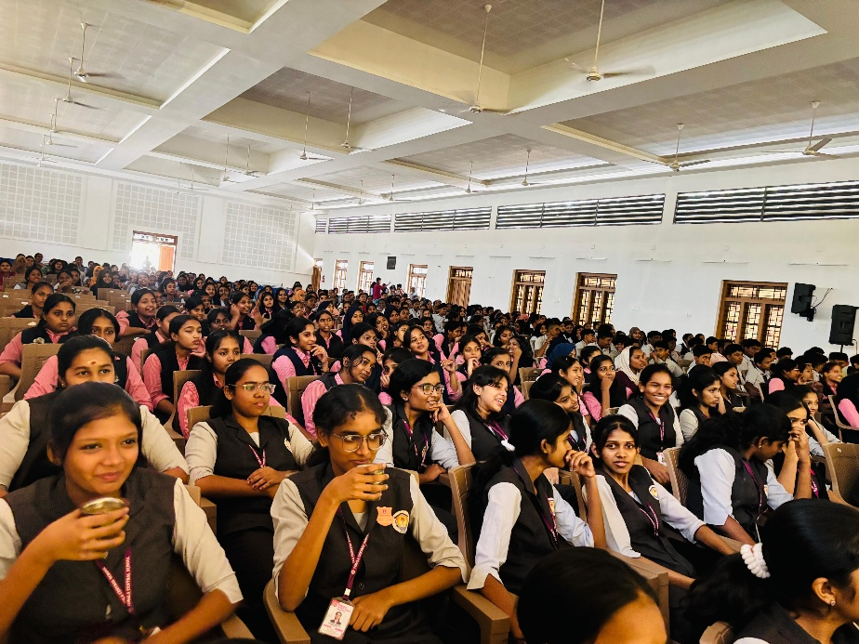

📅 28 January 2025
The Playhouse, the Drama Club of the Department of English, staged an original production titled The Quest, a reimagining of Kate Chopin’s The Awakening. The play explored themes of freedom, identity, and the constraints of domestic life.
National Seminar: “At the Faultlines of Survival: Reading Vulnerability and Precarity in Contemporary Indian Narratives”

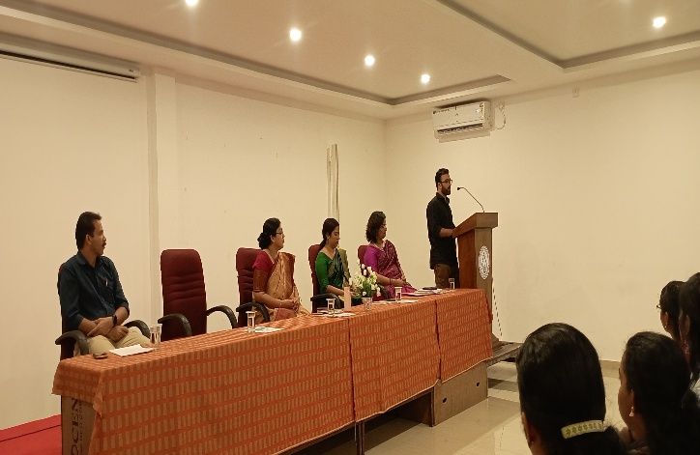
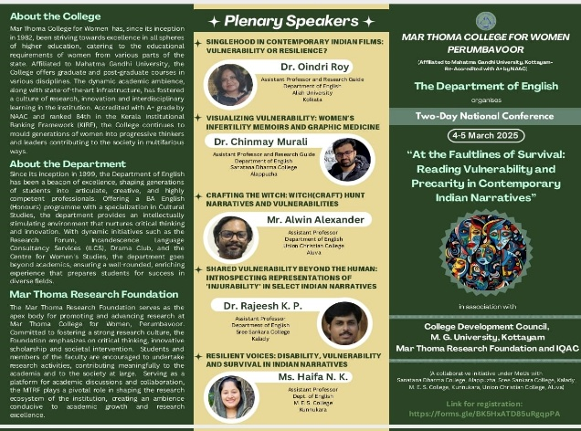
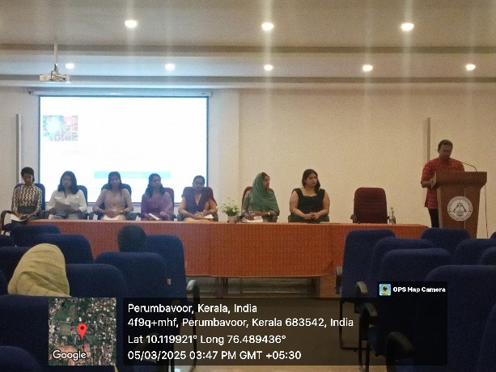
📅 4-5 March 2025
The Department of English, in association with the College Development Council, Mahatma Gandhi University, the Mar Thoma Research Foundation, and the IQAC, organized a two-day national seminar on Vulnerability Studies, titled “At the Faultlines of Survival: Reading Vulnerability and Precarity in Contemporary Indian Narratives.” The resource persons included Dr. Oindri Roy, Assistant Professor, Aliah University, Kolkata, Dr. Chinmay Murali, Assistant Professor, Sanatana Dharma College, Alappuzha, Mr. Alwin Alexander, Assistant Professor, Union Christian College, Aluva, Dr. Rajeesh K.P., Assistant Professor, Sree Sankara College, Kalady and Ms. Haifa, Assistant Professor, M.E.S. College, Kunnukara.

